NOW YOU ARE THE BODY OF CHRIST

1 Corinthians 12:1–31
Key Verse: 12:27

“Now you are the body of Christ and individually members of it.”

Do you ever feel unwanted? Be honest. It’s tough. It can happen with friends or family, at school or work, on sports teams or auditions, and sadly, even in church. When we’re ignored or treated with disrespect, we start wondering why we’re there. Why do we get ignored? Often it’s because of people’s ambitions, or because we don’t fit in with people’s expectations. Then we get hurt. We withdraw and check out. How can we be restored? And how can we function well in church? In today’s passage Paul explains. He proclaims a fundamental truth: as believers, each one of us is a member of the body of Christ. What does that mean? How can we see ourselves and others this way? How does this affect how we live and engage? May God open our hearts and speak to us through his word today.

In this letter Paul has been writing about various problems in the Corinthian church. In fact, he’s just rebuked them: “...when you come together it is not for the better but for the worse. For…when you come together as a church, I hear that there are divisions among you…do you despise the church of God and humiliate…?” (11:17–18,22). Due to their divisions, Paul said they couldn’t even celebrate the Lord’s Supper properly. It was shameful. Now in chapter 12 he goes deeper. He wants to help these diverse people realize who they are in Christ and how to start building healthy spiritual unity among them.

- “One and the same Spirit” (1–11)

Paul began this letter stating his faith that the Corinthians had accepted the gospel. They had become “the church of God…those sanctified in Christ Jesus” and “called to be saints” (1:2). They had received the grace of God (1:4), and in every way had been enriched in Christ (1:5). They were not lacking in any gift (1:7). A little later, he explained that unspiritual people cannot understand spiritual things (2:13–15). Then he rebuked them: “I…could not address you as spiritual people, but as people of the flesh, as infants in Christ” (3:1). Their spiritual immaturity had caused divisions (1:10), jealousy and strife among them (3:3).

After addressing many of their problems, in chapter 12 Paul discusses “spiritual gifts” (1), or “spiritual persons” (see footnote). He first reminds them that when they were pagans, they were led astray to mute idols (2). Then he gets to his point. Read verse 3. What does this mean? In one sense Paul is sharing the basis of spiritual discernment; in another, he’s saying to trust each other in the Holy Spirit. No one speaking in the Spirit of God will be led astray to speak blasphemy. And anyone confessing faith in Jesus as Lord is doing so “in the Holy Spirit.” It’s the Holy Spirit who makes anyone a genuine Christian and a spiritual person.

Read verses 4–6. This is yet another of Paul’s statements in the Bible about the Trinity. As those who have a personal confession of faith in Jesus, we all know the same Spirit, the same Lord, the same God. This Triune God is the source of our spiritual unity. But this unity doesn’t mean uniformity. We’re not all exactly the same. Among us we have varieties of gifts, varieties of service, varieties of activities. And these varieties are all good! They don’t divide us; they actually help us. Read verse 7. The Spirit enables all these varieties to contribute to “the common good.” “The common good” literally means “for every person.” In brief, the Spirit enables us to use our gifts not to show off, but to build each other up.

Then Paul lists some of the gifts the Spirit gives. Look at verses 8–10. These are: to speak wisdom and knowledge; to exercise faith; to heal; to work miracles; to prophesy; to distinguish between spirits; to speak and interpret various tongues. The Bible says there are other gifts as well (Ro12:6–8; Eph4:7,11; 1Pe4:9–11). Read verse 11. The point here is not to speculate about what all these gifts mean, but to acknowledge where they come from. The expression “the same Spirit” is repeated in these verses four times (4,8,9,11). Paul is saying we shouldn’t be trying to take credit for our spiritual gifts, thinking we’re superior. Instead, we should humbly acknowledge that our gifts are empowered by the Holy Spirit. We also should humbly accept that any gifts we have were given to us according to God’s will. Paul is emphasizing “empowered by the Spirit” and “given according to God’s will,” to keep us from becoming conceited. When we read about these gifts, we may not think we have any of them, and we may not see them in others, either. But these gifts begin to appear when we get busy serving. A healthy church is where everybody is empowered by God’s Spirit, and where we’re all using our various God-given gifts to actively serve one another.

- One body with many members (12–31)

Paul continues to explain who we are in Christ, using the analogy of a human body. Read verse 12. Though a body has such a wide variety of members, or parts, they’re all organically fused into one. This illustrates a Christian community so well. Read verse 13. The church in Corinth was very diverse. Some were Jews; most were Greeks; most were from the lower classes; some were well-born, wealthy and educated (1:26; 11:22). Socially, these people would never have gotten together on their own. But through being baptized into faith in Christ, whether they realized it or not, they were closely united in the Spirit.

Paul develops this further. Look at verses 14–20. What’s the point? Paul is suggesting that some people may not feel like they belong to the church. Why? Paul likens people to certain body parts. Interesting. Which part are you? Some people might think a foot is inferior to a hand, an ear inferior to an eye, a nose inferior to an ear, etc. Likewise, certain people think they are inferior, or their gifts are inferior. But in a body, each part is essential to the whole. My wife, who’s a hand therapist, told me that in treating the hand, the pinky finger is revered by surgeons and therapists. It seems like the smallest and weakest finger, but without it, the hand can’t make a proper grip. And, it’s the hardest part of the hand to repair. In the same way, the body really needs all its parts. Each part has a clear and necessary function. And, each part has its own wonder and beauty.

Paul makes another key point here. Read verse 18. God is sovereign in how he made each of us, how he gifts us, and where he places us in a specific church body. So, instead of comparing ourselves with others or trying to force things with our own ideas or ambitions, we need to accept God’s sovereign will in our lives.

Paul develops this image further. Read verse 21. The point is, in the body of Christ, we all need each other. Paul is again addressing those who feel unwanted or unnecessary; he’s also addressing those who tend to dismiss or disregard others. Read verses 22–24. By emphasizing the body’s weaker, less honorable, unpresentable parts, Paul is urging those with the more prominent gifts not to despise their weaker church members, but to bestow greater honor and greater modesty on them. Doing this creates such graceful harmony in a church community. This is what the Corinthian church lacked. Look at verse 24b. Paul again highlights how “God has so composed the body,” meaning the church is God’s master design. We all need to discern what God is doing among us.

Where is Paul going with this? Read verse 25. To the Corinthians it was another stinging rebuke. They were divided, based on race, education, wealth and social class. In Greek, the word “care” in this verse is literally “be anxious for.” Our sinful nature makes us anxious only for ourselves, our own families, our own kind of people. But God calls us to a body of Christ to be anxious for each precious member in it, across typical cultural and generational barriers.

How can we show such genuine concern? Read verse 26. In our sinful nature, when somebody is honored, we get jealous. When somebody suffers, we’re indifferent. In our pragmatism, just one person doesn’t matter so much. If one person leaves, we just say, “Oh, well.” But being empowered by the Spirit changes us. Even one person who suffers causes everybody to suffer together. Even one person who’s honored causes everybody to rejoice together. Wow, what a beautiful community! It’s not a fantasy; it’s possible in our Lord Jesus Christ. But to really have it, we’ve got to repent. We’ve got to repent of our giant egos and of fighting over philosophies of ministry. We’ve got to repent of pretending to be better than we are. We’ve got to repent of a self-righteous, judgmental spirit. We’ve got to repent of attacking one another based on exaggerations and half-truths. We’ve got to repent of holding onto grudges and perceived hurts. We’ve got to repent of our hardened and cruel hearts towards each other. We’ve got to see ourselves and each other not based on labels, but on a precious Biblical truth.

Read verse 27. Here Paul proclaims our new identity, both collectively and individually. Collectively, we’re not just a motley crew of people who decided to get together. Through faith, we are, each one, every single one of us, together, the body of Christ. How did we become members of his body? Paul explained it back in verse 13: by one Spirit we were baptized into one body. Here, baptism means we all repented of our sins and turned to Christ by faith. We confessed our faith in him and received the same Holy Spirit, the forgiveness of sins, and the new life only he can give. We all committed ourselves to obey him as Lord. Now, through him we all share the same living hope in the kingdom of God. We’re diverse in our individuality, but one in our spirituality. Now, in his body, every person who shares this confession of faith is so precious to us.

Paul continues. Read verse 28. These are just some of the spiritually gifted people God has given his church. Paul begins with the leaders and goes on to all the others. Then he asks a series of rhetorical questions. Look at verses 29–30. His point here is that we can’t all have the same gift. That’s not the way God works. God brings diversity into his body so that it can function well. We need to accept God’s sovereignty in our giftedness and start using our gifts, whatever they are, to diligently serve in our congregation. Our gifts are not for self-advancement, but to serve God and enhance the spiritual growth of our church members. If we’re called to be up front to teach or preach, we should give it our all. If we’re called to be behind the scenes to serve and to help, again, we should give it our all. The only obstacle to living like this is our pride.

If we’re being honest, some of us are feeling useless, or burned out, or hurt. May God renew his Spirit in us, to see ourselves and each other as precious members of the body of Christ. May God show us how to serve this body with whatever gifts he gives us. And may God help us develop a healthy, beautiful, Christ-like community which can really bless people living in this dark world.

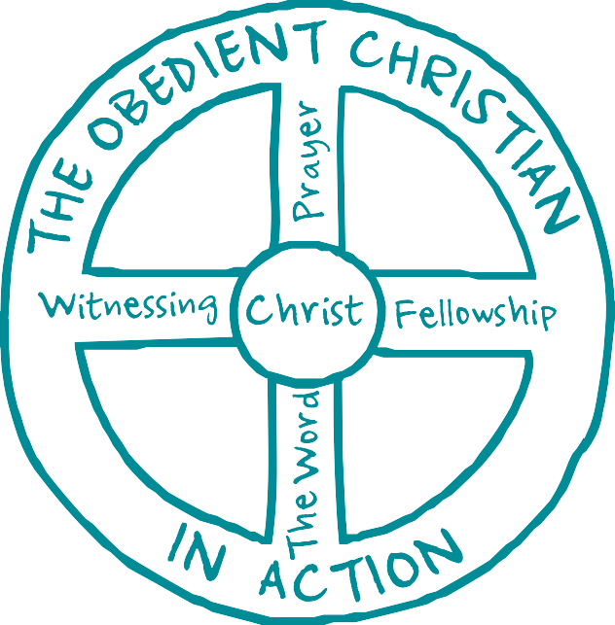
Navigators Discipleship Tool

The Wheel diagram, created by Navigator founder Dawson Trotman in the 1930s, is a simple and effective way to visually explain the structure of a God-glorifying life. Sharing it can be as simple as drawing it on a napkin or notepad. The diagram challenges us to think deeply about how to be an obedient follower of Christ and each part represents a crucial component of a vibrant Christian life.

THE WHEEL
How you relate to yourself

THE CENTER HUB AND OUTER RIM
- Christ: Total surrender to Christ’s authority and Lordship is not always a decision made right at conversion, but is a necessary act of the will. For the believer, the “old life” has gone and the new has come (2 Corinthians 5:17), because Christ has begun to dwell in us (Galatians 2:20). God creates within us the desire to do what He wants us to do in order to express His Lordship in our lives.
- The Obedient Christian in Action: Some acts of obedience to God are internal, such as attitudes, habits, motives, values and
day-to-day thoughts. But even these eventually surface outwardly in our relationships with other people. Keeping His commands in obedience is our outward indication of inward health
and love for Christ (John 14:21, Romans 12:1).

How you relate to God

THE VERTICAL SPOKES
- The Word: God uses His word to speak directly to us, revealing not only who He is, but how He calls us to live and interact with everyone around us (2 Timothy 3:16). This means an earnest personal intake of God’s Word is essential for our spiritual health and growth (Joshua 1:8). As God speaks to us through the Scriptures, we learn how to obey Him and apply the gospel to every part of our lives. We also come to know Jesus personally and find He is worthy of our steadfast allegiance.
- Prayer: Prayer is the natural response to God as we hear Him speak through His Word. It is sharing our heart with the One who longs for our companionship and who cares about our concerns. Prayer not only trains our hearts and minds to know the power and glory of God, but also turns His ear towards action in our lives (John 15:7, Philippians 4:6-7).

How you relate to others

THE HORIZONTAL SPOKES
- Fellowship: God has directed Christians to build each other up through interdependence and loving relationships with each other (Hebrews 10:24-25). Gathering together as the Body of Christ draws God close around us as we praise Him and encourage one another (Matthew 18:20).
- Witnessing: God has given believers the joy and responsibility of telling the world about the good news of Christ’s work on Earth (Matthew 4:19). In fact, sharing about His amazing grace is the natural overflow of a rich, vibrant life in Christ (Romans 1:16).

THIS TOOL IS MEANT TO BE SHARED. To download a copy visit navlink.org/wheel
The Wheel ©1976, (2016) by The Navigators. All rights reserved.

