August 10, 2018 4:00-5:30 P.M.
TITLE: “YOUNG MEN WILL SEE VISIONS”
[SHORT-TERM MISSIONS SESSION— ISBC 2018]
Key Verse: “’In the last days, God says, I will pour out my Spirit on all people. Your sons and daughters will prophesy, your young men will see visions, your old men will dream dreams.’” Acts 2:17
[Short term mission committee: Agnes Jordan, James Ahn, Daniel Sohn, Richard Choi]
- Prayer: Daniel Sohn
- Introduction (15 min): Richard Choi
- Short-term mission testimonies/reports (40 min)
- One representative from Vision Camps (Washington DC UBF): Next Gens Vision Camps, July-August 2018
- Steven Giesbrecht & Jonathan Christopher (Montreal, Canada): Sendai Japan, June-July 2018
- Junmo Kwon & David Henkins (IIT, Chicago): Rwanda, June-July 2018
- Jacob Staal (UIC, Chicago): Uganda, July 2018
- Philmar Mendoza (North Park, Chicago): Marshall Islands, May 2018
- Mission Opportunities (15 min): Agnes Jordan
- Open discussion (Q/A) (15 min): Daniel Sohn, James Ahn, Richard Choi, Agnes Sohn
- Prayer and announcement (5 min): James Ahn/Richard Choi

Contact Persons: UBF World Mission Department
- Director: Jacob Lee, Washington DC, jacobleeubf@gmail.com
- Vice Directors: Short-term Missions: Richard Choi, Chicago, rchoiubf@gmail.com, (James Ahn, jamesahn120@gmail.com, Agnes Jordan (Sohn), agnessohn@gmail.com, Daniel Sohn,
dsohn6638@gmail.com)
Education and Training: Dr. Ezra Cho, Washington DC, ezra5978@gmail.com
Long-term Missions: David Kim, Indianapolis, iupuiubfdavidkim@gmail.com
Silver Missions: Daniel Yang, Rwanda, dyang121@gmail.com

UBF SHORT-TERM MISSION SUMMARY:
“We live in the age of the Holy Spirit that our sons and daughters will prophesy, our young men will see visions, our old men will dream dreams. (Acts 2:17) When we receive the Holy Spirit through our Lord Jesus we are a kingdom and priests to serve our Lord Jesus and his world mission. We are called to be short term missionaries, long term missionaries and silver missionaries to bring the good news of salvation to homes, cities, nations, and to the ends of the earth. (Acts 1:8: “But you will receive power when the Holy Spirit comes on you; and you will be my witnesses in Jerusalem, and in all Judea and Samaria, and to the ends of the earth.”) The kingdom of God is where these three generations--children, young adults and parents--work together as a family, church, and nation for his world salvation work through the Holy Spirit. Furthermore, our children (HBF) and young adults (college students) are called to be kingdom workers with world mission vision. They are also eager to serve gospel ministry as missionaries to the world. Therefore, we encourage and pray for our new generation of young people to participate in short term mission and experience a missionary life with God’s kingdom vision. In the long run, we hope and pray that God will lead them to commit to his kingdom work, discipleship ministry on campus and world mission. God has sent out 1,802 UBF missionaries to 97 countries thus far. We pray for 100,000 missionaries to be raised up and evangelize all the major cities and campuses around the world in the generation (by 2041). We the short-term mission committee will present on UBF short term mission history, opportunities, testimonies, and preparation (programs/training, expenses, etc.). We will invite all attendants to join an open discussion about short term mission topics and collect their ideas and suggestions on promoting and improving our short- term missions for mobilization, training, sending and following up with short term mission candidates/missionaries. We also hope and pray that many young people will volunteer to be short term missionaries during the meeting and Conference.”

- UBF Short Term Missions History and Facts:
- There are at least 18 short term missionaries who have served or been serving world mission this year 2018: Lesly Lopez in Dominican Republic; Carlos Santiago in Puerto Rico; Denise Guerrero in Korea; Brooke Budzileni in Kenya; Steven Giesbrecht, Jonathan Christopher, Shaina Castle in Japan; Esther Cheng, Emerald Brooks in Uganda; David Henkins, Junmo Kwon, Anna Joy Ahn, David Won Jr. in Rwanda (and Uganda); Grace Sambuco, Summer Thomas in Zambia; Joshua Jung and Joshua Jung Jr. in Israel; Philmar Mendoza in Marshall Islands.
- In addition, there were the Short-Term Mission Vision Camps for the next gens leaders who were trained and equipped with world mission visions in Washington DC, LA and NJ with more than 129 participants just before this Conference started. Also, some of young leaders such as Anna Sakis (Podil Ukrain), Rebecca Fernandez (Guadalajara Mexico), Anna Sung (London Canada) joined the local chapters in the USA for the missionary field experience.
- In 2017 at least 21 short term missionaries were sent out: Dennie Deliva—Thailand, Taiwan; Brooke Budzileni—Ecuador; Courtney Rinehart—Uganda; Danny Holowicki—Philippines; Augustine Park, Caleb Kim, Grace Chun, John Kim, Luke Kim, David Park, Grace Seo, Ashia Lara, Joy Kim, Rebecca Chun—Belize; Francis Choi, Theresa Choi—Uganda; Paul Roth, Faith Hong, Lindsey Fung—Middle East; Sarah; Philmar Mendoza—Marshall Islands

- What we as members of the short-term mission committee have done:
In September 2017, by God’s grace based on Acts 1:8 we (Daniel Sohn, James Ahn, Agnes Sohn and I) formed a mission committee in Chicago UBF. Since then we met twice a month to pray for God’s blessing and revival of world mission in NA. Under the leadership of P. Jacob Lee, the world mission department director, God has helped us to serve the world mission as prayer servants:
- Established a missionary database for communications
- Collected and shared their prayer topics, photos and video clips and prayed for them at SWS
- Written letters and Christmas cards to them in order to establish a missionary network for mutual encouragement and serving of world mission as a family of God
- Recruited missionary candidates providing them with UBF chapters that were looking for short-term missionaries
  - Created tentative programs for training including vision camps and local chapter missionary field experience n
  - Welcomed and served the missionaries who came to attend the ISBC

- What we are praying for:
  - To solidify the missionary network to pray for and support them to serve God’s world mission work in their mission fields and mobilize them as spiritual models and mentors to those who have short-term and long-term mission visions
  - to collaborate with our educational department to implement training courses/programs for missionary training
  - to hold annual Vision Camp for the next gens leaders to be equipped and trained for world mission
  - to have short-term missions on UBF website—it is under construction
  - to build and operate the retreat/education centers at strategic regions for missionaries and missionary candidates
  - to encourage/inspire our members to become short-term, long-term and silver missionaries and raise 100,000 missionaries by 2041 as a kingdom of priests and a holy nation for evangelizing 136 unreached countries including Muslim countries, China and North Korea

- TRAINING PROGRAM FOR SHORT TERM MISSIONS
Contact Persons: UBF World Mission Department
- Director: Jacob Lee, Washington DC, jacobleeubf@gmail.com
- Vice Directors: Short-term Missions: Richard Choi, Chicago, rchoiubf@gmail.com, (James Ahn, jamesahn120@gmail.com, Agnes Jordan (Sohn), agnessohn@gmail.com, Daniel Sohn,
dsohn6638@gmail.com)
Education and Training: Dr. Ezra Cho, Washington DC, ezra5978@gmail.com
Long-term Missions: David Kim, Indianapolis, iupuiubfdavidkim@gmail.com
Silver Missions: Daniel Yang, Rwanda, dyang121@gmail.com

- SHORT TERM MISSION OPPORTUNTIES

1. NEXT GENERATION VISION CAMPS (AND MISSIONARY FIELD EXPERIENCE PROGRAMS)—Every Summer by a Country/Chapter chosen for hosting

In previous years, Korea UBF sent around 200 Korean students to the conference. They would go on tours afterwards. This year we tried something new: we invited students from Korea UBF and overseas UBF to come for a short-term missionary experience. We prepared and offered two tracks for STM opportunities for the students: Vision Camps (in Washington DC (50), LA (30) and NJ (30)) and Missionary Field Experience Program.

Los Angeles VC (7.20-8.8): By David Park

The Title: "Victory in Jesus." Altogether 74: <30 delegates and 44 LA members are attending now: (12 JBF/HBF (Poland, France, Canada, Arizona) and 17 College UBF (Bolivia,
Canada, Korea) with 44 LA JBF/HBF/UBF.)>
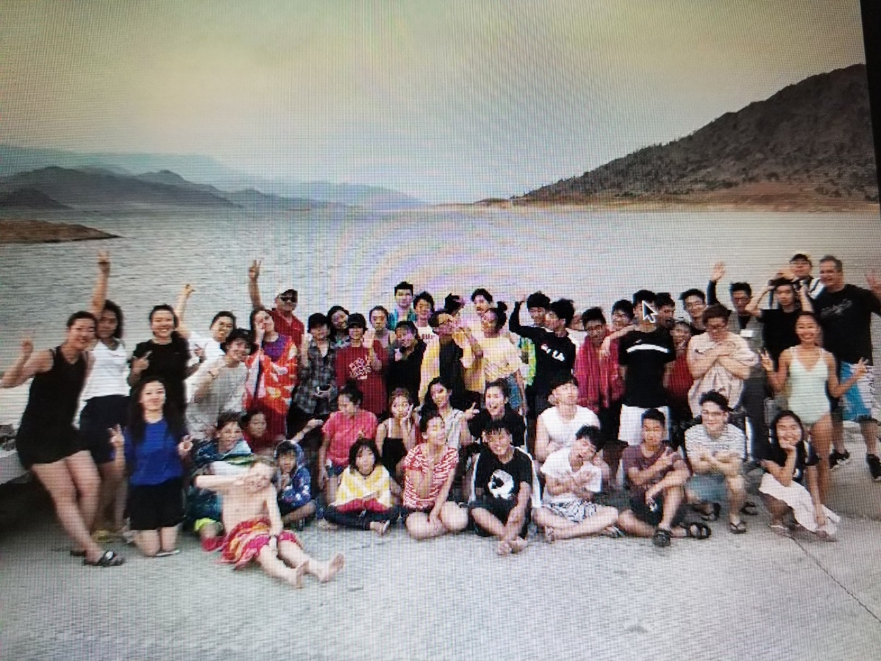

New Jersey Global Leadership Empowerment Forum, 7.24-8.6-- By John Park

The Title: "You will be my witnesses" (Acts 1:8). 49 registered. The high lights this week was Dr. Mark Yang's inductive Bible study workshop in three sessions as well as Blad Mir Point's opening, Joshua Lee (Toronto), David Kim, John Park"s UBF spiritual legacy, Little Sarah's Jesus in Genesis. Factual studies and question making workshops and Dr. Petrus Chang's God's redemptive history on Maps series. On 7/28 we have an NY visiting. The Sunday Worship service message is by Joseph Lee (Mk3) and Dr. John Jun's marriage by faith will be presented.

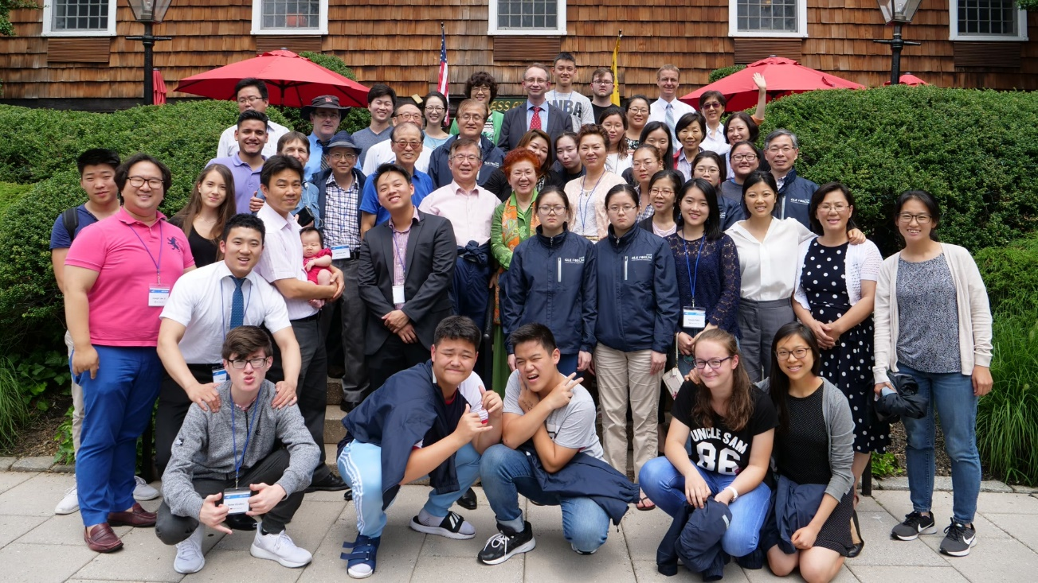

Washington DC, 7/30-8/8/18—By Jacob Lee

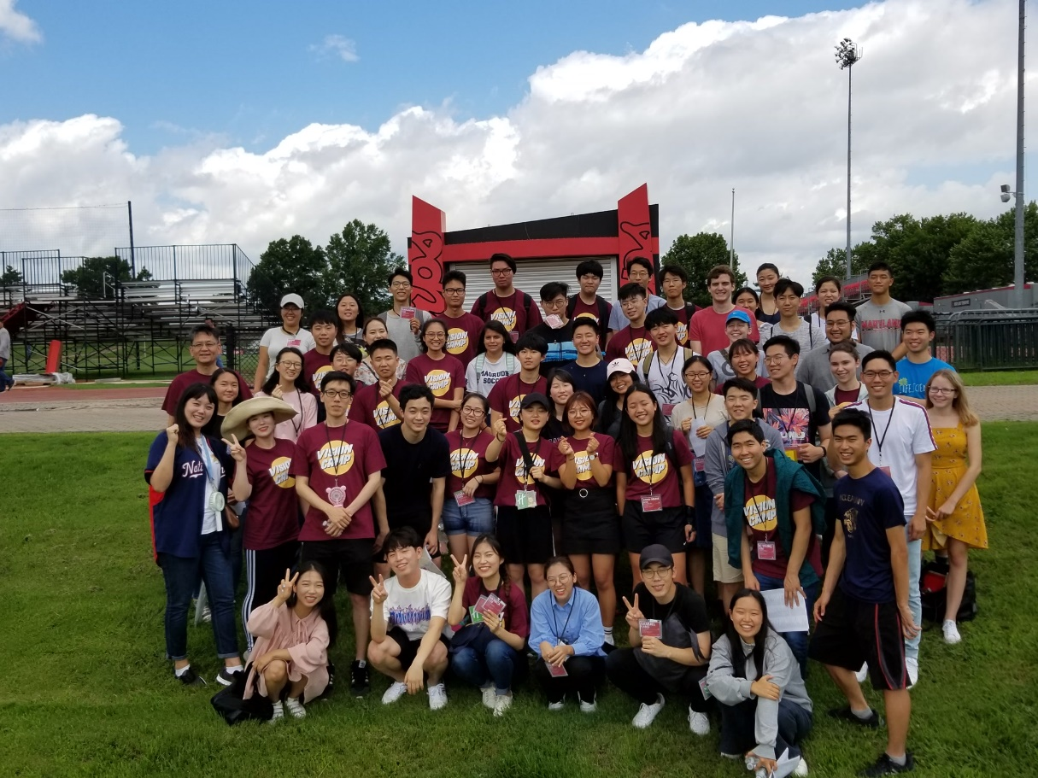

The NGVC is a program for those who are willing to receive training and serve the world mission. We expect to have about 50 students from Korea and other overseas countries who will receive vigorous training in a concentrated time and program. (The NGVC will be running as a pilot program this year and be continuing every summer for students, especially HS graduates.)

Missionary Field Experience Program, July to August 2018—By Local Chapter Directors (Paul Choi, St. Louis, choi8149@yahoo.com)
Our MFEP this summer will be a very flexible program, in which Korean students will be able to see the real-life experience of our ministries in North America and the practical lives of our missionaries.
We believe that missionaries in many of our smaller chapters will be refreshed and revitalized by receiving these students and having spiritual fellowship with them. We also believe that the students will
be blessed to learn how God is working in North America. Ultimately, we pray God would call and raise permanent missionaries for the whole world through our STM ministry.
Chicago UBF hosted: Anna Sung (London, Canada), Rebecca Fernandez (Guadalajara, Mexico), Ana Sakis (Podil, Ukraine), ,,,,

2. MISSION OPPORTUNITIES WITH UBF WORLDWIDE
1) Rwanda-- Daniel & Deborah Yang
[We welcome anyone (English Bible teachers) young and old who is interested in serving world mission.]
Prayer Topics:
* To raise up faithful disciples of Jesus who has calling and commitment for campus discipleship ministry (Sh. Hodal, James, Felicien, Emmy, Emmanuel, Patrick, Cynthia, Seth)
* New fishing ministry in October
* Good health of M. Daniel and Deborah Yang
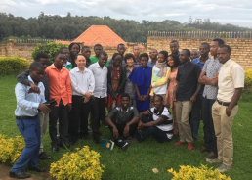

2) Uganda (Makerere)—Dr. Livingstone Kang
[We welcome a music servant who can serve choir members for praise and worship for at least 3 months; an experienced nurse and administrator who can speak English and work as a long term missionary in our hospital]

34 People Participated in the Eleventh UBF Uganda Healing Mission Camp, UGANDA
Key verse: Luke 12:33a, “Sell your possessions and give to the poor.”
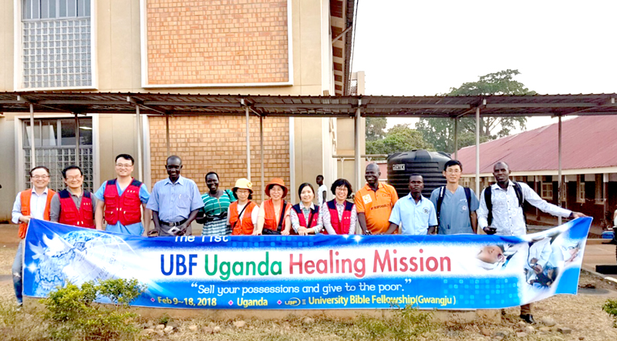
<Group Photo in Hoima Regional Referral Hospital>
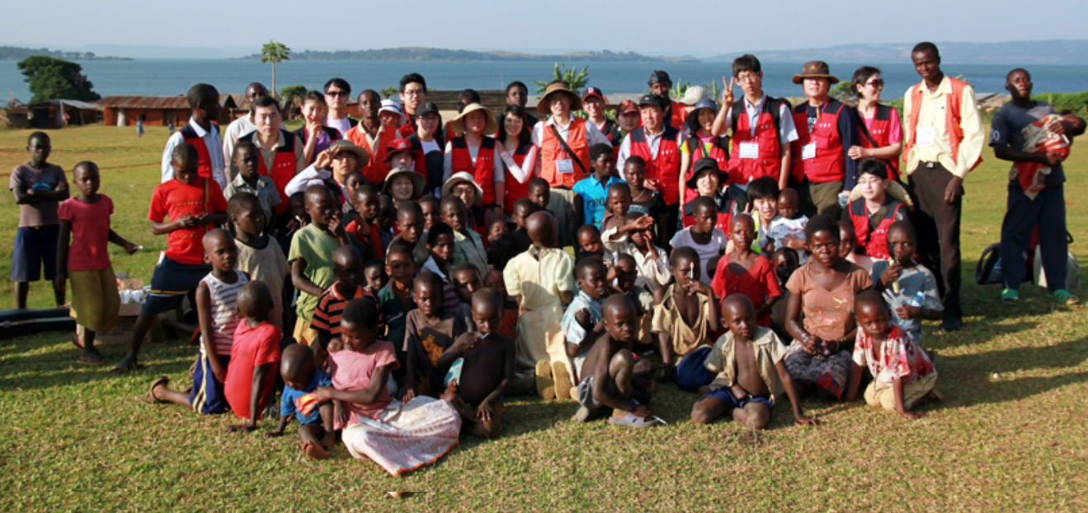
We heard Sunday message about five loaves and two fish through Shepherd David Park (Gwangju 3) before leaving for medical camp. We believe that God already accepted our five loaves and two fish that we brought to Jesus. We thanked God for using us to serve Ugandan people through the eleventh healing mission.

3) Greece (Athens)—Paul Lee

[We need one short term missionary who can serve teaching the Bible in English for two months to six months; we prefer a female second gen.]

We have been serving Greek campus ministry (Athens' National University) about 27 years; and now we have 2 chapters established and about 20 members working together: 4 Korean missionary families, one shepherd’s family, 9 second gens from 25 to 10 years old and native students and others.
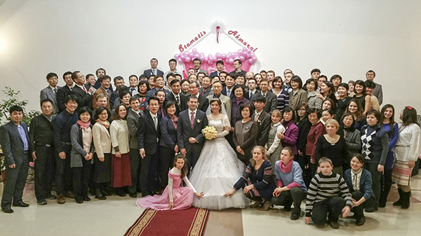
P. Abraham Kim officiated the wedding between Stamatis (Greece) and Akmaral (Astana, Kazakhstan) with Matthew 6:33 after the CIS directors' conference. It was held at the Kiev UBF center at 5 p.m with more than 130 attendees. It was so joyful that it reminded us of the wedding of Cana in Galilee. All were full of joy in prayer for this inter-continental house church to be a blessing for Greece and Kazakhstan, Europe and CIS, and the whole world by seeking God first.

4) Ukraine, Podil—John/Maria Peace
[We are looking for an English Bible teacher. We want him/her to stay for two months.]

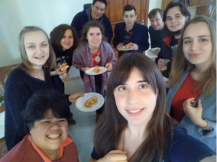
God bless our 2018 Spring Bible Conference. Though many of our students had exams before and after the conference, many came by faith, about 13. This conference was about What Faith is. Those who came experienced it. Please pray for them to pass their exams this week. Vlad a 2nd year student of Economics in KMA gave the message on the life of Moses. It was the first time that he ever gave a message and we were moved by it. It was powerful because he himself sincerely accepted the word of God. God poured out his Spirit upon us from the beginning to the end. Thank you for all your prayers for us. Two of our sisters were baptized. We prayed for 25 to come and 27 came. Esther Nett from Germany came and she led our Inductive Bible study and trained the Group Bible Leaders as well.

5) Indonesia, BSD – Dr. William Kim
We have an English ministry. But we don't have a piano player, i.e. we need a music servant. We need either a long term or a short-term servant as soon as possible. We serve UPH university and University of Indonesia. But we need a servant who can visit the campus regularly. Or I need someone who can deliver a message in turn with me. I am the only one who can deliver the Sunday and Conference messages. I need a rest on and off.
I had served a ministry for 14 years in the USA as a Korean born missionary. And I got a teaching job in an International school where only English is used in Indonesia in 2011 with my wife for the first time. So without knowing the Indonesian language, I could come to Indonesia. However, while I can't speak Indonesian language, English is also not my native Language. So in terms of teaching language, I need a help mostly from the US co-worker.
1) Brother Darien and Sister Sonya may keep growing to be a shepherd and a shepherdess.
2) Sister Nadia, Sister Yulia, Brother Irvan, and Ibu Licu may keep studying the Bible.
3) Luke's Gospel Bible Study and Sunday message
4)10 SWS and 10 One to One
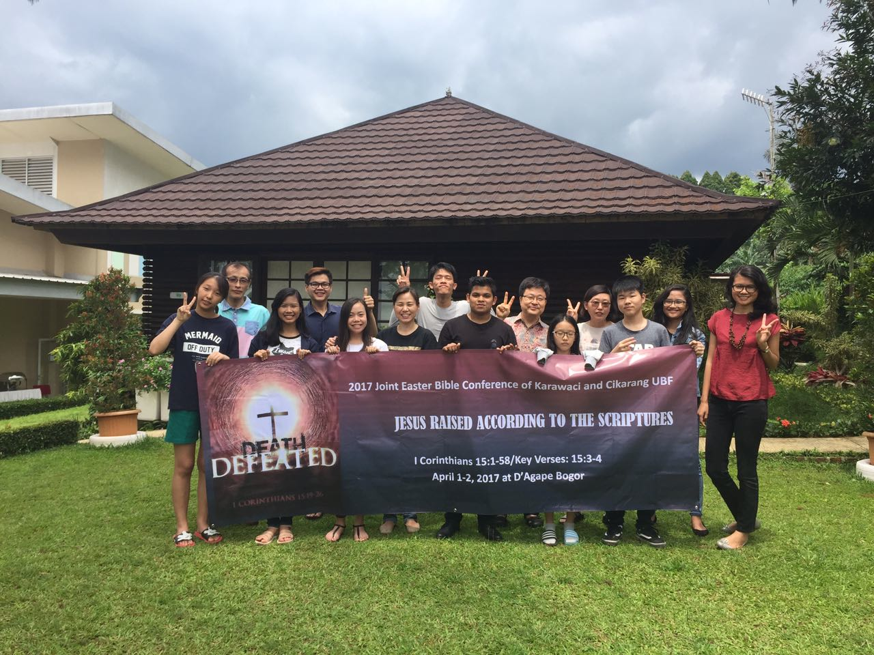

6) Bolivia (Santa Cruz I)—Mateo Carmelo (Dr. Steban Cho)
[We are looking for a music servant or an English Bible teacher.]
We thank God for raising 6 new disciples of Jesus last Sunday. Our discipleship course began on April 30, 2017 and ended on August 27, 2017. These were almost 4 months of training where discipleship candidates were trained in the following areas: Personal Devotion, Service, A Disciple’s Material Life, and Preaching. The course was led by Bolivian shepherds along with the collaboration of M. Esteban Cho.
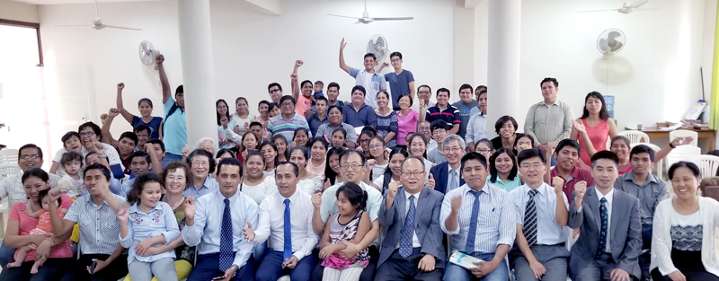
We praised God because God has done great work in Bolivia through M. Esteban and Pauline Cho's near 30 years of sacrificial service! On Jan 21st (Sun), Sp. Mateo Arebalo succeeded to M. Esteban as the director of Santa Cruz 1, Bolivia. Abraham Eric will be the first president of the board of elders.

7) Kyrgyzstan (Bishkek)—Mark Phang
[We are looking for English Bible teachers; we also need teachers who can teach English and Biology for elementary and high school students (Hope Academy)]
Hope Academy of Bishkek
https://www.facebook.com/hopebishkek/

8) North Korea – PUST
Medical Mission or Faculty members at PUST
For more info about Pyongyang University of Science and Technology (PUST)
http://www.nytimes.com/2010/10/26/world/asia/26pyongyang.html

http://money.cnn.com/2009/09/14/magazines/fortune/pyongyang_university_north_korea.fortune/index.htm

3. More mission opportunities with relief organizations and agencies outside UBF
Brooke Budzileni’s Mission trip to Kenya
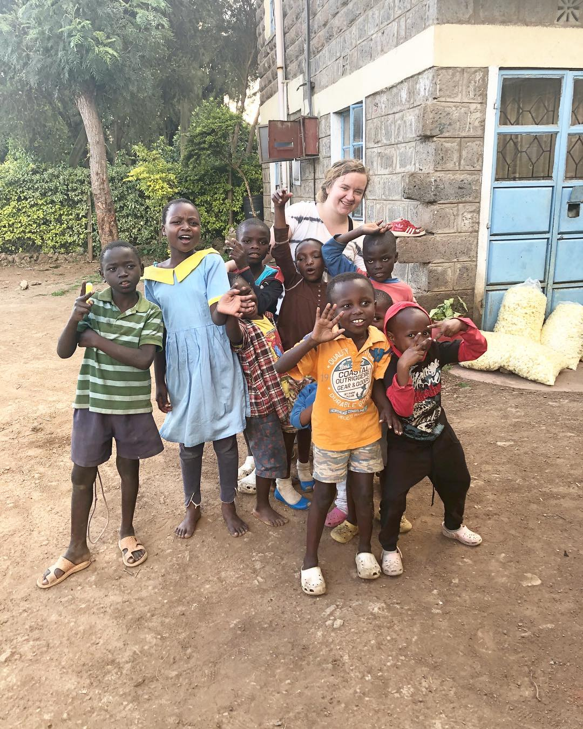

Philmar's Short Term Mission to Marshall Islands

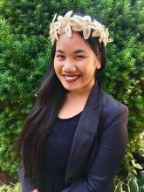

God’s Marshallese People
- To meet Jesus personally, to have an intimate and personal relationship with Him, and to grow as His true disciples and as witnesses of Jesus and as Gospel workers worldwide.
- John 4:39-42 “Many of the Samaritans from that town believed in Him (Jesus) because of the woman’s testimony, ‘He told me everything I ever did.’ So when the Samaritans came to Him, they urged Him to stay with them, and He stayed two days. And because of his words much more became believers. They said to the woman, ‘We no longer believe just because of what you said; now we have heard for ourselves, and we know that this man really is the Savior of the world.’”

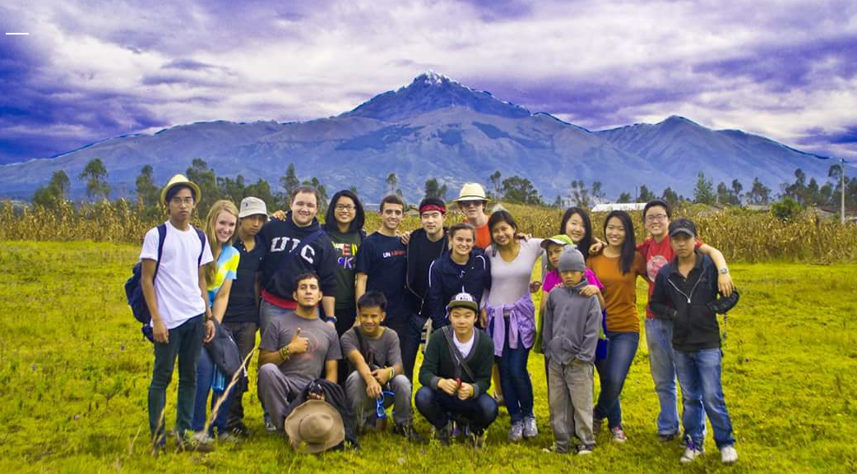

July 2011 – Quito, Ecuador

Chicago HBF's Short Term Mission Trip to Quito, Equador

“For we are God’s workmanship, created in Christ Jesus to do good works, which God prepared in advance for us to” Ephesians 2: 10

This summer, God opened a door for a team of students to go on a short term mission’s trip to Quito, Ecuador. For this short term mission’s trip, UBF partnered up with Youth World, a non- profit organization that connects teams from all over the world to serve local churches in Ecuador. For eleven days from July 8 to July 18, a team of eleven high school students and three team leaders packed up our bags in Chicago, got on a plane, and flew off to Ecuador to serve churches in the name of Christ. Theeleven high school students include: Angelo Mendoza, Esther Ahn, Faith Hong, Faith Koh, Grace Mederich, John Mederich, John Ward, Joseph Wang, Marlene Lenthang, Paul Albright, and Timothy Fernandez. The three team leaders includemyself as well as the High School Bible Fellowship Coordinators, Sam Toh and Francis Choi.

Outside Missions Agencies (recommended by our members):
- Pais Movement - encourages young people to lead missions trips to other countries where they reach high school students in schools and through extracurricular activities.
https://paismovement.com/
An overview over about what Pais does and what their vision:
https://paismovement.com/about/
Some words about the organization from Esther Nett (Germany), who was in Ghana for three years through Pais: “It can really be a stepping stone for young people to start living by faith whether in another country or even in their home country.
It would be so great if advancing God's Kingdom is not the stuff we do in our free time but the purpose we wake up to each and every day. Young people are naturally passionate and if we can canal this passion into God's Kingdom and train them to share their faith with others the Kingdom of God can grow rapidly.”
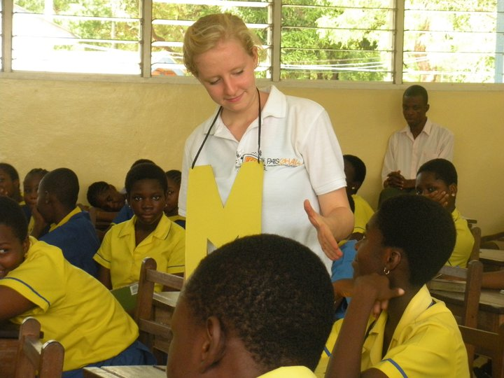
Just before I finished High School I had made the decision to re-dedicate my life to Jesus. I was not ready to go to university yet because I was longing to experience God on a much deeper level than I had before. I asked myself that if God is real and if His Word is true then there must be a way that I can still experience Him like the people in the Bible. I figured if I go to a place where everything is unfamiliar to me, then God can be the constant factor. I excluded all “Western” countries from my list and thought Africa would be the most exotic place I could go to: people are dark - I am white, I know nothing about their culture and have never really been exposed to African people either. By God’s guidance I heard about Pais and loved the fact that they were also based in Ghana, Westafrica. So I applied and got through.
The motto of Pais is: Missionaries making missionaries. Pais equips and trains you to be a missionary and to train others to become missionaries in their own schools, families and communities. Pais missionaries serve in local churches and support the youth ministry. During the week they go to schools and build relationship to students to empower them to share their faith with their peers but also to invite “unchurched” kids to the church and integrate them there. Pais apprentices are the familiar face in the church and in the school and create a bridge for those on either side. Pais has unique approaches to Bible study, mission and discipleship that have transformed my thinking: I had thought that all these three aspects of our Christian life don’t work in our modern world anymore. Now I have seen that they are still applicable in this 21st century, you just need to challenge ourselves to really do them the way Jesus did.
I had planned to do Pais for one year between school and university. But God showed himself so powerfully at work among us that I decided to stay on for three years. These years were probably the ones where I grew most in my faith so far. I am even working with Pais full time now training and equipping young people in Germany to be missionaries around the globe.
Our Vision: Our vision is that one day the primary mission of every Christian will be to advance the Kingdom of God and be equipped to do it the way Jesus modeled it.
I can recommend this to you if you
- want to experience God and see yourself and others transformed by the gospel
- are eager to be trained and train others in Mission, Discipleship and Bible Study
- are ready to be challenged in your faith, your character and in your skills
- are ready to serve others!
Facts:
- You need to be at least 18 years old if you want to join Pais.
- Pais serves in 14 countries on 5 continents.
- Website: www.paismovement.com
- For Germans: www.paisdeutschland.de
- There is a documentary about the work of Pais: www.thespiritofapioneer.com

2) Intercp
http://www.intercp.org/
I will share M. Joshua Jung’s mission report and slideshow so that you can see his experience!
3) YouthWorld
http://youthworld.org.ec/
HBF worked with them twice to go to Quito Ecuador
- Please ask Sam Toh or other HBF members for more info, personal testimony or pictures.

4) Show mercy international
http://showmercy.org/smi/
This is the organization HBF partnered with to go to Uganda.
Please ask Sam Toh or other HBF members for more info, personal testimony or pictures.

5) International Volunteer Headquarters (not explicitly missions-oriented, but can request a Christian placement)
Ivhq.org
Please ask Brooke for more info.
ivhq.org
“This is not a Christian organization, however, I requested a Christian placement. Basically, this company contracts with different non-profits throughout the world in almost forty countries. So, they placed with an orphanage called Priscilla Home and School, which is located in Ngong, Kenya a
Kenya is a good place because most people, while their main language is Swahili, also speak English.”

Short-term mission reports/testimonies
Jonathan Christopher and Steven Giesbrecht’s mission trip to Sendai in Japan -- 2018
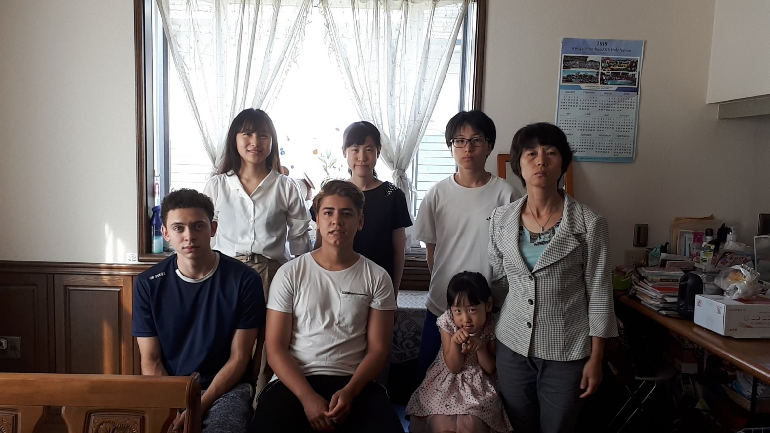
In our ministry, the places for short term missions were announced. There were many places that we could have chosen but what drove us to pick Japan for our first mission trip was our interest in Japanese culture. We were very excited to visit the country that produced our favorite anime. Also, we wanted to learn the Japanese language. I think God used these interests of ours to send us to Japan. We first started a go-fund-me account to ask for financial support. It was intimidating at first because we did not really know much about Japanese culture besides what we saw on internet. Thankfully God provided us with people to prepare us for our trip. Brother Alex from Ottawa UBF who had personal experience teaching English to Japanese students, as well as Hina and Valeria who are Japanese. They told us about how Japanese people were like and helped us discover the best strategies when teaching English.
The first few weeks in Japan were the hardest because we needed time to adjust to different factors. Among these difficulties were campus mission, communication, Japanese culture and other minor things. First, campus fishing was a new thing for us so we were struggling a little at the start. We didn’t know how to approach people, how to act, what to say and how to say it. Thankfully missionary Pauline was always with us so she was leading the way for us. Communication was also a big problem because the family we were staying with could not really understand or speak English. So, there was a lot of awkward communication at the start. Another trial was the difference in culture. Japanese people are more rigid and not very open. They seem to have more difficulty to show their real persona and are hiding their true selves with politeness. We had a lot of discussions about these differences in culture with missionary Paul because in Canada people are encouraged to be themselves. Even he still has trouble really understanding Japanese people sometimes.
We went fishing everyday and we would get students but most of them would only come once. Or, they would contact us about being interested but when we would ask the time and date, they would not reply. Japanese people are very self- conscious about their English speaking. They are afraid of being judged and of failing. Success is a very important thing to them. Also, we noticed that foreign students in the college would only be hanging around other foreigners. We never saw Japanese people hanging around foreigners. So we think that another reason why they wouldn’t contact us back was because they are afraid of foreigners. However, we managed to get 2 regular students. We think that our tactics were lacking in interest in the beginning. Also, we acted more as friends to them then as teachers. So we learned that the best approach would be to become friends with them instead of teachers.
Japan is very clean and a quiet place. So, we got to experience a different kind of environment than what we were used to in Montreal. Also, the food was very good, so there were no troubles there.
Jonathan Christopher's reflection:
This mission trip helped us learn a lot of valuable lessons about mission work. We learned that in order to have a strong impact its important to learn the native language. I felt that this was one of our shortcomings because we could of done even more to learn Japanese. Language and communication is one of the big obstacles that could help us break the cultural barriers because they would feel more comfortable speaking with us. So i feel that this is very important for future missions. Also, this mission gave us experience and knowledge that could help future mission trips. We were able to see the challenges of missions. Its very hard work. It can get you down and be very discouraging, but God helped us get through it. The best example to follow would be that of Apostle Paul because he became like the people he was evangelising to appeal to their insecurities towards foreigners.
I thank God for giving us this opportunity to see and understand more of his creation. God gave us this perfect chance to have a small taste of his world mission and to see how his heart pours out to different nations. I thank the UBF community for being so supportive financially and in your prayers. I thank brother Alex, Hina and Valeria for helping us with strategies to overcome the cultural barriers and I thank God for the Sendai ministry for offering us their hospitality for a whole month.
Steven Giesbrecht's reflection:
First off, I want to tell you that I’m exceptionally grateful for missionary Paul’s family. They offered us their hospitality, love, care, kindness and they were very patient with us because of the fact that there was a serious language barrier between us. we had some bumps along the way and have had to undergo some troubles which arose displeasures and setbacks in our journey. However, I feel that God was able to train our hearts to persist and he illustrated through meaningful relationships and English teaching that God wants me and Johnny to keep reaching out to Gods children and also inspire future short term missionaries. I say this because we made two really good friends who we taught English and I feel like we broke walls of despair or indifference because they opened up to us along the way. I also say this because Japanese people wear masks to hide their emotions and they live in a culture that encourages them to have a conformist behaviour instead of being taught to be yourself like us. This is why I must say with conviction that God is leading the way for new generations to step into the world that he created and break as many walls of enclosure or whatever it may be.

Rwanda & Uganda Mission Trip by Junmo Kwon, June/July 2018 (IIT, Chicago)
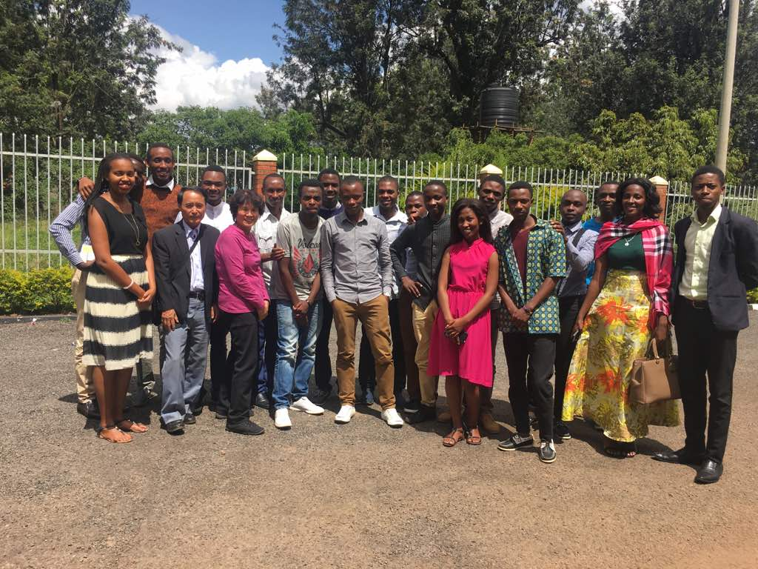
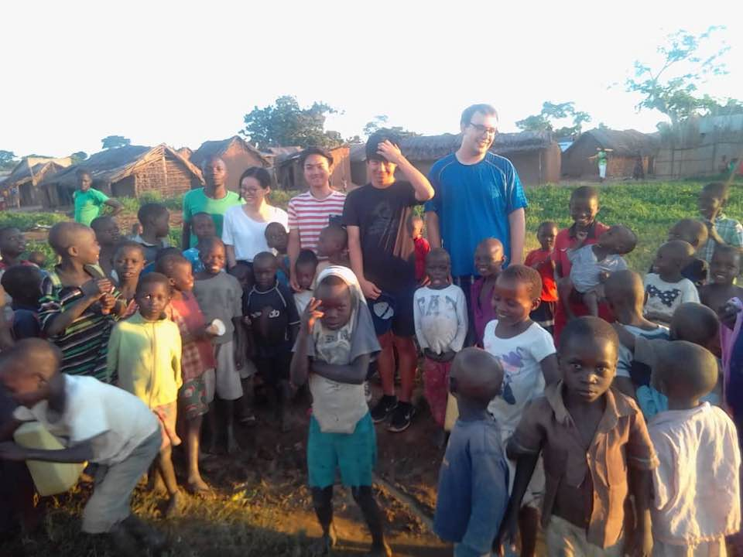
Going to Rwanda & Uganda is one of the greatest opportunities for me. I’ve learned so much through the study of the Genesis and daily breads. I truly believe that this is the turning point of my life to live my life for God’s mission. Even few days before I arrived to Rwanda, I struggled to find the purpose of life, and I had no goal in mind, but to make a lot of money by working on the online business. However, I found a purpose of life through lessons at Rwanda. I learned that my purpose of life is to fulfill God’s mission by walking faithfully with God! According to Genesis 1:28, God said to Adam and Eve, “Be fruitful and increase in number; fill the earth and subdue it. Rule over the fish in the sea and the birds in the sky and over every living creature that moves on the ground.” Our mission is to fill the earth with Godly people after the fall of Adam and Eve. I want to become an eye doctor and use my profession to become a missionary and spread the word of God.
Last two years, I was in a dark place. I was blind spiritually, and had no vision for my future. But now, through Genesis workshop and daily bread, I can see God’s vision for my future, and I understand what I have to do walk with God and to live for God’s glory. Instead of living an anxious and prideful life, I want to trust in God whole heartily, and let him lead my life. If I trust in God and put him first, he will provide all my needs. I am devoting myself to do daily bread every morning where ever I go. One verse that touched me from the Genesis bible work shop is from Genesis 6:9b. It reads “Noah was a righteous man, blameless among the people of his time, and he walked faithfully with God.” I want to obey God’s command faithfully like Noah and be used preciously to do God’s work.
During the Bible training workshop at Uganda I was amazed by Moses’ calling by God to work for his mission. After Moses ran away from the Egypt, God called him to deliver Israelites out of Egypt. Moses first responded to God saying “Who am I that I should go to Pharaoh and bring the Israelites out of Egypt?” Moses was not confident with his ability to deliver Israelites out of Egypt; his faith was not strong enough at the moment. However, God responded by saying “I will be with you. And this will be the sign to you that it is I who have sent you: When you have brought the people out of Egypt, you will worship God on this mountain.” God assured Moses that he will be with Moses to fulfill God’s mission of delivering Israelites out of Egypt. I pray that my faith in God would grow to trust in God that he will be with me throughout my journey in life, and live my life to fulfill his mission.
I am very thankful to God for so many blessings, giving me a loving family and wonderful UBF community. I am very thankful for God using missionaries in Rwanda and Uganda to have an impact on not just my life, but life of students there. I am thankful to God for food, electricity, and water. I thank God for this opportunity to go to Africa, and take so much away from the experience. I pray that I may remain faithful, and live for God’s mission.
One word: Trust in the Lord and he shall direct your paths

Focus Uganda Experience – Jacob Staal (UIC, Chicago, July 2018)
Romans 10:10-16
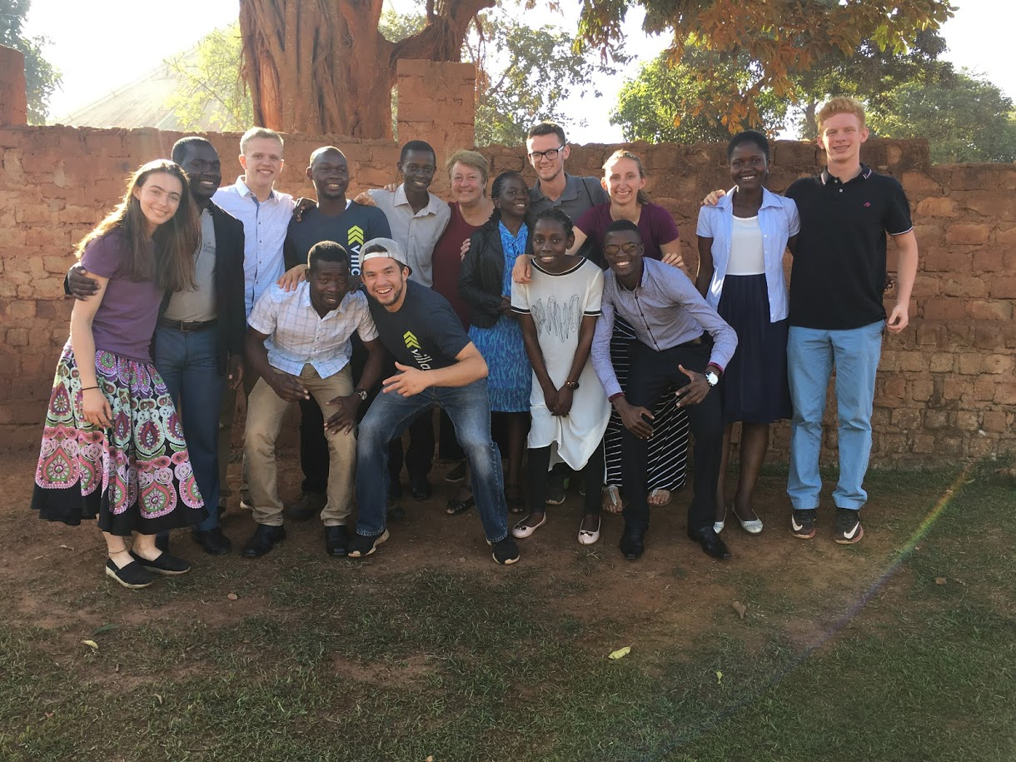
My trip to Uganda was nothing short of seeing God working in the lives and hearts of the team and the people we encountered. As Christ’s servants, we are called to preach the Gospel to the ends of the Earth so that everyone can know of the everlasting and all-powerful God. Before leaving for the trip, I was flooded with the feeling of inadequacy, that I was not mature enough in my walk with Christ and I would not know the words to say or how I could accomplish what God has called every single believer to do. However, God had a different outcome for me than I could have ever anticipated.
I was beyond blessed to have worked with the FOCUS staff, because without them we would not have been able to have our words translated, and they just worked so well with the locals of the community. The Holy Spirit had just worked miraculously through their words and their willingness to work with us. Not only did each one of us connect and work so much next to our own partners, but God allowed me especially to just grow so much in working with people of a different culture. I praise God because of his love in showing me to be able to adapt and show that Christ’s love is cross-cultural and it has no boundaries or limitations. Not even those that speak a different language can outrun the good news of Christ, thanks to the FOCUS staff and the work of the Holy Spirit in me that guided every one of my words that I spoke to people in need.
We wanted to show the people that God is faithful, and that we serve a jealous God who wants all of our hearts, not just whenever it is convenient. But I just saw God working through the hearts of the people. I was just blown away by the people’s willingness and openness to share their story and what they are going through, especially to some random white strangers from the US. The conversations where people did not know Christ, were the most challenging, but the most rewarding. I just felt so filled with joy and with the Holy Spirit when telling others about who Jesus is, and what He has done for me personally. Remember how I said I felt so inadequate about preaching the Gospel? Yeah, there’s this awesome power, it’s called the HOLY SPIRIT, and it worked in all of us and especially through me!
If you were to ask me how the trip went overall, this is what I would tell you; God’s will was accomplished this week through the Holy Spirit’s enabling and overwhelming power. Never have I experienced a trip like Uganda. We were preaching the good news everywhere, every single day, and because of this, we were bound to lead someone to Christ. We were the hands and feet, and though it was spiritually challenging, God turned my inadequacy into his glorification. This is the God we serve! From schools to hospitals to prisons to slums, we had all been used to show God’s love and power to all people, and I will never be the same again for God alone is the one who changes and transforms hearts, including mine and everyone we encountered.

Uganda Mission Report—By Francis Choi

Mission Report Uganda
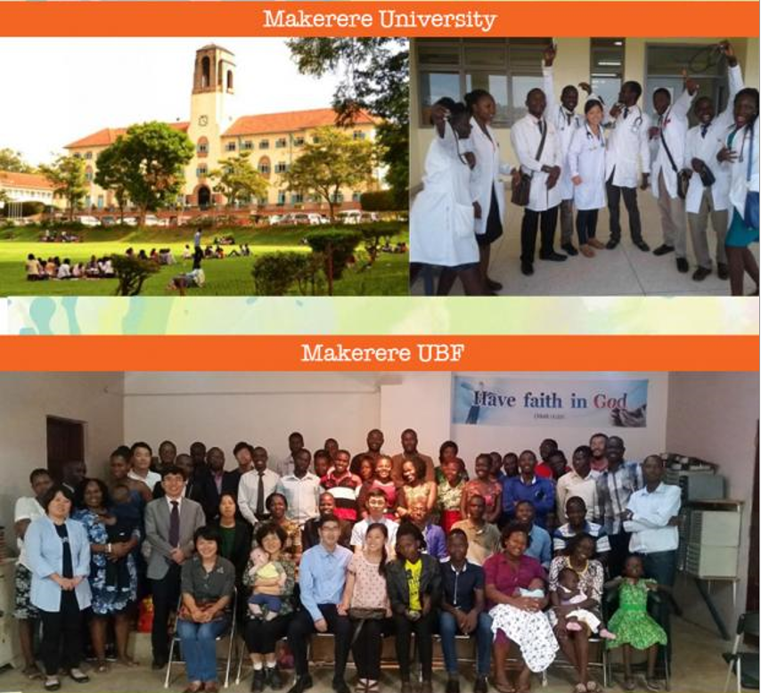

Mt 6:33, “But seek first His kingdom and righteousness, and all these things will be given to you as well.”
Oli otya! Good evening!
My name is Francis Choi, currently a PhD student at UIC. My wife is Theresa Choi, who served as a student missionary to Uganda for the last 5 years. Last summer I went to Uganda and served as a missionary for one year together with my wife. We both served the UBF ministry at Makerere University, the top university in Uganda. It is hard to briefly summarize all that I experienced living and serving in this developing country. Although it has only been a few weeks since we’ve returned from Uganda, I feel it has been much longer because of how different our lives are now in the US. Uganda, although a beautiful country teeming with wildlife and dramatic landscapes, is not a comfortable place to live for those accustomed to first world benefits. At the same time, I felt very much at peace in Uganda as I learned to be fully present in the moment and appreciative of life each day. Ugandans often say “I thank God for my life” and genuinely mean it in the midst of many hardships. I can only thank God for giving me the opportunity to experience the privilege of mission life abroad. It was the adventure of a lifetime. Looking back I can testify God has been my good Father who poured out His grace even when I was faithless. He was my strength in times of weakness and my great hope in times of challenge. Though I had nothing much to give, God could work through my small efforts to bless the Ugandan people, moreover blessing me through them. In accordance with God’s will, I hope my family may return to serve African mission again in the future.
I held onto Matthew 6:33 as my key verse for mission life: “But seek first His kingdom and His righteousness, and all these things will be given to you as well.” Coming to Uganda initially was not an easy decision to make. I had just received a promotion at my work and was earning the highest salary of my career. I was on a clear path towards rapidly achieving my financial and practical goals, and going to Uganda would disrupt that. But after considerable prayer, God moved my heart to sacrifice for His kingdom. I held onto the promise that God would provide every necessity when I simply sought His kingdom in my heart. I can testify God truly did provide everything we needed in Africa, including an apartment right next to the church (through Dr. Joseph and Esther Chung), a loving spiritual community and wonderful ministry responsibilities. Moreover, I can testify God opened my heart to see His Kingdom grow, both in my heart and in the hearts of others, even if it started out very small.
There are 2 simple but major lessons I’ve learned through my mission life: 1) Have faith in God and 2) The greatest life is to live for His kingdom. Regarding faith, I learned my life is in God’s hands, therefore I can trust Him for everything including my physical health and safety. Before going to Uganda, I was very risk-averse, often calculating and opting for safety. But life in Uganda exposed me to all kinds of risk every day, from riding on reckless bodabodas (motorcycle taxis) to eating questionably prepared food and traveling to unfamiliar, even somewhat dangerous areas alone. Allergies and diarrhea lost weight. I had to learn to surrender my life to God, whether it was regarding my safety or comfort or even future security. Regarding the Kingdom centered life, I could experience how blessed it is to participate in God’s Kingdom work in a foreign land. Initially, I hoped to spend more time volunteering for a NGO in Kampala while serving the ministry. Sometimes I struggled because I thought I should find a paying job. But Dr. Livingstone Kang, the director of Makerere UBF, asked me to serve in full time ministry work. Dr. Luke Lim also allowed me to volunteer for the medical clinic.
As a part of my ministry duties over the year, I was given the task of helping lead our small group fellowship each week, called Cornerstone. This fellowship started off small with 1 or 2 students, but through some prayer and effort, God grew it over the year with many students attending. I’m praying it may continue to grow with committed members. I really enjoyed meditating on God’s Word by preparing Sunday messages as a part of the messenger team. I also invited many young Makerere students to the ministry for Bible studies and fellowship. I had many Bible students, including some whom Dr. Joseph gave to me. Though not all of them remained or came faithfully, there were a few brothers under my care who really loved our ministry and committed themselves, including Paddy Andrew, Griffin, Pious, Ronald and Fred. I’m praying for each of them to grow into future leaders for the ministry and Uganda overall. I really learned much through Bible studies with Makerere students regarding Ugandan life. Many students suffer from poverty, sickness, financial insecurity and even hunger. Theresa and I tried our very best to serve our students spiritually and practically, though we did not have much to offer. Our house became a station for young people who came and had both spiritual and physical food.
I was also privileged this year to visit Rwanda and support M. Daniel Yang in his new ministry through outreach on the campus and delivering the Sunday sermon. Through my time with him and the Rwandan brothers and sisters, I could also witness the growing power of the Kingdom as M. Daniel had around 25 Bible studies a week with hungry souls. The kingdom of God truly starts small like a mustard seed but eventually grows to become a large tree. Coming to Uganda, I only had a small heart for the people, but by the time of my departure my heart was full of God’s love. Theresa and I were sad to leave all our friends and students whom we prayed for and taught the Bible to. But we know God will continue to do His mighty work in Africa, especially through the humble sacrifices of the missionaries and native leaders. May the Lord continue to do His good work and bring it to completion for the salvation of souls in Africa. Amen.

