BOOK OF 1 THESSALONIANS INTRODUCTION

MAY YOU BE SANCTIFIED UNTIL OUR LORD COMES AGAIN

“May he strengthen your hearts so that you will be blameless and holy in the presence of our God and Father when our Lord Jesus comes with all his holy ones.” (3:13)

Author, Date and Place of Writing

The senders of this letter are “Paul, Silas and Timothy” (1:1). References to “I” indicate that Paul was the actual writer (2:18; 3:5; 5:27). Paul included Silas and Timothy because they were his fellow workers in Thessalonica and shared his concern for the believers there (3:6-10; Ac 17:5,10,14,15).

During his second missionary journey, Paul and his companions, including Silas and Timothy, began in Philippi, and then went to Thessalonica and Berea (see map 1). Due to persecution, Paul went on to Athens alone (17:14-15), and then to Corinth (Ac 18:1), where he stayed at least one year and a half (see map 2). While Paul was in Corinth, he received a report from Timothy (Ac 18:5; 1Th 3:6). In response, Paul sent this letter to the Thessalonians. So this letter was written from Corinth. Gallio was proconsul of Achaia at the time Paul was in Corinth (Ac 18:12). Archeological evidence (an inscription found at Delphi) indicates that Gallio’s rule was from A.D. 51-52. So it seems that Paul wrote this letter sometime around that time.

Literary Features

This book is an epistle, and so intended for public reading. At the same time, it is very personal in nature, like a father or mother writing to their children: encouraging, correcting and giving instructions for practical life.

Recipients

This letter is addressed to “the church of the Thessalonians” (1:1). Thessalonica was essentially Greek in its character. Some were Jewish believers, but the majority were native Greeks who had turned from idols and sexual immorality to serve the living and true God (1:9; 4:3-5; Ac 17:4).

Historical Background: City of Thessalonica

Thessalonica was founded in 315 B.C. by the Macedonian general Cassander. He named the city after his wife, who was the daughter of Philip, and the step-sister of Alexander the Great. When Macedonia was conquered by the Romans in 168 B.C., Thessalonica became the capital city of Roman Macedonia. In the first century, it was a bustling seaport city with a population of over 100,000. The majority of its inhabitants were native Greeks, but it contained a considerable mixture of Romans, Asiatics, and Orientals of various backgrounds, including a sizable group of Jews. Located on the Egnatian Way, in between the Danube River and Aegean Sea, it served as a center of trade and communication and became a wealthy city. During the second Roman civil war, Thessalonica remained loyal to Anthony and Octavian. As a result, it was granted the privilege of being a “free city.” In light of the city’s loyalty to Rome, adherence to the imperial cult was strongly emphasized. In that environment, to proclaim that Jesus is Lord was regarded as treasonous. That is the main reason that Paul could not remain there after preaching the gospel. The charge against Paul was defying Caesar’s decrees and saying there is another king, one called Jesus (Ac 17:7). As a Macedonian city, it was obviously influenced by Greek philosophy. Religiously, the city was committed to the Greco-Roman pantheon. They worshiped the Greek and Egyptian gods. The worship of these idols was closely associated with sexual immorality. The Thessalonian believers had turned from these idols to the true and living God, and had begun to live holy lives (1:9b). But there was always a great temptation for them to return to their former way of life. So Paul strongly exhorted them to live a holy life (4:3-8). While many ancient cities have disappeared, Thessalonica is still a vibrant city today. It is currently the second largest city in Greece with a metropolitan population of 1.1 million people.

Historical Background: Thessalonian Church

After the Council of Jerusalem, Silas was Paul’s chief missionary partner (Ac 15:40). In Lystra, he invited the young man Timothy to join them (Ac 16:1-3), and in Troas Luke was added to the team (see Ac 16:11, where Luke begins to use the pronoun “we”). So Paul, Silas, Timothy and Luke were the four missionaries who sailed across the Northern Aegean Sea into Europe. Before coming to Thessalonica, Paul and Silas had been “treated outrageously” in Philippi; in fact they had been unfairly flogged and imprisoned (2:1-2). After being released from prison, Paul and his companions stayed at Lydia’s house and encouraged the believers there (Ac 16:40). After a remarkably successful mission in Philippi, Paul, Silas and Timothy moved on in a south-westerly direction. They passed through Amphipolis and Apollonia and came to Thessalonica, where there was a Jewish synagogue (Ac 17:1). On three Sabbath days Paul reasoned with them from the Scriptures, explaining and proving that the Messiah had to suffer and rise from the dead, and that “This Jesus I am proclaiming to you is the Messiah” (Ac 17:3). There was a great work of God in the short period of time that Paul was there. Some Jews were persuaded as well as a large number of God-fearing Greeks and quite a few prominent women (Ac 17:4). This aroused the jealousy of Jews in the area who persecuted the believers and drove Paul out of the city. In spite of persecution, the Thessalonian believers became a model to all the believers in Macedonia and Achaia (1:7). They were also imitators of God’s churches in Judea because they suffered from their own people the same things the Judean churches suffered from the Jews (2:14).

Occasion and Purpose of Writing

When Paul left Thessalonica abruptly in the midst of persecution, the Thessalonians were left alone like spiritual orphans, facing severe persecution. In Paul’s absence, persecutors arose among their own countrymen who slandered Paul to discredit the gospel ministry (2:14). Specifically, they accused him of having impure motives and using deception and flattery to win praise from people. They also accused him of being greedy (2:3-6). Persecutors used the fact that Paul did not return to Thessalonica as evidence for their accusations. Paul was afraid that the tempter would work to nullify his labor to preach the gospel. He sent Timothy to find out about their faith (3:5). Hearing from Timothy that the Thessalonians had kept their faith and love, Paul was encouraged. At the same time, they needed to be reminded to live holy lives and were confused regarding those who had already died in relation to Jesus’ second coming.

So he wrote a letter to encourage them and instruct them in several ways:
- Like a father or mother to their children, Paul expressed his thankfulness for them and encouraged them to stand firm in the faith all the more (1:2-3; 2:7,11; 3:7-9).
- He refuted false charges against himself, defended the authenticity of his gospel ministry, and showed his great affection for them (1:5; 2:3-12,19).
- Paul instructed them that living a holy life is God’s will and urged them to do so (4:1-8).
- Paul instructed them what happens to those who sleep in Christ, so they would not grieve like those who have no hope (4:13-5:11).
- Paul taught them how to live in the hope of Jesus’ second coming (5:12-22).

Main Theme

The main theme of this letter is to have hope of Jesus’ second coming and live a holy life. Jesus’ second coming is an essential aspect of the gospel. The word “gospel” is repeated six times in this short letter (1:4; 2:2,4,8,9; 3:2). In addition the words “message” and “word of God,” with an equivalent meaning to “gospel,” are also mentioned (1:6,8; 2:13). The gospel saves us from our sins, enables us to live a holy life, and gives us true hope of Jesus’ second coming and final victory. Specifically, the Thessalonians had experienced the power of the gospel to save them from idol worship and sexual immorality. They began to live a holy life and were filled with faith, love and hope (1:3; 3:6). But they needed to grow in holiness in order to fight against the strong streams of ungodly culture. So Paul strongly exhorted them to live a holy life (4:3-8). In terms of faith and love, they excelled (1:8; 3:6-7; 4:9-10). They also had hope in Jesus and his second coming (1:10). But it seems that this hope needed to be more correctly grounded and strengthened. So Paul wanted to supply what was lacking in their faith, regarding their hope in Jesus’ second coming (3:10). He emphasized “hope” and “Jesus’ second coming” from the beginning to the end of this letter (1:3,10; 2:19; 3:13; 4:13,14,15,16,17; 5:2,8,23). With this hope, he taught them to please God by living a life worthy of God (2:12; 4:1). Precisely, he taught them not to grieve, be idle or disruptive, and instead to be joyful, prayerful, thankful, hardworking and spiritually awake (5:6,10,14,16-18).

Characteristics

A church formed quickly through the power of the gospel and the Holy Spirit: We are not sure exactly how long Paul and his company were in Thessalonica, but in comparison to some other places, it was short, perhaps just a month or two. During that time Paul simply presented the gospel by reasoning from the Scriptures (Ac 17:2-3). Then a remarkable thing happened. The Holy Spirit worked in an amazing way to bring the gospel into the hearts of the Thessalonians; it was not simply with words, but with power, with the Holy Spirit and with deep conviction (1:5). They received the gospel not as a human word but as God’s word (2:13). The gospel changed their lives and lifestyles and established a community of believers which became a model to Macedonia and Achaia.

An emphasis on the Lordship of Christ: Paul refers to Jesus as “the Lord Jesus” or “the Lord Jesus Christ” (1:1,3; 2:15,19; 3:11,13; 4:1,2,; 5:9,23,28). His emphasis on the word “Lord” is more frequent in this letter than in any other. Paul deliberately wrote in this way to encourage the Thessalonians. At that time Caesar was regarded as a deity by the Romans and referred to as “Lord.” When the Thessalonians called Jesus “Lord,” the Romans regarded it as treasonous and began to persecute them (Ac 17:7). Paul strongly encouraged them to keep their faith and hope in Jesus who comes again (4:17).

God’s will is to be sanctified, joyful, prayerful and thankful: Two times in this letter Paul specifically explains what God’s will is. It is God’s will that his people be sanctified: that they should avoid sexual immorality; that they should learn to control their own bodies in a way that is holy and honorable, and not in passionate lusts (4:3-5). It is also God’s will that his people rejoice always, pray continually and give thanks in all circumstances (5:17).

Unique teachings regarding Jesus’ second coming: The Thessalonian believers lacked the detailed knowledge to cope with recent deaths among them. They responded with bewildered hopelessness (4:13). Paul taught them in detail what happens when Jesus comes again. Jesus will come from heaven with a loud command, with the voice of the archangel and with the trumpet call of God. At that time, the dead in Christ will rise first. Then those who are left alive on the earth will be caught up with the Lord in the air. We will all live together with the Lord forever (4:14-17). Some people speculate about the rapture based on this text, but Paul’s intention was to comfort grieving people with accurate knowledge of Jesus’ second coming. We should understand the teaching in context.

Paul’s affection for the Thessalonians: Paul’s affection for the Thessalonians is expressed throughout this letter, as we see through his words:
- “Just as a nursing mother cares for her children, so we cared for you”(2:7-8)
- “Because we loved you so much, we were delighted to share with you not only the gospel, but our lives as well” (2:8)
- “We dealt with each of you as a father deals with his own children (2:11)
- “…out of our intense longing we made every effort to see you” (2:17)
- “For what is our hope, our joy, or the crown in which we will glory in the presence of our Lord Jesus when he comes? Is it not you? Indeed, you are our glory and joy” (2:19-20)
- “For now we really live, since you are standing firm in the Lord. How can we thank God enough for you in return for all the joy we have in the presence of God because of you? Night and day we pray most earnestly that we may see you again and supply what is lacking in your faith” (3:8-10)

The importance of humble coworking: The expression “we,” referring to Paul, Silas and Timothy appears more than 50 times in this short letter (1:2,3,4,5,7; 2:2[2],3[2], 4[2], 5[2], 6[2], 7, 8[3], 9[2], 10, 11, 13, 17[2], 18, 19; 3:1[2], 2, 3, 4[3], 6, 7, 8, 9[2], 10 [2]; 4:1[2], 2, 6, 9, 10, 11, 13; 5:1, 12, 14). Paul worked with his coworkers as a team; he loved and deeply respected them as fellow servants of God, as one with him. He wrote this letter as a representative. In truth, Paul, Silas and Timothy shared life and ministry together with the same mindset. They practiced the humility of Christ and humbly co-worked together for the kingdom of God. This is one of the secrets of success of their ministry.

Purpose of Our Study
Through the study of 1 Thessalonians we want to:
- Have the hope of Jesus’ second coming in our hearts and live a holy life.
- Help postmodern young people turn from idols to serve the living God, overcoming the relativism and immorality of our times.
- Learn how the gospel shapes the church, and how the church spreads and models the gospel.
- Learn Paul’s motherly and fatherly heart toward young believers.
- Rejoice always, pray continually and give thanks in all circumstances.
Outline

I. Greetings and thanksgiving (1:1-10)
1. Greetings (1)
2. Thanksgiving for the Thessalonians’ faith, love and hope (2-3)
3. Conviction that God chose them and reasons for thanksgiving (4-10)
II. Paul’s defense of his Thessalonian ministry (2:1-16)
1. He preached the gospel with the help of God amidst opposition (1-2)
2. He preached with a pure motive before God (3-6a)
3. He used authority like a nursing mother, spiritual father (6b-12)
4. How they received the gospel and overcame opposition (13-16)
III. Paul’s longing and concern for the Thessalonians (2:17-3:13)
1. They are his glory and joy (2:17-20)
2. Paul’s concern for them and reason for sending Timothy (3:1-5)
3. Paul was encouraged by hearing they were standing firm in faith (3:6-9)
4. Paul’s prayer for them (3:10-13)
IV. How to live to please God (4:1-12)
1. God’s will is to be sanctified (1-8)
2. Love each other more and more (9-10)
3. Work with your hands and win the respect of outsiders (11-12)
V. The Day of the Lord (4:13-5:11)
1. What happens to believers who died in Christ (4:13-18)
2. The Day of the Lord will come and no one will escape (5:1-11)
VI. Final exhortations, prayer and greetings (5:12-28)
1. Acknowledge those who work hard (12-13a)
2. Live in peace with each other (13b-15)
3. Rejoice always, pray continually, give thanks in all circumstances (16-18)
4. Do not quench the Spirit; do not treat prophecies with contempt (19-20)
5. Hold on to what is good, reject every kind of evil (21-22)
6. Paul prays for their sanctification (23-24)
7. Final greetings (25-28)

PAUL’S MISSION JOURNEYS IN MACEDONIA
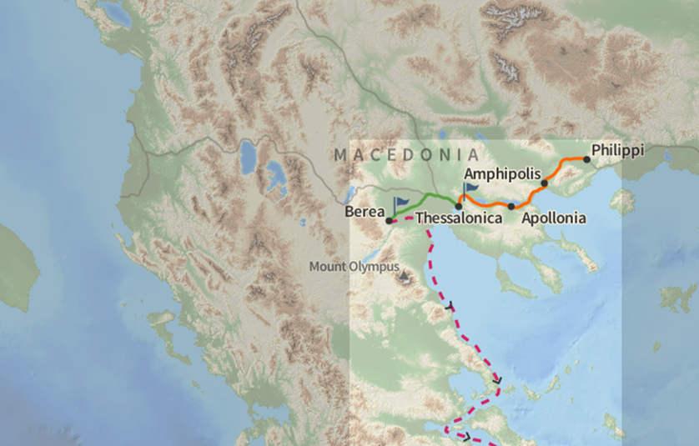
Map 1: Paul’s journey from Philippi to Thessalonica

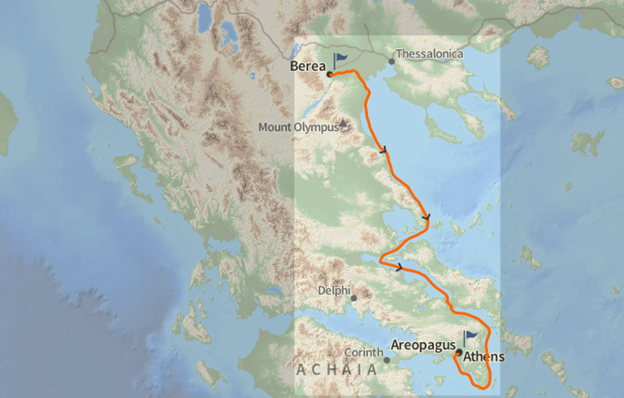

Map 2: Paul’s journey from Berea to Athens

Although we can infer from Acts that Paul’s stay in Thessalonica was roughly about three weeks, many scholars believe that it was longer. This is based primarily on Paul’s letter to the Philippians, thanking them for sending him aid while he was in Thessalonica “more than once” when he was in need (see Php 4:16). Paul’s reference to “how he lived among them” (1:5b) suggests that he did much more than preach three times in the synagogue.

