THERE HE WAS TRANSFIGURED

Mark 9:2-13
Key Verse 2

After six days Jesus took Peter, James and John with him and led them up a high mountain, where they were all alone. There he was transfigured before them.

Introduction

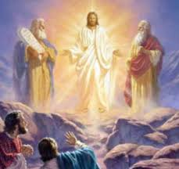
Chapter 8 was a turning point in Mark’s gospel. Peter confessed that Jesus is the Messiah, but he doesn’t really understand what Jesus wants. But Jesus begins to teach them that the Son of Man must suffer many things and be rejected by people. He told them that after three days he would rise again. But his disciples didn’t want to hear about that, especially Peter. So he ended up rebuking Jesus. They must have confused by all that Jesus was trying to tell them. Then Jesus said “Truly I tell you, some who are standing here will not taste death before they see that the kingdom of God has come with power.” So chapter 9 is a powerful audiovisual presentation of what would become of Jesus and his disciples as long as they accepted Jesus and follow His example. May the Lord help us to see the same image that Peter witnessed and live as God’s faithful witnesses despite some suffering on the way. Amen.

- Read verses 2-6. Why might Jesus have only taken three of his disciples up the mountain? (1, 2a) What happened to Him and who appeared to talk with Him? (2b-4) What did Peter blurt out? (5, 6) What did this reveal about him?

1-1, Read verses 2-6.

After six days Jesus took Peter, James and John with him and led them up a high mountain, where they were all alone. There he was transfigured before them. 3 His clothes became dazzling white, whiter than anyone in the world could bleach them. 4 And there appeared before them Elijah and Moses, who were talking with Jesus.
5 Peter said to Jesus, “Rabbi, it is good for us to be here. Let us put up three shelters—one for you, one for Moses and one for Elijah.” 6 (He did not know what to say, they were so frightened.)

1-2, Why might Jesus have only taken three of his disciples up the mountain? (1, 2a)

And he said to them, “Truly I tell you, some who are standing here will not taste death before they see that the kingdom of God has come with power.” 2 After six days Jesus took Peter, James and John with him and led them up a high mountain, where they were all alone.

- Six days had passed since Jesus revealed his impending suffering, rejection, and death at Jerusalem.
- He revealed the way of Messiah was not an easy road but a narrow road. During those six days the disciples were worried about their uncertain future.
- Jesus wanted to help them overcome their fear of death and understand the true meaning of his suffering and death.
- Then Jesus took 3 key disciples and went up to a high mountain where they were alone. Even though he had 12 disciples, he only took Peter, James and John.
- He focused on the key members until they listened to his new teaching about the way of the cross.
- Then the three key members can help the rest of the disciples to understand Jesus’ true Messiahship.
- Jesus took them to a high mountain to show his glorious image to his fearful disciples through his transfiguration.

1-3, What happened to Him and who appeared to talk with Him? (2b-4)

There he was transfigured before them. 3 His clothes became dazzling white, whiter than anyone in the world could bleach them.

- Before Jesus climbed the Mountain of Transfiguration, he looked to his disciples as a poor man, the friend of the sick, needy and broken-hearted.
- In the course of shepherding his people, he resembled a root out of dry ground. In the course of shepherding his people, he was despised and rejected.
- He looked like a man of sorrows. In shepherding his people, he suffered more than one can possibly imagine.
- But the transfigured Jesus looked glorious and majestic. His appearance was a revelation of his majesty as the King of kings and Lord of lords.

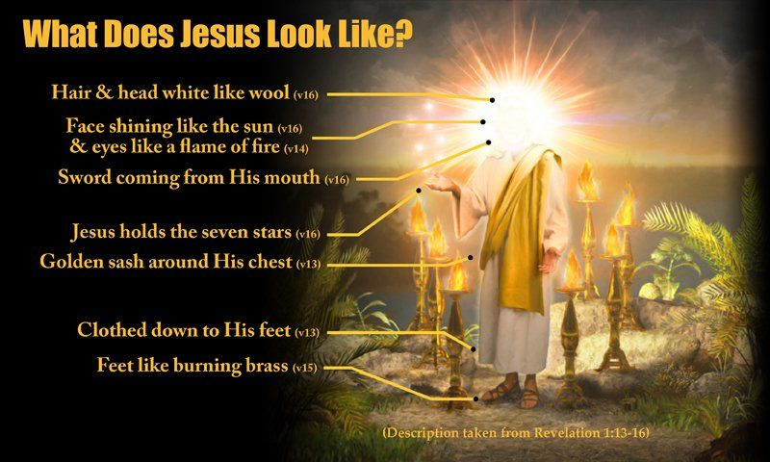

- Revelation 1:13-16 depicts Jesus’ original image. “…and among the lamp-stands was someone ‘like a son of man,’ dressed in a robe reaching down to his feet and with a golden sash around his chest. His head and hair were white like wool, as white as snow, and his eyes were like blazing fire. His feet were like bronze glowing in a furnace, and his voice was like the sound of rushing waters. In his right hand he held seven stars, and out of his mouth came a sharp double-edged sword. His face was like the sun shining in all its brilliance.”

- This image of Jesus was his original heavenly image. His appearance in dazzling white was a revelation that he is the holy and Almighty God.
- This glorious Jesus came to this world and served sinners until his appearance was disfigured so wretchedly.
- And his disciples did not realize why he suffered so much. They were afraid that they would suffer like him and look pain-stricken like him.
- So Jesus brought his top disciples to show them a preview of his glorious resurrection body.

4 And there appeared before them Elijah and Moses, who were talking with Jesus.

- Elijah and Moses appear and talk with the transfigured Jesus. Moses represents the Law. Elijah represents all the prophets because of his mighty spirit.
- Jesus is the fulfillment of God’s law and prophecy. Above all, Moses and Elijah were known in the Old Testament as suffering servants.
- Each of them suffered enough in his own time to save his people from their sins. Moses suffered to deliver Israel from the Egyptian salvery.
- Elijah suffered to save his people from Baal worship. Even though Jesus was the Son of God, it was too difficult for him to die on the cross for the sin of the world.
- People try to live better off in their thirties, for the thirties are a golden time in human life. But Jesus had to die in obedience to God’s salvation plan.
- The conversation between the transfigured Jesus and the two must have been Jesus’ death. Peter had urged Jesus not to talk about his death, but Moses and Elijah came all the way from heaven to talk about Jesus’ death and resurrection.
- Jesus came into this world to save His people from their sins. He met and talked with Elijah and Moses, who suffered to fulfill God’s will.
- By talking with them, Jesus was convinced that even though Elijah and Moses suffered, they are alive forever in God.
- Even though they suffered a lot to serve God’s people, in the end they were glorious. This means the glory comes after much suffering.

1-4, What did Peter blurt out? (5, 6)

5 Peter said to Jesus, “Rabbi, it is good for us to be here. Let us put up three shelters—one for you, one for Moses and one for Elijah.” 6 (He did not know what to say, they were so frightened.)

- When Peter saw the glory of Jesus, he was very happy and said, “Rabbi, it is good for us to be here. Let us put up three shelters–one for you, one for Moses and one for Elijah.”
- He did not say, “One for me.” He looked polite to them outwardly but he was saying to himself in his inner thoughts, “One shelter for me.”

1-5, What did this reveal about him?

- But Peter did not know what he was saying. “It is good for us to be here” reveals his hidden human desire.
- He revealed his shelter faith. Six days before, he had made a confession of Christ. But he had the easygoing desire like us.
- He wanted to be like Elijah and Moses instantly skipping their suffering part. He just wanted to enjoy the fruit without planting and harvesting.
- We all want to become great servants of God feeding 12 sheep but do not want to suffer at all. We are much like Peter.

- Read verses 7-9. What then happened and what voice came from above? (7) What important truth might Jesus’ three disciples have learned through this event? (8) What did Jesus want them to do? (9)

2-1, Read verses 7-9.

Then a cloud appeared and covered them, and a voice came from the cloud: “This is my Son, whom I love. Listen to him!”
8 Suddenly, when they looked around, they no longer saw anyone with them except Jesus.
9 As they were coming down the mountain, Jesus gave them orders not to tell anyone what they had seen until the Son of Man had risen from the dead.

2-2, What then happened and what voice came from above? (7)

7 Then a cloud appeared and covered them, and a voice came from the cloud: “This is my Son, whom I love. Listen to him!”

2-3, What important truth might Jesus’ three disciples have learned through this event? (8)

8 Suddenly, when they looked around, they no longer saw anyone with them except Jesus.

- Right after Peter spoke, a cloud came and covered them. This figuratively tells us that in the end, none remains to each of us but Jesus.
- In the Old Testament, clouds represent God coming down to his people (Ex 13:21). And clouds coming down also represent God’s glory revealed (Ex 24:16).
- God’s voice spoke out of the cloud, “This is my Son, whom I love. Listen to him!”. Now God appeared on the scene to support Jesus.
- This teaching was the core course for the disciples. Even God came down to help Jesus’ disciples.
- Peter, James and John had heard his teaching concerning his death and resurrection. But they had not received Jesus’ words.
- Finally, God spoke to them directly out of the cloud. This tells us how stubborn they were, and how important it is to accept Jesus’ teachings about God’s way of saving people through his death and resurrection.
- Here we learn the importance of listening to Jesus even though we may not like his teaching. When we do so, we can grow in faith and understand his teaching.

2-4, What did Jesus want them to do? (9)

9 As they were coming down the mountain, Jesus gave them orders not to tell anyone what they had seen until the Son of Man had risen from the dead.

- Jesus wanted them to keep this preview of his resurrection body a secret in their deep hearts and be filled with this mysterious preview of his person.
- So he charged them not to tell anyone what they had seen until after the Son of Man had risen from the dead.
- No wonder the disciples were awe-struck by the glory of Jesus. The privileged three never got over such a blaze of glory.
- It gave them a sense of security as they came to face their martyrdom for the sake of Christ.

- This glorious image of Jesus on the Mount of Transfiguration made a lasting impression on Peter when he had to live in this hard world as a witness of Jesus’ death and resurrection and as the leader of the whole church of God.
- Peter said in 2 Peter 1:16, “We did not follow cleverly invented stories when we told you about the power and coming of our Lord Jesus Christ, but we were eyewitnesses of his majesty.”

- Because John the Apostle witnessed that Jesus is the Christ, he was imprisoned in a dark cave on the island of Patmos.
- There he saw a glorious vision of Jesus who was coming again. John’s experience with Jesus helped him endure many hardships to the end.

- James became the first martyr for His sake among the apostles. We need a spiritual inspiration like Jesus’ transfiguration.

- The glory of Jesus will help us not to give up our mission life in spite of many crosses to bear. So we must study the Bible and pray until the glorious image of Jesus fills our hearts.

- Read verses 10-13. What did Jesus’ disciples ask Him about? (10-11) What did Jesus teach them about Elijah? (12-13) What can we learn from this passage?

3-1, Read verses 10-13.

10 They kept the matter to themselves, discussing what “rising from the dead” meant.11 And they asked him, “Why do the teachers of the law say that Elijah must come first?” 12 Jesus replied, “To be sure, Elijah does come first, and restores all things. Why then is it written that the Son of Man must suffer much and be rejected? 13 But I tell you, Elijah has come, and they have done to him everything they wished, just as it is written about him.”

3-2, What did Jesus’ disciples ask Him about? (10-11)

10 They kept the matter to themselves, discussing what “rising from the dead” meant. 11 And they asked him, “Why do the teachers of the law say that Elijah must come first?”

- In the past, they talked and acted according to their feelings and desires. But this time, they began to listen to God’s voice and began to think.
- The people of Israel looked for the emergence of Elijah before the coming of the Messiah.

Malachi 4:5-6 reads,

“See, I will send the prophet Elijah to you before that great and dreadful day of the Lord comes. 6 He will turn the hearts of the parents to their children, and the hearts of the children to their parents; or else I will come and strike the land with total destruction.”

3-3, What did Jesus teach them about Elijah? (12-13) What can we learn from this passage?

12 Jesus replied, “To be sure, Elijah does come first, and restores all things. Why then is it written that the Son of Man must suffer much and be rejected? 13 But I tell you, Elijah has come, and they have done to him everything they wished, just as it is written about him.”

- Jesus was referring to John the Baptist as Elijah. Jesus told them that John the Baptist came in the spirit of Elijah, preaching a baptism of repentance.
- Then Jesus continued, “Elijah has come, and they have done to him everything they wished, just as it is written about him.”
- People are fond of seeing miracles or supernatural things. But Jesus limited to the main topic of being the suffering Messiah.
- John the baptist suffered and Jesus suffered as they are written in the Scriptures. No cross, no crown. May the Lord help us to listen and follow Jesus.

Living Bible translates as below,

11 Now they began asking him about something the Jewish religious leaders often spoke of, that Elijah must return before the Messiah could come. 12-13 Jesus agreed that Elijah must come first and prepare the way—and that he had, in fact, already come! And that he had been terribly mistreated, just as the prophets had predicted. Then Jesus asked them what the prophets could have been talking about when they predicted that the Messiah would suffer and be treated with utter contempt.

Conclusion

Today we learned that Jesus wanted us to have His glorious image in our hearts. First of all, there is surely life after death. Like Jesus, Moses, and Elijah, we will recognize each other in the resurrection. Our eternal home is not here on earth but it is in heaven. It is foolish to build a shelter on earth because no one can live here forever. Whenever we have to suffer to fulfill God’s will, we must think about the glory of God we will share with Jesus. Instead of sympathizing and removing our spiritual and physical children’s crosses, we should encourage them to take up the cross of mission positively and experience the glory of Jesus. May God bless us to become the witness of Jesus’ glorious image like Peter, John, and James. One word: He’s transfigured!

