CITIES OF REFUGE

Joshua 18:1-21:45
Key Verse 20:9

Any of the Israelites or any foreigner residing among them who killed someone accidentally could flee to these designated cities and not be killed by the avenger of blood prior to standing trial before the assembly.

Introduction
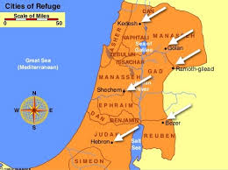

Today’s passage consists of the division of the land for the last 7 tribes (C18-19), the cities of refuge (C20) and the inheritance for the Levites (C21). Although the Israelites had subdued the land, 7 of the tribes had yet to claim the land God promised each them. But according to God's promise they were given the lands. May we learn to apply God's good promises to our lives. In this passage, we can also see the weaknesses and sins of God’s people and God’s graceful encouragement and merciful care for the vulnerable and helpless. God helped Levites to live in 48 towns to help the Israelites with God’s words. May the Lord raise us up as kingdom of priests to serve all nations.

1. Read 18:1-28. What did the whole assembly of the Israelites do at Shiloh? (1) What did Joshua say to the seven tribes who had not received their inheritance? (2-10) Describe the allotted territory for the tribe of Benjamin (11-28).

1-1, Read 18:1-28.

The whole assembly of the Israelites gathered at Shiloh and set up the tent of meeting there. The country was brought under their control, 2 but there were still seven Israelite tribes who had not yet received their inheritance.
3 So Joshua said to the Israelites: “How long will you wait before you begin to take possession of the land that the Lord, the God of your ancestors, has given you? 4 Appoint three men from each tribe. I will send them out to make a survey of the land and to write a description of it, according to the inheritance of each. Then they will return to me. 5 You are to divide the land into seven parts. Judah is to remain in its territory on the south and the tribes of Joseph in their territory on the north. 6 After you have written descriptions of the seven parts of the land, bring them here to me and I will cast lots for you in the presence of the Lord our God. 7 The Levites, however, do not get a portion among you, because the priestly service of the Lord is their inheritance. And Gad, Reuben and the half-tribe of Manasseh have already received their inheritance on the east side of the Jordan. Moses the servant of the Lord gave it to them.”
8 As the men started on their way to map out the land, Joshua instructed them, “Go and make a survey of the land and write a description of it. Then return to me, and I will cast lots for you here at Shiloh in the presence of the Lord.” 9 So the men left and went through the land. They wrote its description on a scroll, town by town, in seven parts, and returned to Joshua in the camp at Shiloh. 10 Joshua then cast lots for them in Shiloh in the presence of the Lord, and there he distributed the land to the Israelites according to their tribal divisions.

Allotment for Benjamin
11 The first lot came up for the tribe of Benjamin according to its clans. Their allotted territory lay between the tribes of Judah and Joseph:
12 On the north side their boundary began at the Jordan, passed the northern slope of Jericho and headed west into the hill country, coming out at the wilderness of Beth Aven. 13 From there it crossed to the south slope of Luz (that is, Bethel) and went down to Ataroth Addar on the hill south of Lower Beth Horon.
14 From the hill facing Beth Horon on the south the boundary turned south along the western side and came out at Kiriath Baal (that is, Kiriath Jearim), a town of the people of Judah. This was the western side.
15 The southern side began at the outskirts of Kiriath Jearim on the west, and the boundary came out at the spring of the waters of Nephtoah. 16 The boundary went down to the foot of the hill facing the Valley of Ben Hinnom, north of the Valley of Rephaim. It continued down the Hinnom Valley along the southern slope of the Jebusite city and so to En Rogel. 17 It then curved north, went to En Shemesh, continued to Geliloth, which faces the Pass of Adummim, and ran down to the Stone of Bohan son of Reuben. 18 It continued to the northern slope of Beth Arabah[a] and on down into the Arabah. 19 It then went to the northern slope of Beth Hoglah and came out at the northern bay of the Dead Sea, at the mouth of the Jordan in the south. This was the southern boundary.
20 The Jordan formed the boundary on the eastern side.
These were the boundaries that marked out the inheritance of the clans of Benjamin on all sides.
21 The tribe of Benjamin, according to its clans, had the following towns:
Jericho, Beth Hoglah, Emek Keziz, 22 Beth Arabah, Zemaraim, Bethel, 23 Avvim, Parah, Ophrah,24 Kephar Ammoni, Ophni and Geba—twelve towns and their villages.
25 Gibeon, Ramah, Beeroth, 26 Mizpah, Kephirah, Mozah, 27 Rekem, Irpeel, Taralah, 28 Zelah, Haeleph, the Jebusite city (that is, Jerusalem), Gibeah and Kiriath—fourteen towns and their villages.
This was the inheritance of Benjamin for its clans.

1-2, What did the whole assembly of the Israelites do at Shiloh? (1)

The whole assembly of the Israelites gathered at Shiloh and set up the tent of meeting there. The country was brought under their control,

- The tent of meeting was a place of worship. It was also called the tabernacle. Until this time, the tent of meeting was at Gilgal.
- But after the war Israel set it up at Shiloh. Since then, Shiloh became the center of worship and the assembly place for the people of Israel.
- Why did they move and set up the tent of meeting at Shiloh at this time instead of doing it after finishing the division of the land first?
- During the division of the land, the tribe of Joseph complained to Joshua about their inheritance.
- In reality they received the largest and richest portion of inheritance in Canaan. But they thought that their inheritance was too small and they complained.
- They were not mindful of the 7 tribes that did not even receive any inheritance. Their selfishness and greed, pride and complaint influenced the other tribes and caused disunion and bitterness between tribes.
- And according to verse 3, the 7 tribes that didn’t receive the inheritance were even very reluctant to take possession of their inheritance.
- Joshua knew their real problem that was their spiritual problem. So he set up the tabernacle at Shiloh to renew their spirit, life-focus, and attention on the Lord.

- We see human frictions, complains and fighting everywhere—at school, workplace, home and even at church. It is because we human beings are selfish, greedy and proud. So it is not easy even for a husband and wife to be one.
- How can we solve human friction, complaints and disunion which stem from selfishness, greed and pride? Can we solve them through lots of dialogues?
- But fundamentally, we cannot resolve these human problems and disunity. But when we come together to God and worship him from our heart, we can truly solve these problems. Reconciling with God is the breakthrough for conflicts.
- When we love God with all our heart and God is at the center of our hearts, we can solve these problems.
- That was why Joshua gathered the whole assembly of the Israelites and set up the tent of meeting at Shiloh.
- Joshua knew the fundamental solution of their problem that was to come before God with their problems and worship God.
- Let us come to God with our problems and worship him wholeheartedly. Then we can see God’s answer to our problems.

1-3, What did Joshua say to the seven tribes who had not received their inheritance? (2-10)

2 but there were still seven Israelite tribes who had not yet received their inheritance. 3 So Joshua said to the Israelites: “How long will you wait before you begin to take possession of the land that the Lord, the God of your ancestors, has given you?

- Joshua rebuked them that they were not using due diligence. They were lazy. They lost their spirit to go to possess the land.
- They forgot why God had taken them all the way from Egypt to the Promised Land. They were not interested in God’s purpose for them to be a kingdom of priests and a holy nation. They just hold it off because of their personal affairs.
- They neglected even to take their inheritance. They just postponed this work of God continually, because it required lots of sweat and blood.
- Satan allures us to postpone the work of God, “Do it tomorrow! Next year! After finishing my degree? After getting a job!”
- But our life of faith and mission is to be done at present. How long will you wait before you begin to take possession of the land? We must rise and go now at present and engage in it.
- Otherwise, we will be swallowed up by tomorrow Satan and later demon just like the 7 negligent tribes. Let us renew our heart by worshipping God and go and preach the word and take our inheritance no matter how busy we are!

4 Appoint three men from each tribe. I will send them out to make a survey of the land and to write a description of it, according to the inheritance of each. Then they will return to me. 5 You are to divide the land into seven parts. Judah is to remain in its territory on the south and the tribes of Joseph in their territory on the north. 6 After you have written descriptions of the seven parts of the land, bring them here to me and I will cast lots for you in the presence of the Lord our God. 7 The Levites, however, do not get a portion among you, because the priestly service of the Lord is their inheritance. And Gad, Reuben and the half-tribe of Manasseh have already received their inheritance on the east side of the Jordan. Moses the servant of the Lord gave it to them.”

- Joshua asked each tribe to send 3 men into the land to survey it and write a description of it. To survey means to describe & to map out the details of the land.
- Joshua wanted them to go and see firsthand how good the land was. A picture says a thousand words. They would see beautiful pastureland, orchards, rolling hills, gentle streams and established cities that they were to take them.
- In this way, Joshua wanted them to have God’s wonderful vision as they saw and surveyed the land.
- We must have our own survey map and blueprint. After seeing and touching the beautiful land and campus students, they began to have their own spiritual survey map and prayed to be God’s servants and missionaries.
- Let us draw our own vision map and pray that God will bless us accordingly. May the Lord bless our second gen children to see God’s vision through vision camps.

8 As the men started on their way to map out the land, Joshua instructed them, “Go and make a survey of the land and write a description of it. Then return to me, and I will cast lots for you here at Shiloh in the presence of the Lord.” 9 So the men left and went through the land. They wrote its description on a scroll, town by town, in seven parts, and returned to Joshua in the camp at Shiloh.

- As Joshua instructed them these men left, wrote its description, town by town, in seven parts and returned to Joshua in the camp at Shiloh.
- When these men obeyed they could receive God's vision in their hearts. It must have been inspiring to When they had God's vision they could be inspired were faithful and the fear of the lord was with them to return back to Shiloh.
- Without obeying they wouldn't have this vision. Some people want to have a great vision from God. Actually, without God's vision our future isn't impressive.
- We need to have a wide vision from God. But how can we get it? We need to obey his promises. By faith in this way God can inspire us. He helped Abraham to walk through the land when he doubted.
- Through Bible study and testimonies may we have God's beautiful vision for our lives and obey God. When we see the west coast of America it is very beautiful.

10 Joshua then cast lots for them in Shiloh in the presence of the Lord, and there he distributed the land to the Israelites according to their tribal divisions.

- Joshua trusted God to distribute the land of God's inheritance. It was God's land. He needed to trust God in order that the tribes could inherit the land.
- Let us trust that God will help us claim our spiritual inheritance to the end. May we bring our problems to God in prayer. That we can be assured he fairly hears us and gives us what is best for us.

1-4, Describe the allotted territory for the tribe of Benjamin (11-28).

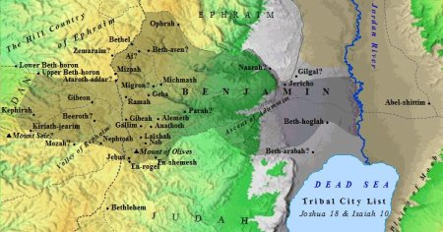

Allotment for Benjamin
11 The first lot came up for the tribe of Benjamin according to its clans. Their allotted territory lay between the tribes of Judah and Joseph:
12 On the north side their boundary began at the Jordan, passed the northern slope of Jericho and headed west into the hill country, coming out at the wilderness of Beth Aven. 13 From there it crossed to the south slope of Luz (that is, Bethel) and went down to Ataroth Addar on the hill south of Lower Beth Horon.
14 From the hill facing Beth Horon on the south the boundary turned south along the western side and came out at Kiriath Baal (that is, Kiriath Jearim), a town of the people of Judah. This was the western side.
15 The southern side began at the outskirts of Kiriath Jearim on the west, and the boundary came out at the spring of the waters of Nephtoah. 16 The boundary went down to the foot of the hill facing the Valley of Ben Hinnom, north of the Valley of Rephaim. It continued down the Hinnom Valley along the southern slope of the Jebusite city and so to En Rogel. 17 It then curved north, went to En Shemesh, continued to Geliloth, which faces the Pass of Adummim, and ran down to the Stone of Bohan son of Reuben. 18 It continued to the northern slope of Beth Arabah[a] and on down into the Arabah. 19 It then went to the northern slope of Beth Hoglah and came out at the northern bay of the Dead Sea, at the mouth of the Jordan in the south. This was the southern boundary.
20 The Jordan formed the boundary on the eastern side.
These were the boundaries that marked out the inheritance of the clans of Benjamin on all sides.
21 The tribe of Benjamin, according to its clans, had the following towns:
Jericho, Beth Hoglah, Emek Keziz, 22 Beth Arabah, Zemaraim, Bethel, 23 Avvim, Parah, Ophrah,24 Kephar Ammoni, Ophni and Geba—twelve towns and their villages.
25 Gibeon, Ramah, Beeroth, 26 Mizpah, Kephirah, Mozah, 27 Rekem, Irpeel, Taralah, 28 Zelah, Haeleph, the Jebusite city (that is, Jerusalem), Gibeah and Kiriath—fourteen towns and their villages.
This was the inheritance of Benjamin for its clans.

- The first lot went to the tribe of Benjamin. This was the youngest son of Jacob and the second son of “Rachael” whom she had while she was dying.
- She named him 'Ben-oni' which means 'son of trouble' but his father Jacob named him Benjamin which means 'son of my right hand'.
- He was Joseph's younger brother. Judah swore his life to protect Benjamin in order to get Simeon out of prison in Egypt. Now Benjamin received land between Judah and Ephraim which is Joseph's son.

2. Read 19:1-51. From where did the Simeonites receive their inheritance? (1-9) Describe the inheritance of Zebulen (10-16), Issachar (17-23), Asher (24-31), Naphtali (32-39), and Dan (40-48). Who were given their land last? (49-51)

2-1, Read 19:1-51.

The second lot came out for the tribe of Simeon according to its clans. Their inheritance lay within the territory of Judah. 2 It included:
Beersheba (or Sheba),[a] Moladah, 3 Hazar Shual, Balah, Ezem, 4 Eltolad, Bethul, Hormah, 5 Ziklag, Beth Markaboth, Hazar Susah, 6 Beth Lebaoth and Sharuhen—thirteen towns and their villages;
7 Ain, Rimmon, Ether and Ashan—four towns and their villages— 8 and all the villages around these towns as far as Baalath Beer (Ramah in the Negev).
This was the inheritance of the tribe of the Simeonites, according to its clans. 9 The inheritance of the Simeonites was taken from the share of Judah, because Judah’s portion was more than they needed. So the Simeonites received their inheritance within the territory of Judah.

Allotment for Zebulun
10 The third lot came up for Zebulun according to its clans:
The boundary of their inheritance went as far as Sarid. 11 Going west it ran to Maralah, touched Dabbesheth, and extended to the ravine near Jokneam. 12 It turned east from Sarid toward the sunrise to the territory of Kisloth Tabor and went on to Daberath and up to Japhia. 13 Then it continued eastward to Gath Hepher and Eth Kazin; it came out at Rimmon and turned toward Neah. 14 There the boundary went around on the north to Hannathon and ended at the Valley of Iphtah El. 15 Included were Kattath, Nahalal, Shimron, Idalah and Bethlehem. There were twelve towns and their villages.
16 These towns and their villages were the inheritance of Zebulun, according to its clans.

Allotment for Issachar
17 The fourth lot came out for Issachar according to its clans. 18 Their territory included:
Jezreel, Kesulloth, Shunem, 19 Hapharaim, Shion, Anaharath, 20 Rabbith, Kishion, Ebez, 21 Remeth, En Gannim, En Haddah and Beth Pazzez. 22 The boundary touched Tabor, Shahazumah and Beth Shemesh, and ended at the Jordan. There were sixteen towns and their villages.
23 These towns and their villages were the inheritance of the tribe of Issachar, according to its clans.

Allotment for Asher
24 The fifth lot came out for the tribe of Asher according to its clans. 25 Their territory included:
Helkath, Hali, Beten, Akshaph, 26 Allammelek, Amad and Mishal. On the west the boundary touched Carmel and Shihor Libnath. 27 It then turned east toward Beth Dagon, touched Zebulun and the Valley of Iphtah El, and went north to Beth Emek and Neiel, passing Kabul on the left. 28 It went to Abdon,[b]Rehob, Hammon and Kanah, as far as Greater Sidon. 29 The boundary then turned back toward Ramahand went to the fortified city of Tyre, turned toward Hosah and came out at the Mediterranean Sea in the region of Akzib, 30 Ummah, Aphek and Rehob. There were twenty-two towns and their villages.
31 These towns and their villages were the inheritance of the tribe of Asher, according to its clans.

Allotment for Naphtali
32 The sixth lot came out for Naphtali according to its clans:
33 Their boundary went from Heleph and the large tree in Zaanannim, passing Adami Nekeb and Jabneel to Lakkum and ending at the Jordan. 34 The boundary ran west through Aznoth Tabor and came out at Hukkok. It touched Zebulun on the south, Asher on the west and the Jordan[c] on the east.35 The fortified towns were Ziddim, Zer, Hammath, Rakkath, Kinnereth, 36 Adamah, Ramah, Hazor,37 Kedesh, Edrei, En Hazor, 38 Iron, Migdal El, Horem, Beth Anath and Beth Shemesh. There were nineteen towns and their villages.
39 These towns and their villages were the inheritance of the tribe of Naphtali, according to its clans.

Allotment for Dan
40 The seventh lot came out for the tribe of Dan according to its clans. 41 The territory of their inheritance included:
Zorah, Eshtaol, Ir Shemesh, 42 Shaalabbin, Aijalon, Ithlah, 43 Elon, Timnah, Ekron, 44 Eltekeh, Gibbethon, Baalath, 45 Jehud, Bene Berak, Gath Rimmon, 46 Me Jarkon and Rakkon, with the area facing Joppa.
47 (When the territory of the Danites was lost to them, they went up and attacked Leshem, took it, put it to the sword and occupied it. They settled in Leshem and named it Dan after their ancestor.)
48 These towns and their villages were the inheritance of the tribe of Dan, according to its clans.

Allotment for Joshua
49 When they had finished dividing the land into its allotted portions, the Israelites gave Joshua son of Nun an inheritance among them, 50 as the Lord had commanded. They gave him the town he asked for—Timnath Serah[d] in the hill country of Ephraim. And he built up the town and settled there.
51 These are the territories that Eleazar the priest, Joshua son of Nun and the heads of the tribal clans of Israel assigned by lot at Shiloh in the presence of the Lord at the entrance to the tent of meeting. And so they finished dividing the land.

2-2, From where did the Simeonites receive their inheritance? (1-9)

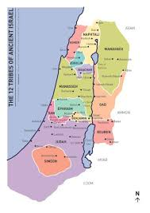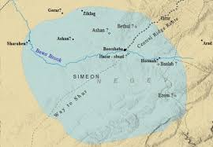
The second lot came out for the tribe of Simeon according to its clans. Their inheritance lay within the territory of Judah. 2 It included:
Beersheba (or Sheba), Moladah, 3 Hazar Shual, Balah, Ezem, 4 Eltolad, Bethul, Hormah, 5 Ziklag, Beth Markaboth, Hazar Susah, 6 Beth Lebaoth and Sharuhen—thirteen towns and their villages;
7 Ain, Rimmon, Ether and Ashan—four towns and their villages— 8 and all the villages around these towns as far as Baalath Beer (Ramah in the Negev).
This was the inheritance of the tribe of the Simeonites, according to its clans. 9 The inheritance of the Simeonites was taken from the share of Judah, because Judah’s portion was more than they needed. So the Simeonites received their inheritance within the territory of Judah.

2-3, Describe the inheritance of Zebulen (10-16), Issachar (17-23), Asher (24-31), Naphtali (32-39), and Dan (40-48).

Allotment for Zebulun

10 The third lot came up for Zebulun according to its clans:
The boundary of their inheritance went as far as Sarid. 11 Going west it ran to Maralah, touched Dabbesheth, and extended to the ravine near Jokneam. 12 It turned east from Sarid toward the sunrise to the territory of Kisloth Tabor and went on to Daberath and up to Japhia. 13 Then it continued eastward to Gath Hepher and Eth Kazin; it came out at Rimmon and turned toward Neah. 14 There the boundary went around on the north to Hannathon and ended at the Valley of Iphtah El. 15 Included were Kattath, Nahalal, Shimron, Idalah and Bethlehem. There were twelve towns and their villages.
16 These towns and their villages were the inheritance of Zebulun, according to its clans.

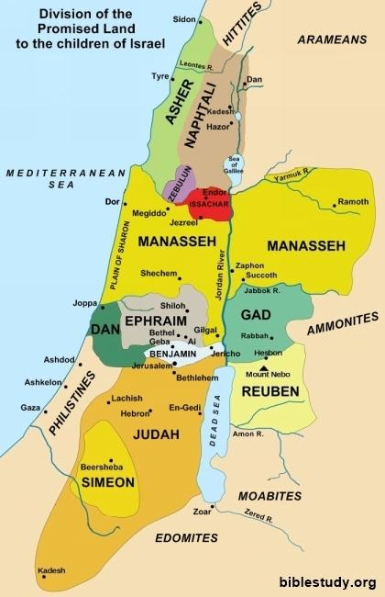

Allotment for Issachar
17 The fourth lot came out for Issachar according to its clans. 18 Their territory included:
Jezreel, Kesulloth, Shunem, 19 Hapharaim, Shion, Anaharath, 20 Rabbith, Kishion, Ebez, 21 Remeth, En Gannim, En Haddah and Beth Pazzez. 22 The boundary touched Tabor, Shahazumah and Beth Shemesh, and ended at the Jordan. There were sixteen towns and their villages.
23 These towns and their villages were the inheritance of the tribe of Issachar, according to its clans.

Allotment for Asher
24 The fifth lot came out for the tribe of Asher according to its clans. 25 Their territory included:
Helkath, Hali, Beten, Akshaph, 26 Allammelek, Amad and Mishal. On the west the boundary touched Carmel and Shihor Libnath. 27 It then turned east toward Beth Dagon, touched Zebulun and the Valley of Iphtah El, and went north to Beth Emek and Neiel, passing Kabul on the left. 28 It went to Abdon,[b]Rehob, Hammon and Kanah, as far as Greater Sidon. 29 The boundary then turned back toward Ramahand went to the fortified city of Tyre, turned toward Hosah and came out at the Mediterranean Sea in the region of Akzib, 30 Ummah, Aphek and Rehob. There were twenty-two towns and their villages.
31 These towns and their villages were the inheritance of the tribe of Asher, according to its clans.

Allotment for Naphtali
32 The sixth lot came out for Naphtali according to its clans:
33 Their boundary went from Heleph and the large tree in Zaanannim, passing Adami Nekeb and Jabneel to Lakkum and ending at the Jordan. 34 The boundary ran west through Aznoth Tabor and came out at Hukkok. It touched Zebulun on the south, Asher on the west and the Jordan[c] on the east.35 The fortified towns were Ziddim, Zer, Hammath, Rakkath, Kinnereth, 36 Adamah, Ramah, Hazor,37 Kedesh, Edrei, En Hazor, 38 Iron, Migdal El, Horem, Beth Anath and Beth Shemesh. There were nineteen towns and their villages.
39 These towns and their villages were the inheritance of the tribe of Naphtali, according to its clans.

Allotment for Dan
40 The seventh lot came out for the tribe of Dan according to its clans. 41 The territory of their inheritance included:
Zorah, Eshtaol, Ir Shemesh, 42 Shaalabbin, Aijalon, Ithlah, 43 Elon, Timnah, Ekron, 44 Eltekeh, Gibbethon, Baalath, 45 Jehud, Bene Berak, Gath Rimmon, 46 Me Jarkon and Rakkon, with the area facing Joppa.
47 (When the territory of the Danites was lost to them, they went up and attacked Leshem, took it, put it to the sword and occupied it. They settled in Leshem and named it Dan after their ancestor.)
48 These towns and their villages were the inheritance of the tribe of Dan, according to its clans.

2-4, Who were given their land last? (49-51)

Allotment for Joshua
49 When they had finished dividing the land into its allotted portions, the Israelites gave Joshua son of Nun an inheritance among them, 50 as the Lord had commanded. They gave him the town he asked for—Timnath Serah in the hill country of Ephraim. And he built up the town and settled there.
51 These are the territories that Eleazar the priest, Joshua son of Nun and the heads of the tribal clans of Israel assigned by lot at Shiloh in the presence of the Lord at the entrance to the tent of meeting. And so they finished dividing the land.

- Joshua could have gotten the first land. But he waited. Then they gave him the land he asked for. Leaders including him set an example to receive the land last and by lot, in a fair way.
- He is almost 90 years old. He encouraged, challenged and asked people to get up and take possession.
- In some sense people are comfortable. But we need to shake off comfort zone and take possession of the land. If he just let them relax they wouldn't get the land.
- It is important to have challenging spirit and trust God protects us. The whole land got rest on every side. The property division was over.

3. Read 20:1-9. What is God’s message to Joshua? Why was this needed? (1-6, 9) Describe the cities of refuge? (7-8) What does the establishment of these cities of refuge tell us about God?

3-1, Read 20:1-8.

Then the Lord said to Joshua: 2 “Tell the Israelites to designate the cities of refuge, as I instructed you through Moses, 3 so that anyone who kills a person accidentally and unintentionally may flee there and find protection from the avenger of blood. 4 When they flee to one of these cities, they are to stand in the entrance of the city gate and state their case before the elders of that city. Then the elders are to admit the fugitive into their city and provide a place to live among them. 5 If the avenger of blood comes in pursuit, the elders must not surrender the fugitive, because the fugitive killed their neighbor unintentionally and without malice aforethought. 6 They are to stay in that city until they have stood trial before the assembly and until the death of the high priest who is serving at that time. Then they may go back to their own home in the town from which they fled.”
7 So they set apart Kedesh in Galilee in the hill country of Naphtali, Shechem in the hill country of Ephraim, and Kiriath Arba (that is, Hebron) in the hill country of Judah. 8 East of the Jordan (on the other side from Jericho) they designated Bezer in the wilderness on the plateau in the tribe of Reuben, Ramoth in Gilead in the tribe of Gad, and Golan in Bashan in the tribe of Manasseh. 9 Any of the Israelites or any foreigner residing among them who killed someone accidentally could flee to these designated cities and not be killed by the avenger of blood prior to standing trial before the assembly.

3-2, What is God’s message to Joshua?
3-3, Why was this needed? (1-6, 9)

Then the Lord said to Joshua: 2 “Tell the Israelites to designate the cities of refuge, as I instructed you through Moses, 3 so that anyone who kills a person accidentally and unintentionally may flee there and find protection from the avenger of blood. 4 When they flee to one of these cities, they are to stand in the entrance of the city gate and state their case before the elders of that city. Then the elders are to admit the fugitive into their city and provide a place to live among them. 5 If the avenger of blood comes in pursuit, the elders must not surrender the fugitive, because the fugitive killed their neighbor unintentionally and without malice aforethought. 6 They are to stay in that city until they have stood trial before the assembly and until the death of the high priest who is serving at that time. Then they may go back to their own home in the town from which they fled.”
9 Any of the Israelites or any foreigner residing among them who killed someone accidentally could flee to these designated cities and not be killed by the avenger of blood prior to standing trial before the assembly.

- God knew that accidents and unintentional manslaughter might have happened among the Israelites. So he gave a law for this kind of situation.
- Joshua was to designate the cities of refuge where anyone who killed another accidentally could run and find protection from the avenger of blood.
- At the entrance of the city gate, they should state his case clearly before the elders of that city who would admit him first, investigate the case.
- If he did, he would be protected from the avenger of blood within the city. However, they who left the city of refuge, the avenger would have the right to kill him (Nu 35:24-28).
- He should stay in that city until the death of the high priest who was serving at that time. Then he could go back to his own home in the town from which he fled.
- It was God who set this specific law. Somehow, this law was pointing to the great High Priest Jesus whose death gives sinners salvation and freedom from eternal condemnation.

3-4, Describe the cities of refuge? (7-8)

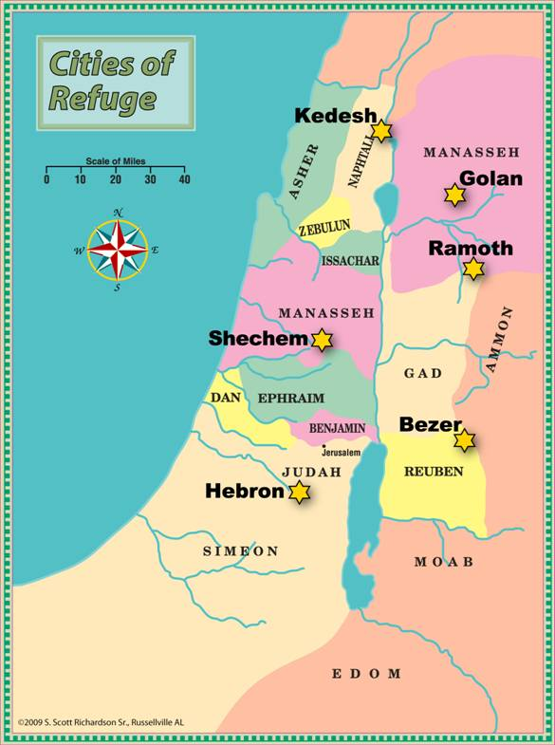
7 So they set apart Kedesh in Galilee in the hill country of Naphtali, Shechem in the hill country of Ephraim, and Kiriath Arba (that is, Hebron) in the hill country of Judah. 8 East of the Jordan (on the other side from Jericho) they designated Bezer in the wilderness on the plateau in the tribe of Reuben, Ramoth in Gilead in the tribe of Gad, and Golan in Bashan in the tribe of Manasseh.

- These cities were strategically chosen so that anyone in Israel either the Israelite or alien who killed someone accidentally could flee to one of them for refuge within a day or less.

3-5, What does the establishment of these cities of refuge tell us about God?

- It is quite amazing to see that God commanded Israel to designate the cities of refuge with specific and practical instructions.
- God is holy and hates sin, particularly murder is a serious offense to God who created human beings in his own image with his sovereign plan and purpose.
- “You shall not murder.” It is in the 10 Commandments of God. Genesis 9:6 reads, “Whoever sheds human blood, by humans shall their blood be shed; for in the image of God has God made mankind.”
- However, God sees a difference between murder and manslaughter. The cities of refuge were not the idea of man, just as the Gospel is not a human invention.
- God’s words about the cities of refuge had been recorded many different parts of the Bible—Exodus 21:12-13, Numbers 35:9-34 (long passage), Deuteronomy 4:41-43, Deuteronomy 19:1-13 (somewhat long passage) and Joshua 20.
- We can see God’s attention and care for the cities of refuge. The cities of refuge were the purpose and plan of God who wanted to save and protect the slayer who killed another person accidentally and unintentionally.
- Most probably, very few people in a year fled to the cities. For the small numbers of unfortunate slayers God provided the cities of refuge to save them from bloodshed.
- God abhors the sin of murder. But he wants to save and protect one who kills another person unintentionally or accidentally. God is the origin of refuge and he is our refuge. Psalm 91:2 reads, “I will say of the Lord, ‘He is my refuge and my fortress…’”

- Sinners are spiritual refuge seekers. They are chased by the avenger of blood that is the wrath of God or guilty conscience or the devil.
- We all have troubles and problems physically and spiritually. We all have sins. We also makes mistakes even though no one among us killed someone accidentally or unintentionally.
- We all need the refuge. We thank God for providing us the everlasting refuge, Jesus. Let us find our true refuge in Jesus. Let our church, which is the body of Christ be a place of refuge to many students and other people in the city.

4. Read 21:1-45. Describe how the Levites received their towns. (1-42). What did the author see and conclude when the LORD gave Israel the entire land of promise? (43-45)

4-1, Read 21:1-45.

Now the family heads of the Levites approached Eleazar the priest, Joshua son of Nun, and the heads of the other tribal families of Israel 2 at Shiloh in Canaan and said to them, “The Lord commanded through Moses that you give us towns to live in, with pasturelands for our livestock.” 3 So, as the Lordhad commanded, the Israelites gave the Levites the following towns and pasturelands out of their own inheritance:
4 The first lot came out for the Kohathites, according to their clans. The Levites who were descendants of Aaron the priest were allotted thirteen towns from the tribes of Judah, Simeon and Benjamin. 5 The rest of Kohath’s descendants were allotted ten towns from the clans of the tribes of Ephraim, Dan and half of Manasseh.
6 The descendants of Gershon were allotted thirteen towns from the clans of the tribes of Issachar,Asher, Naphtali and the half-tribe of Manasseh in Bashan.
7 The descendants of Merari, according to their clans, received twelve towns from the tribes of Reuben, Gad and Zebulun.
8 So the Israelites allotted to the Levites these towns and their pasturelands, as the Lord had commanded through Moses.
9 From the tribes of Judah and Simeon they allotted the following towns by name 10 (these towns were assigned to the descendants of Aaron who were from the Kohathite clans of the Levites, because the first lot fell to them):
11 They gave them Kiriath Arba (that is, Hebron), with its surrounding pastureland, in the hill country of Judah. (Arba was the forefather of Anak.) 12 But the fields and villages around the city they had given to Caleb son of Jephunneh as his possession.
13 So to the descendants of Aaron the priest they gave Hebron (a city of refuge for one accused of murder), Libnah, 14 Jattir, Eshtemoa, 15 Holon, Debir, 16 Ain, Juttah and Beth Shemesh, together with their pasturelands—nine towns from these two tribes.
17 And from the tribe of Benjamin they gave them Gibeon, Geba, 18 Anathoth and Almon, together with their pasturelands—four towns.
19 The total number of towns for the priests, the descendants of Aaron, came to thirteen, together with their pasturelands.
20 The rest of the Kohathite clans of the Levites were allotted towns from the tribe of Ephraim:
21 In the hill country of Ephraim they were given Shechem (a city of refuge for one accused of murder) and Gezer, 22 Kibzaim and Beth Horon, together with their pasturelands—four towns.
23 Also from the tribe of Dan they received Eltekeh, Gibbethon, 24 Aijalon and Gath Rimmon, together with their pasturelands—four towns.
25 From half the tribe of Manasseh they received Taanach and Gath Rimmon, together with their pasturelands—two towns.
26 All these ten towns and their pasturelands were given to the rest of the Kohathite clans.
27 The Levite clans of the Gershonites were given:
from the half-tribe of Manasseh,
Golan in Bashan (a city of refuge for one accused of murder) and Be Eshterah, together with their pasturelands—two towns;
28 from the tribe of Issachar,
Kishion, Daberath, 29 Jarmuth and En Gannim, together with their pasturelands—four towns;
30 from the tribe of Asher,
Mishal, Abdon, 31 Helkath and Rehob, together with their pasturelands—four towns;
32 from the tribe of Naphtali,
Kedesh in Galilee (a city of refuge for one accused of murder), Hammoth Dor and Kartan, together with their pasturelands—three towns.
33 The total number of towns of the Gershonite clans came to thirteen, together with their pasturelands.
34 The Merarite clans (the rest of the Levites) were given:
from the tribe of Zebulun,
Jokneam, Kartah, 35 Dimnah and Nahalal, together with their pasturelands—four towns;
36 from the tribe of Reuben,
Bezer, Jahaz, 37 Kedemoth and Mephaath, together with their pasturelands—four towns;
38 from the tribe of Gad,
Ramoth in Gilead (a city of refuge for one accused of murder), Mahanaim, 39 Heshbon and Jazer,together with their pasturelands—four towns in all.
40 The total number of towns allotted to the Merarite clans, who were the rest of the Levites, came to twelve.
41 The towns of the Levites in the territory held by the Israelites were forty-eight in all, together with their pasturelands. 42 Each of these towns had pasturelands surrounding it; this was true for all these towns.
43 So the Lord gave Israel all the land he had sworn to give their ancestors, and they took possession of it and settled there. 44 The Lord gave them rest on every side, just as he had sworn to their ancestors. Not one of their enemies withstood them; the Lord gave all their enemies into their hands. 45 Not one of all the Lord’s good promises to Israel failed; everyone was fulfilled.

4-2, Describe how the Levites received their towns. (1-42).

Now the family heads of the Levites approached Eleazar the priest, Joshua son of Nun, and the heads of the other tribal families of Israel 2 at Shiloh in Canaan and said to them, “The Lord commanded through Moses that you give us towns to live in, with pasturelands for our livestock.” 3 So, as the Lord had commanded, the Israelites gave the Levites the following towns and pasturelands out of their own inheritance:
4 The first lot came out for the Kohathites, according to their clans. The Levites who were descendants of Aaron the priest were allotted thirteen towns from the tribes of Judah, Simeon and Benjamin. 5 The rest of Kohath’s descendants were allotted ten towns from the clans of the tribes of Ephraim, Dan and half of Manasseh.
6 The descendants of Gershon were allotted thirteen towns from the clans of the tribes of Issachar,Asher, Naphtali and the half-tribe of Manasseh in Bashan.
7 The descendants of Merari, according to their clans, received twelve towns from the tribes of Reuben, Gad and Zebulun.
8 So the Israelites allotted to the Levites these towns and their pasturelands, as the Lord had commanded through Moses.
9 From the tribes of Judah and Simeon they allotted the following towns by name 10 (these towns were assigned to the descendants of Aaron who were from the Kohathite clans of the Levites, because the first lot fell to them):
11 They gave them Kiriath Arba (that is, Hebron), with its surrounding pastureland, in the hill country of Judah. (Arba was the forefather of Anak.) 12 But the fields and villages around the city they had given to Caleb son of Jephunneh as his possession.
13 So to the descendants of Aaron the priest they gave Hebron (a city of refuge for one accused of murder), Libnah, 14 Jattir, Eshtemoa, 15 Holon, Debir, 16 Ain, Juttah and Beth Shemesh, together with their pasturelands—nine towns from these two tribes.
17 And from the tribe of Benjamin they gave them Gibeon, Geba, 18 Anathoth and Almon, together with their pasturelands—four towns.
19 The total number of towns for the priests, the descendants of Aaron, came to thirteen, together with their pasturelands.
20 The rest of the Kohathite clans of the Levites were allotted towns from the tribe of Ephraim:
21 In the hill country of Ephraim they were given Shechem (a city of refuge for one accused of murder) and Gezer, 22 Kibzaim and Beth Horon, together with their pasturelands—four towns.
23 Also from the tribe of Dan they received Eltekeh, Gibbethon, 24 Aijalon and Gath Rimmon, together with their pasturelands—four towns.
25 From half the tribe of Manasseh they received Taanach and Gath Rimmon, together with their pasturelands—two towns.
26 All these ten towns and their pasturelands were given to the rest of the Kohathite clans.
27 The Levite clans of the Gershonites were given:
from the half-tribe of Manasseh,
Golan in Bashan (a city of refuge for one accused of murder) and Be Eshterah, together with their pasturelands—two towns;
28 from the tribe of Issachar,
Kishion, Daberath, 29 Jarmuth and En Gannim, together with their pasturelands—four towns;
30 from the tribe of Asher,
Mishal, Abdon, 31 Helkath and Rehob, together with their pasturelands—four towns;
32 from the tribe of Naphtali,
Kedesh in Galilee (a city of refuge for one accused of murder), Hammoth Dor and Kartan, together with their pasturelands—three towns.
33 The total number of towns of the Gershonite clans came to thirteen, together with their pasturelands.
34 The Merarite clans (the rest of the Levites) were given:
from the tribe of Zebulun,
Jokneam, Kartah, 35 Dimnah and Nahalal, together with their pasturelands—four towns;
36 from the tribe of Reuben,
Bezer, Jahaz, 37 Kedemoth and Mephaath, together with their pasturelands—four towns;
38 from the tribe of Gad,
Ramoth in Gilead (a city of refuge for one accused of murder), Mahanaim, 39 Heshbon and Jazer,together with their pasturelands—four towns in all.
40 The total number of towns allotted to the Merarite clans, who were the rest of the Levites, came to twelve.
41 The towns of the Levites in the territory held by the Israelites were forty-eight in all, together with their pasturelands. 42 Each of these towns had pasturelands surrounding it; this was true for all these towns.
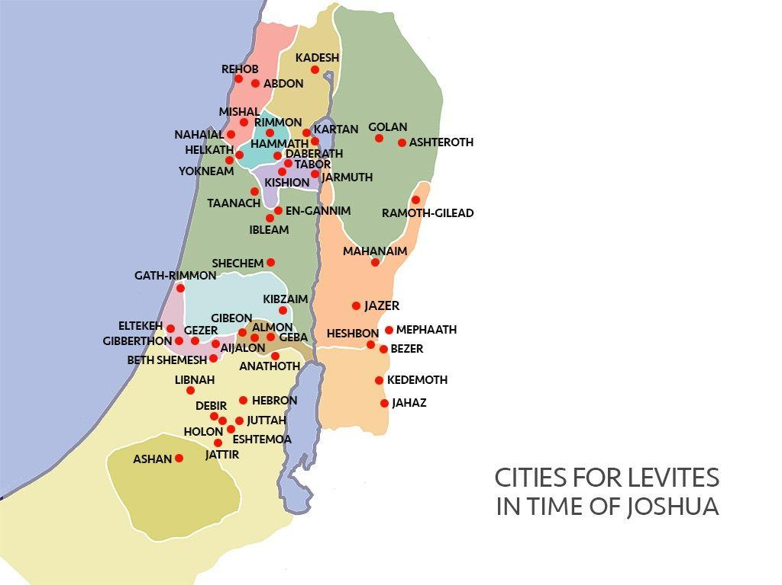
- Through participating in the division and allotment of land the Israelites began to open their hearts it seemed.

- When the Levites came to claim their towns and pasturelands the Israelites gave it to them as God commanded. They asked based on God's promise to them. And as God commanded, thankfully the Israelites obeyed.

- As the Lord had commanded, the Israelites gave the Levites the following towns and pasturelands out of their own inheritance: The first lot came out for the Kohathites, according to their clans.
- We also see in Ge49:7 Jacob said about his son Levi “Cursed be their anger, so fierce, and their fury, so cruel! I will scatter them in Jacob and disperse them in Israel.” This seems to be a curse to them. But we can find God's purpose in it.
- Normally, the Levites helped with the priestly chores serving at the central Tabernacle.
- But now the people are spread out. They wouldn't worship centrally as often as they had. So God put the Levites throughout the land. They would serve as shepherds and Bible teachers.
- Moreover, all the cities of refuge are Levite cities. They lived together teaching others about the peace and understanding of God. They taught to share and support serving the lord.
- We here see the picture of the nation of Israel forming under the promises of God to be a city on a hill. A kingdom of priests and a holy nation through assigning this land to the Levites as Bible teachers and shepherds.
- Likewise we are called as Bible teachers and shepherds. May we serve college campuses in the east coast as modern Levites.

4-3, What did the author see and conclude when the LORD gave Israel the entire land of promise? (43-45)

43 So the Lord gave Israel all the land he had sworn to give their ancestors, and they took possession of it and settled there. 44 The Lord gave them rest on every side, just as he had sworn to their ancestors. Not one of their enemies withstood them; the Lord gave all their enemies into their hands.

- In this passage it repeats Here it says “The Lord gave” 3 times. God's sovereignty is revealed. The Lord gave them all the land he swore. He gave them rest as he swore and all their enemies into their hands.
- The Israelites were unorganized 2nd generation from slave parents. They didn't have a country or unlimited resources available. But they did one thing. They took possession of the land God gave them by obedience.
- God has given us so much. We hear his word very frequently. Let's take possession of his promises through Jesus.

45 Not one of all the Lord’s good promises to Israel failed; everyone was fulfilled.

- This is the conclusion here of all of God's promises since Genesis. God's promises are good for everyone. Human promises aren't good for everyone.
- But God's promises are good for everyone. Not one of them failed Israel. They won't fail us either.
- May we each day depend on God's good promise. That Jesus will satisfy us and give us vision for the future. I pray that we can build our lives on this permanent good foundation!

One word: God’s promises will be fulfilled for sure!

