IN CONFESSION AND IN WORSHIPING THE LORD

Nehemiah 9:1-37
Key verse 3

“They stood where they were and read from the Book of the Law of the Lord their God for a quarter of the day, and spent another quarter in confession and in worshiping the Lord their God.”

Introduction
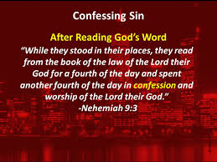

Isaiah 66:2 reads, “These are the ones I look on with favor: those who are humble and contrite in spirit, and who tremble at my word.” People tend to worship God with singing and inspiring preaching or etc. Yet one thing that honors the Lord the most is humble confession with a contrite heart. He looks in favor upon those who come before him. Today’s passage shows that the Israelites humbly came to the Lord and worshipped God. May the Lord help us to imitate their good examples in light of true worship.

1. Read verses 1-5. What was the purpose of the gathering of the Israelites on the 24th day of the month? (1-2) What did they do? (3) How did the Levites lead God’s people in worship? (4-5)

1-1, Read verses 1-5.

On the twenty-fourth day of the same month, the Israelites gathered together, fasting and wearing sackcloth and putting dust on their heads. 2 Those of Israelite descent had separated themselves from all foreigners. They stood in their places and confessed their sins and the sins of their ancestors. 3 They stood where they were and read from the Book of the Law of the Lord their God for a quarter of the day, and spent another quarter in confession and in worshiping the Lord their God. 4 Standing on the stairs of the Levites were Jeshua, Bani, Kadmiel, Shebaniah, Bunni, Sherebiah, Bani and Kenani. They cried out with loud voices to the Lord their God. 5 And the Levites—Jeshua, Kadmiel, Bani, Hashabneiah, Sherebiah, Hodiah, Shebaniah and Pethahiah—said: “Stand up and praise the Lord your God, who is from everlasting to everlasting.”
“Blessed be your glorious name, and may it be exalted above all blessing and praise.

1-2, What was the purpose of the gathering of the Israelites on the 24th day of the month? (1-2)

On the twenty-fourth day of the same month, the Israelites gathered together, fasting and wearing sackcloth and putting dust on their heads. 2 Those of Israelite descent had separated themselves from all foreigners. They stood in their places and confessed their sins and the sins of their ancestors.

- The 24th day of the same month - Since they celebrated the feast of the booths, 16 days passed.

So on the first day of the seventh month Ezra the priest brought the Law before the assembly, which was made up of men and women and all who were able to understand. (8:2)

Day after day, from the first day to the last, Ezra read from the Book of the Law of God. They celebrated the festival for seven days, and on the eighth day, in accordance with the regulation, there was an assembly. (8:18)

- They did not go back to their old lives of sins after reading the Bible and the feast.
- Rather they gathered together to pray together. “Fasting, wearing sackcloth, and putting dust on their heads” reveals their sincere attitude and humility before God.
- They separated themselves from all foreigners. Although they had built the wall of Jerusalem, they wanted to live holy lives by separating themselves from all foreigners. They wanted to resume their spiritual identity.
- They stood in their places. They tried to accept their sinful status before God and repent of their sins.
- They confessed their sins as well as their ancestors’ sins. We are affected by our parents’ sins, esp., fathers. When we write our life testimonies, we come to know how our sins were inherited from our fathers.
- The Israelites wanted to repent of their own sins as well as the wickedness of their ancestors. In this way they wanted to break the chains of cursed lives running in the family.

1-3, What did they do? (3)

They stood where they were and read from the Book of the Law of the Lord their God for a quarter of the day, and spent another quarter in confession and in worshiping the Lord their God.

- They stood where they were and read from the Book of the Law of the Lord. The book of the Law of the Lord are Moses’ 5 books.
- They read the Book for a quarter of the day and spent another quarter in confession and in worshiping the Lord their God.
- There was an order: reading God’s law first and confession and worshiping the Lord. Worship can not be based on our feelings or situation. Rather it should be based on the words of God always.
- Humble repentance and confession of sin would have been incomplete if it were not for reading the words of God.

1-4, How did the Levites lead God’s people in worship? (4-5)

Standing on the stairs of the Levites were Jeshua, Bani, Kadmiel, Shebaniah, Bunni, Sherebiah, Bani and Kenani. They cried out with loud voices to the Lord their God. 5 And the Levites—Jeshua, Kadmiel, Bani, Hashabneiah, Sherebiah, Hodiah, Shebaniah and Pethahiah—said: “Stand up and praise the Lord your God, who is from everlasting to everlasting.” “Blessed be your glorious name, and may it be exalted above all blessing and praise.

- The Levites led the people to worship God. The 16 Levites were mentioned and divided. One group cried out with loud voices to the Lord their God.
- The other group said, “Stand up and praise the Lord your God, who is from everlasting to everlasting.” “Blessed be your glorious name and may be exalted above all blessing and praise.
- They must have become the first group who tasted the joy of the Lord. (8:10) They were leading the people to cry out with loud voices to the Lord, for God would not reject them when they earnestly prayed.
- When they gave their hearts to sacrifice their time and security to serve God, they must have experienced who God and His glorious name.

2. Read verses 6-21. Who is the God of Israel? (6) What did God do for Abraham? (7, 8) How did God reveal his compassion and mighty power by leading his people in Egypt through Moses? (9-15) How did God show His great compassion to the Israelites in the wilderness? (16-21)

2-1, Read verses 6-21.

You alone are the Lord. You made the heavens, even the highest heavens, and all their starry host, the earth and all that is on it, the seas and all that is in them. You give life to everything, and the multitudes of heaven worship you. 7 “You are the Lord God, who chose Abram and brought him out of Ur of the Chaldeans and named him Abraham. 8 You found his heart faithful to you, and you made a covenant with him to give to his descendants the land of the Canaanites, Hittites, Amorites, Perizzites, Jebusites and Girgashites. You have kept your promise because you are righteous. 9 “You saw the suffering of our ancestors in Egypt; you heard their cry at the Red Sea. 10 You sent signs and wonders against Pharaoh, against all his officials and all the people of his land, for you knew how arrogantly the Egyptians treated them. You made a name for yourself, which remains to this day. 11 You divided the sea before them, so that they passed through it on dry ground, but you hurled their pursuers into the depths, like a stone into mighty waters. 12 By day you led them with a pillar of cloud,and by night with a pillar of fire to give them light on the way they were to take. 13 “You came down on Mount Sinai; you spoke to them from heaven. You gave them regulations and laws that are just and right, and decrees and commands that are good. 14 You made known to them your holy Sabbath and gave them commands, decrees and laws through your servant Moses. 15 In their hunger you gave them bread from heaven and in their thirst you brought them water from the rock; you told them to go in and take possession of the land you had sworn with uplifted hand to give them. 16 “But they, our ancestors, became arrogant and stiff-necked, and they did not obey your commands.17 They refused to listen and failed to remember the miracles you performed among them. They became stiff-necked and in their rebellion appointed a leader in order to return to their slavery. But you are a forgiving God, gracious and compassionate, slow to anger and abounding in love. Therefore you did not desert them, 18 even when they cast for themselves an image of a calf and said, ‘This is your god, who brought you up out of Egypt,’ or when they committed awful blasphemies. 19 “Because of your great compassion you did not abandon them in the wilderness. By day the pillar of cloud did not fail to guide them on their path, nor the pillar of fire by night to shine on the way they were to take. 20 You gave your good Spirit to instruct them. You did not withhold your manna from their mouths, and you gave them water for their thirst. 21 For forty years you sustained them in the wilderness; they lacked nothing, their clothes did not wear out nor did their feet become swollen.

2-2, Who is the God of Israel? (6)

You alone are the Lord. You made the heavens, even the highest heavens, and all their starry host, the earth and all that is on it, the seas and all that is in them. You give life to everything, and the multitudes of heaven worship you.

- This verse reminds us of Genesis chapter 1. The God of Israel is the only Lord Almighty who is everlasting to everlasting. (5b) God made the heavens.
- The highest heavens is most likely where God now has His heavenly throne. It may be synonymous with the 3rd heaven.
- They confessed God the Creator God. They acknowledge that the God is the Creator and the Sovereign over all things.
- The God who knows the past present and future, and the God whose in his sovereignty has every right to be worshiped and blessed and honored in their life and the life of their nation.
- You give life to everything. And the multitudes of heaven worship God. God wants us to praise Him, to humble ourselves before Him, and to trust Him. We sometimes want our own reasons, but God gives us plenty of His own reasons.

2-3, What did God do for Abraham? (7, 8)

“You are the Lord God, who chose Abram and brought him out of Ur of the Chaldeans and named him Abraham. 8 You found his heart faithful to you, and you made a covenant with him to give to his descendants the land of the Canaanites, Hittites, Amorites, Perizzites, Jebusites and Girgashites. You have kept your promise because you are righteous.

- They confessed that God is the God of history. The prayer servants walk through history to reveal the sovereign God who is also the sovereign over history, the one who guides history according to his own purpose.
- God chose Abram(Genesis 11 & 12) for a good purpose and brought him out of Ur of the Chaldeans and named him Abraham. (Genesis 17) God found his heart faithful to Him. God made a covenant with him to give to his descendants the land of promise. God also kept His promise.

2-4, How did God reveal his compassion and mighty power by leading his people in Egypt through Moses? (9-15)

“You saw the suffering of our ancestors in Egypt; you heard their cry at the Red Sea. 10 You sent signs and wonders against Pharaoh, against all his officials and all the people of his land, for you knew how arrogantly the Egyptians treated them. You made a name for yourself, which remains to this day.11 You divided the sea before them, so that they passed through it on dry ground, but you hurled their pursuers into the depths, like a stone into mighty waters. 12 By day you led them with a pillar of cloud,and by night with a pillar of fire to give them light on the way they were to take. 13 “You came down on Mount Sinai; you spoke to them from heaven. You gave them regulations and laws that are just and right, and decrees and commands that are good. 14 You made known to them your holy Sabbath and gave them commands, decrees and laws through your servant Moses. 15 In their hunger you gave them bread from heaven and in their thirst you brought them water from the rock; you told them to go in and take possession of the land you had sworn with uplifted hand to give them.

- This portion is mainly about the book of Exodus and the book of Leviticus. God revealed his compassion to answer the prayer of His people and led them out of Egypt with His mighty hands in and through his servant, Moses.
- They confessed that God is the God of promises. They prayed to the God who had continued to fulfill his good and great promises not only to Abraham as an individual, but to his descendants as a whole.

2-5, How did God show His great compassion to the Israelites in the wilderness? (16-21)

16 “But they, our ancestors, became arrogant and stiff-necked, and they did not obey your commands.17 They refused to listen and failed to remember the miracles you performed among them. They became stiff-necked and in their rebellion appointed a leader in order to return to their slavery. But you are a forgiving God, gracious and compassionate, slow to anger and abounding in love. Therefore you did not desert them, 18 even when they cast for themselves an image of a calf and said, ‘This is your god, who brought you up out of Egypt,’ or when they committed awful blasphemies. 19 “Because of your great compassion you did not abandon them in the wilderness. By day the pillar of cloud did not fail to guide them on their path, nor the pillar of fire by night to shine on the way they were to take. 20 You gave your good Spirit to instruct them. You did not withhold your manna from their mouths, and you gave them water for their thirst. 21 For forty years you sustained them in the wilderness; they lacked nothing, their clothes did not wear out nor did their feet become swollen.

- In verse 21, for forty years you sustained them in the wilderness; they lacked nothing. It talks about the book of numbers. There is a great contrast between “You” and “they” in light of their rebellion and God’s compassionate love for them.
- Verse 17 shows God’s character the most. But you are a forgiving God, gracious and compassionate, slow to anger and abounding in love.

3. Read verse 22-37. How did God fulfill his promise? (22-25) What was the pattern of the people’s unfaithfulness and God’s mercy throughout the history of Israel? (26-31) What was their conclusion? (32-35) How did they honestly describe their current condition after returning from exile? (36, 37)

3-1, Read verse 22-37.

“You gave them kingdoms and nations, allotting to them even the remotest frontiers. They took over the country of Sihon[c] king of Heshbon and the country of Og king of Bashan. 23 You made their children as numerous as the stars in the sky, and you brought them into the land that you told their parents to enter and possess. 24 Their children went in and took possession of the land. You subdued before them the Canaanites, who lived in the land; you gave the Canaanites into their hands, along with their kings and the peoples of the land, to deal with them as they pleased. 25 They captured fortified cities and fertile land; they took possession of houses filled with all kinds of good things, wells already dug, vineyards, olive groves and fruit trees in abundance. They ate to the full and were well-nourished; they reveled in your great goodness. 26 “But they were disobedient and rebelled against you; they turned their backs on your law. They killed your prophets, who had warned them in order to turn them back to you; they committed awful blasphemies. 27 So you delivered them into the hands of their enemies, who oppressed them. But when they were oppressed they cried out to you. From heaven you heard them, and in your great compassion you gave them deliverers, who rescued them from the hand of their enemies. 28 “But as soon as they were at rest, they again did what was evil in your sight. Then you abandoned them to the hand of their enemies so that they ruled over them. And when they cried out to you again, you heard from heaven, and in your compassion you delivered them time after time. 29 “You warned them in order to turn them back to your law, but they became arrogant and disobeyed your commands. They sinned against your ordinances, of which you said, ‘The person who obeys them will live by them.’ Stubbornly they turned their backs on you, became stiff-necked and refused to listen. 30 For many years you were patient with them. By your Spirit you warned them through your prophets. Yet they paid no attention, so you gave them into the hands of the neighboring peoples.31 But in your great mercy you did not put an end to them or abandon them, for you are a gracious and merciful God. 32 “Now therefore, our God, the great God, mighty and awesome, who keeps his covenant of love, do not let all this hardship seem trifling in your eyes—the hardship that has come on us, on our kings and leaders, on our priests and prophets, on our ancestors and all your people, from the days of the kings of Assyria until today. 33 In all that has happened to us, you have remained righteous; you have acted faithfully, while we acted wickedly. 34 Our kings, our leaders, our priests and our ancestors did not follow your law; they did not pay attention to your commands or the statutes you warned them to keep. 35 Even while they were in their kingdom, enjoying your great goodness to them in the spacious and fertile land you gave them, they did not serve you or turn from their evil ways. 36 “But see, we are slaves today, slaves in the land you gave our ancestors so they could eat its fruit and the other good things it produces. 37 Because of our sins, its abundant harvest goes to the kings you have placed over us. They rule over our bodies and our cattle as they please. We are in great distress.

3-2, How did God fulfill his promise? (22-25)

22 “You gave them kingdoms and nations, allotting to them even the remotest frontiers. They took over the country of Sihon king of Heshbon and the country of Og king of Bashan. 23 You made their children as numerous as the stars in the sky, and you brought them into the land that you told their parents to enter and possess. 24 Their children went in and took possession of the land. You subdued before them the Canaanites, who lived in the land; you gave the Canaanites into their hands, along with their kings and the peoples of the land, to deal with them as they pleased. 25 They captured fortified cities and fertile land; they took possession of houses filled with all kinds of good things, wells already dug, vineyards, olive groves and fruit trees in abundance. They ate to the full and were well-nourished; they reveled in your great goodness.

- This portion is mainly about the book of Deuteronomy. Despite the unfaithfulness of His people, God kept his promises to give them kingdoms and nations.
- We can have a glance view with the below drawing and map.
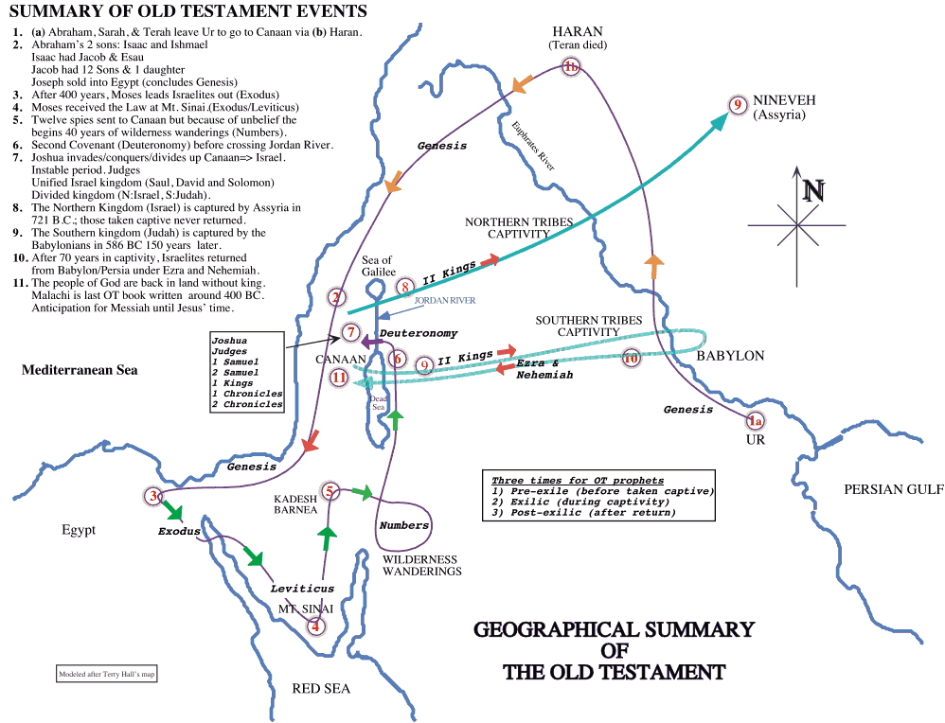

3-3, What was the pattern of the people’s unfaithfulness and God’s mercy throughout the history of Israel? (26-31)

“But they were disobedient and rebelled against you; they turned their backs on your law. They killed your prophets, who had warned them in order to turn them back to you; they committed awful blasphemies. 27 So you delivered them into the hands of their enemies, who oppressed them. But when they were oppressed they cried out to you. From heaven you heard them, and in your great compassion you gave them deliverers, who rescued them from the hand of their enemies. 28 “But as soon as they were at rest, they again did what was evil in your sight. Then you abandoned them to the hand of their enemies so that they ruled over them. And when they cried out to you again, you heard from heaven, and in your compassion you delivered them time after time. 29 “You warned them in order to turn them back to your law, but they became arrogant and disobeyed your commands. They sinned against your ordinances, of which you said, ‘The person who obeys them will live by them.’ Stubbornly they turned their backs on you, became stiff-necked and refused to listen. 30 For many years you were patient with them. By your Spirit you warned them through your prophets. Yet they paid no attention, so you gave them into the hands of the neighboring peoples.31 But in your great mercy you did not put an end to them or abandon them, for you are a gracious and merciful God.

- This portion covers the book of Judges and the book of Samuel and the book of Kings and the book of Chronicles, for Ezra is believed to be the author.
- So far they confessed that they had always been unworthy sinners who did not deserve what God had done for them.
- Throughout their confessions on that day, they were clear to confess all the sins of their forefathers. They had been disobedient. They had been unfaithful. They had been rebellious.
- In spite of the wickedness of the Israelites, God had been patient with them. God sent many prophets. God sent Assyria, Babylon, and Persia so far. But God did not put an end to them, because God is a gracious and merciful God.
- Throughout today’s passage God and God’s pronoun “You” repeated so many times. This prayer focus on who God is throughout the history.

3-4, What was their conclusion? (32-35)

“Now therefore, our God, the great God, mighty and awesome, who keeps his covenant of love, do not let all this hardship seem trifling in your eyes—the hardship that has come on us, on our kings and leaders, on our priests and prophets, on our ancestors and all your people, from the days of the kings of Assyria until today. 33 In all that has happened to us, you have remained righteous; you have acted faithfully, while we acted wickedly. 34 Our kings, our leaders, our priests and our ancestors did not follow your law; they did not pay attention to your commands or the statutes you warned them to keep. 35 Even while they were in their kingdom, enjoying your great goodness to them in the spacious and fertile land you gave them, they did not serve you or turn from their evil ways.

- They came to the conclusion in the right way and assessment through reviewing the Bible.
- They confessed that as much as their ancestors had been unfaithful to God, so also they too had been unfaithful.
- These people had been good people, listening to God’s words and following God’s direction. They had been those who had come back from the exile with a humble heart ready to obey the word of God and to do what God commands.
- In a sense they were much better than their ancestors who had abused the mercy of God.
- Yet when they prayed, they confessed that their ancestors’ sins were their own sins as well. They knew that they were no better than their wayward ancestors,
- They understood that sins resides in the heart of all men, and that they would need the hand of God’s mercy to prevent them from doing what their ancestors had done.

3-5, How did they honestly describe their current condition after returning from exile? (36, 37)

36 “But see, we are slaves today, slaves in the land you gave our ancestors so they could eat its fruit and the other good things it produces. 37 Because of our sins, its abundant harvest goes to the kings you have placed over us. They rule over our bodies and our cattle as they please. We are in great distress.

- They admitted the fact that they are slaves today because of their sins. “We are in great distress!”
- It is a tremendous moment in a believing life when he or she can honestly look up to God and say, ‘Yes, Lord, You are right and I am wrong,’ when he stops arguing with God, and drops his controversy. He says, ‘Lord, yes. I’ve got what I deserved in this situation. You are right; I am wrong.’

Conclusion

This passage may reminds us of John 4:23-24. “Yet a time is coming and has now come when the true worshipers will worship the Father in the Spirit and in truth, for they are the kind of worshipers the Father seeks. God is spirit, and his worshipers must worship in the Spirit and in truth.” The heart of worship is the word of God, for the word of God was read and was always the living word that moved and shaped and convicted and guided their hearts and their fellowship in the right way, in the way God would lead them. May the Lord help us to worship God in truth and in Spirit so that we may promote right worship with the words of God and confession. Amen.

One word: Worshiping God in His way!

