LET US REBUILD THE WALL

Nehemiah 2:11-3:32
Key Verse 2:17

“Then I said to them, “You see the trouble we are in: Jerusalem lies in ruins, and its gates have been burned with fire. Come, let us rebuild the wall of Jerusalem, and we will no longer be in disgrace.””

Introduction
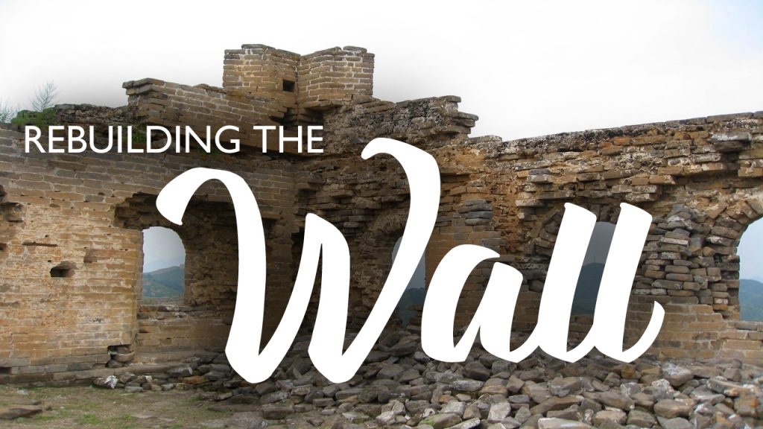
In today’s passage, we will learn how the people had engaged in the work of rebuilding the walls despite troubles. They beautifully pitched in the work on a volunteer basis. The most important ability in the work of the LORD is availability. The one with few gifts and little talent, but with a passion and a desire to see God’s work done, will accomplish far more than a gifted and talented person who doesn’t have desire to do the LORD’s work. May the Lord help each of us to chip in God’s work. May the Lord help us to be more than willing to serve God together with one spirit and one mind!

1. Read 2:11-20. What did Nehemiah do when he arrived in Jerusalem? (2:11-16) How did he encourage the people in Jerusalem? (2:17-18a) What was their response? (2:18b) What did Nehemiah say to the opponents? (2:19-20)

1-1, Read 2:11-20.

I went to Jerusalem, and after staying there three days 12 I set out during the night with a few others. I had not told anyone what my God had put in my heart to do for Jerusalem. There were no mounts with me except the one I was riding on.
13 By night I went out through the Valley Gate toward the Jackal Well and the Dung Gate, examining the walls of Jerusalem, which had been broken down, and its gates, which had been destroyed by fire.14 Then I moved on toward the Fountain Gate and the King’s Pool, but there was not enough room for my mount to get through; 15 so I went up the valley by night, examining the wall. Finally, I turned back and re entered through the Valley Gate. 16 The officials did not know where I had gone or what I was doing, because as yet I had said nothing to the Jews or the priests or nobles or officials or any others who would be doing the work. 17 Then I said to them, “You see the trouble we are in: Jerusalem lies in ruins, and its gates have been burned with fire. Come, let us rebuild the wall of Jerusalem, and we will no longer be in disgrace.” 18 I also told them about the gracious hand of my God on me and what the king had said to me. They replied, “Let us start rebuilding.” So they began this good work. 19 But when Sanballat the Horonite, Tobiah the Ammonite official and Geshem the Arab heard about it, they mocked and ridiculed us. “What is this you are doing?” they asked. “Are you rebelling against the king?” 20 I answered them by saying, “The God of heaven will give us success. We his servants will start rebuilding, but as for you, you have no share in Jerusalem or any claim or historic right to it.”

1-2, What did Nehemiah do when he arrived in Jerusalem? (2:11-16)

I went to Jerusalem, and after staying there three days 12 I set out during the night with a few others. I had not told anyone what my God had put in my heart to do for Jerusalem. There were no mounts with me except the one I was riding on. 13 By night I went out through the Valley Gate toward the Jackal Well and the Dung Gate, examining the walls of Jerusalem, which had been broken down, and its gates, which had been destroyed by fire.14 Then I moved on toward the Fountain Gate and the King’s Pool, but there was not enough room for my mount to get through; 15 so I went up the valley by night, examining the wall. Finally, I turned back and re entered through the Valley Gate. 16 The officials did not know where I had gone or what I was doing, because as yet I had said nothing to the Jews or the priests or nobles or officials or any others who would be doing the work.

- Nehemiah arrived in Jerusalem and he took time to recover from his journey and then began to examine the extent of the problem he faced. He arose at night and with a few trusted companions inspected the wall. He did his inspection quietly and let no one, particularly no enemies know what God had put in his heart.
- Then he thoroughly inspected during the night. He saw for himself what needed to be done. Acknowledging our problems is painful. But for the sake of rebuilding, we have to go through thorough assessment first.

1-3, How did he encourage the people in Jerusalem? (2:17-18a)

17 Then I said to them, “You see the trouble we are in: Jerusalem lies in ruins, and its gates have been burned with fire. Come, let us rebuild the wall of Jerusalem, and we will no longer be in disgrace.” 18 I also told them about the gracious hand of my God on me and what the king had said to me. They replied, “Let us start rebuilding.” So they began this good work.

- After exploring the extent of the problem, he began to involve others in this work. No doubt, Nehemiah alone could not do this good work. He had to involve others. So he appealed to their innermost desire to live for God and his glory by saying, “Look at the ruin around you.”
- That ruins had been there for almost one hundred years. In effect he was saying, “Enough is enough. It is disgraceful to live with the ruins. So let’s begin to act now.” He appealed to them with his testimony that God had already helped them and was with them.
- So now was the time to roll up the sleeves and act. Until that time, the returnees had stopped believing and hoping that their circumstances could change. They had learned to live with broken walls, fear and shame.

1-4, What was their response? (2:18b) What did Nehemiah say to the opponents? (2:19-20)

But when Sanballat the Horonite, Tobiah the Ammonite official and Geshem the Arab heard about it, they mocked and ridiculed us. “What is this you are doing?” they asked. “Are you rebelling against the king?”
- But through Nehemiah’s words and his experience of God’s grace they were all filled with desire to do the work and replied, “Let us start rebuilding.”
- Nehemiah inspired the people by pointing them back to God’s activity and God’s power. Those who have desire to live for God’s glory are spiritual leaders.
- If we are willing to live for God’s glory we can be spiritual leaders and encourage others and involve them in the work of rebuilding our church.
- Rebuilding and recovering work cannot be done unless we all come together in one heart and spirit. “Let us start rebuilding,” and let’s get to work together.

- When God’s people started the rebuilding work, then the enemies mocked and ridiculed them, saying, “What is this you are doing? Are you rebelling against the king?”
- It is almost natural that when God’s work is going on strongly, opposition will also come strongly. It is the real and powerful work of God that God’s people come together and work for God and his glory together.

20 I answered them by saying, “The God of heaven will give us success. We his servants will start rebuilding, but as for you, you have no share in Jerusalem or any claim or historic right to it.”

2. Read 3:1-7. Who is mentioned first among those rebuilding the wall? (3:1) Who took part in rebuilding the wall? (3:2-5a, 6, 7) Who did not put their shoulders to the work? (3:5b) What might lead the people from surrounding towns to participate? (2, 5a, 7)

2-1, Read 3:1-7.

Eliashib the high priest and his fellow priests went to work and rebuilt the Sheep Gate. They dedicated it and set its doors in place, building as far as the Tower of the Hundred, which they dedicated, and as far as the Tower of Hananel. 2 The men of Jericho built the adjoining section, and Zakkur son of Imri built next to them.
3 The Fish Gate was rebuilt by the sons of Hassenaah. They laid its beams and put its doors and bolts and bars in place. 4 Meremoth son of Uriah, the son of Hakkoz, repaired the next section. Next to him Meshullam son of Berekiah, the son of Meshezabel, made repairs, and next to him Zadok son of Baana also made repairs. 5 The next section was repaired by the men of Tekoa, but their nobles would not put their shoulders to the work under their supervisors. 6 The Jeshanah[b] Gate was repaired by Joiada son of Paseah and Meshullam son of Besodeiah. They laid its beams and put its doors with their bolts and bars in place. 7 Next to them, repairs were made by men from Gibeon and Mizpah—Melatiah of Gibeon and Jadon of Meronoth—places under the authority of the governor of Trans-Euphrates.

2-2, Who is mentioned first among those rebuilding the wall? (3:1)

Eliashib the high priest and his fellow priests went to work and rebuilt the Sheep Gate. They dedicated it and set its doors in place, building as far as the Tower of the Hundred, which they dedicated, and as far as the Tower of Hananel.

- High Priest Eliashib and his fellow priests first went to work. They put off their priest robes and put on jeans and construction booths. They rebuilt the Sheep Gate and dedicated it to God.
- Setting a good example is very important, especially among the leaders in the community.

2-3, Who took part in rebuilding the wall? (3:2-5a, 6, 7)

The men of Jericho built the adjoining section, and Zakkur son of Imri built next to them. 3 The Fish Gate was rebuilt by the sons of Hassenaah. They laid its beams and put its doors and bolts and bars in place. 4 Meremoth son of Uriah, the son of Hakkoz, repaired the next section. Next to him Meshullam son of Berekiah, the son of Meshezabel, made repairs, and next to him Zadok son of Baana also made repairs. 5 The next section was repaired by the men of Tekoa, but their nobles would not put their shoulders to the work under their supervisors. 6 The Jeshanah Gate was repaired by Joiada son of Paseah and Meshullam son of Besodeiah. They laid its beams and put its doors with their bolts and bars in place. 7 Next to them, repairs were made by men from Gibeon and Mizpah—Melatiah of Gibeon and Jadon of Meronoth—places under the authority of the governor of Trans-Euphrates.

- It is very remarkable to see sons doing the work of God actively, even doing the hard work putting heavy beams(verse 3).
- Verse 4 shows two names of third generation. In fact, it is great joy see our second gens doing God’s work by obeying UBF world mission and campus mission. Even we must see vision to see our 3rd gens doing the work.
- We continually pray that God may help us to see the great work of God arising among us and California campuses may be pioneered.

2-4, Who did not put their shoulders to the work? (3:5b)

but their nobles would not put their shoulders to the work under their supervisors.

- Nobles was unwilling to participate. Even though the Tekoites are willing to do the work, but their nobles did not take part in the work. For they think they are nobles and they are high and mighty.
- The high priest were working and the district leaders joined. The children of the nobles joined willing. Even the daughters are willing to do their part. What makes them think that they are so noble and are unable to shoulder the responsibility?”
- But the bible tells us that the Tekoites were unaffected by their nobles who refuse to take up the work, even if it means that they must do extra work due to them. In fact, the Tekoites did 2 sections of the wall. (V27)

2-5, What might lead the people from surrounding towns to participate? (2, 5a, 7)

The men of Jericho built the adjoining section, and Zakkur son of Imri built next to them.

The next section was repaired by the men of Tekoa,

Next to them, repairs were made by men from Gibeon and Mizpah—Melatiah of Gibeon and Jadon of Meronoth—places under the authority of the governor of Trans-Euphrates.

- No matter how different backgrounds or places they might have, Nehemiah welcomed them to chip in the work of God.
- It was a very effective leadership from Nehemiah who encouraged neighboring people to join in the work of God.

3. Read 3:8-32. Describe how the Israelite families rebuilt the city wall. (3:8-32) What can we learn from Shallum’s daughters? (12) How did each of the people fulfill his task with a sense of responsibility? In what ways should co-working in the gospel ministry resemble this wall building work? (1 Cor 12:12-27)

3-1, Read 3:8-32.

Uzziel son of Harhaiah, one of the goldsmiths, repaired the next section; and Hananiah, one of the perfume-makers, made repairs next to that. They restored Jerusalem as far as the Broad Wall. 9 Rephaiah son of Hur, ruler of a half-district of Jerusalem, repaired the next section.10 Adjoining this, Jedaiah son of Harumaph made repairs opposite his house, and Hattush son of Hashabneiah made repairs next to him. 11 Malkijah son of Harim and Hasshub son of Pahath-Moab repaired another section and the Tower of the Ovens. 12 Shallum son of Hallohesh, ruler of a half-district of Jerusalem, repaired the next section with the help of his daughters. 13 The Valley Gate was repaired by Hanun and the residents of Zanoah. They rebuilt it and put its doors with their bolts and bars in place. They also repaired a thousand cubits[c] of the wall as far as the Dung Gate.
14 The Dung Gate was repaired by Malkijah son of Rekab, ruler of the district of Beth Hakkerem. He rebuilt it and put its doors with their bolts and bars in place.
15 The Fountain Gate was repaired by Shallun son of Kol-Hozeh, ruler of the district of Mizpah. He rebuilt it, roofing it over and putting its doors and bolts and bars in place. He also repaired the wall of the Pool of Siloam,[d] by the King’s Garden, as far as the steps going down from the City of David. 16 Beyond him, Nehemiah son of Azbuk, ruler of a half-district of Beth Zur, made repairs up to a point opposite the tombs[e] of David, as far as the artificial pool and the House of the Heroes.
17 Next to him, the repairs were made by the Levites under Rehum son of Bani. Beside him, Hashabiah, ruler of half the district of Keilah, carried out repairs for his district. 18 Next to him, the repairs were made by their fellow Levites under Binnui[f] son of Henadad, ruler of the other half-district of Keilah.19 Next to him, Ezer son of Jeshua, ruler of Mizpah, repaired another section, from a point facing the ascent to the armory as far as the angle of the wall. 20 Next to him, Baruch son of Zabbai zealously repaired another section, from the angle to the entrance of the house of Eliashib the high priest. 21 Next to him, Meremoth son of Uriah, the son of Hakkoz, repaired another section, from the entrance of Eliashib’s house to the end of it.
22 The repairs next to him were made by the priests from the surrounding region. 23 Beyond them, Benjamin and Hasshub made repairs in front of their house; and next to them, Azariah son of Maaseiah, the son of Ananiah, made repairs beside his house. 24 Next to him, Binnui son of Henadad repaired another section, from Azariah’s house to the angle and the corner, 25 and Palal son of Uzai worked opposite the angle and the tower projecting from the upper palace near the court of the guard. Next to him, Pedaiah son of Parosh 26 and the temple servants living on the hill of Ophel made repairs up to a point opposite the Water Gate toward the east and the projecting tower. 27 Next to them, the men of Tekoa repaired another section, from the great projecting tower to the wall of Ophel.
28 Above the Horse Gate, the priests made repairs, each in front of his own house. 29 Next to them, Zadok son of Immer made repairs opposite his house. Next to him, Shemaiah son of Shekaniah, the guard at the East Gate, made repairs. 30 Next to him, Hananiah son of Shelemiah, and Hanun, the sixth son of Zalaph, repaired another section. Next to them, Meshullam son of Berekiah made repairs opposite his living quarters. 31 Next to him, Malkijah, one of the goldsmiths, made repairs as far as the house of the temple servants and the merchants, opposite the Inspection Gate, and as far as the room above the corner; 32 and between the room above the corner and the Sheep Gate the goldsmiths and merchants made repairs.

3-2, Describe how the Israelite families rebuilt the city wall. (3:8-32)

8 Uzziel son of Harhaiah, one of the goldsmiths, repaired the next section; and Hananiah, one of the perfume-makers, made repairs next to that. They restored Jerusalem as far as the Broad Wall. 9 Rephaiah son of Hur, ruler of a half-district of Jerusalem, repaired the next section.10 Adjoining this, Jedaiah son of Harumaph made repairs opposite his house, and Hattush son of Hashabneiah made repairs next to him. 11 Malkijah son of Harim and Hasshub son of Pahath-Moab repaired another section and the Tower of the Ovens. 12 Shallum son of Hallohesh, ruler of a half-district of Jerusalem, repaired the next section with the help of his daughters.
13 The Valley Gate was repaired by Hanun and the residents of Zanoah. They rebuilt it and put its doors with their bolts and bars in place. They also repaired a thousand cubits[c] of the wall as far as the Dung Gate.
14 The Dung Gate was repaired by Malkijah son of Rekab, ruler of the district of Beth Hakkerem. He rebuilt it and put its doors with their bolts and bars in place.
15 The Fountain Gate was repaired by Shallun son of Kol-Hozeh, ruler of the district of Mizpah. He rebuilt it, roofing it over and putting its doors and bolts and bars in place. He also repaired the wall of the Pool of Siloam,[d] by the King’s Garden, as far as the steps going down from the City of David. 16 Beyond him, Nehemiah son of Azbuk, ruler of a half-district of Beth Zur, made repairs up to a point opposite the tombs[e] of David, as far as the artificial pool and the House of the Heroes.
17 Next to him, the repairs were made by the Levites under Rehum son of Bani. Beside him, Hashabiah, ruler of half the district of Keilah, carried out repairs for his district. 18 Next to him, the repairs were made by their fellow Levites under Binnui[f] son of Henadad, ruler of the other half-district of Keilah.19 Next to him, Ezer son of Jeshua, ruler of Mizpah, repaired another section, from a point facing the ascent to the armory as far as the angle of the wall. 20 Next to him, Baruch son of Zabbai zealously repaired another section, from the angle to the entrance of the house of Eliashib the high priest. 21 Next to him, Meremoth son of Uriah, the son of Hakkoz, repaired another section, from the entrance of Eliashib’s house to the end of it.
22 The repairs next to him were made by the priests from the surrounding region. 23 Beyond them, Benjamin and Hasshub made repairs in front of their house; and next to them, Azariah son of Maaseiah, the son of Ananiah, made repairs beside his house. 24 Next to him, Binnui son of Henadad repaired another section, from Azariah’s house to the angle and the corner, 25 and Palal son of Uzai worked opposite the angle and the tower projecting from the upper palace near the court of the guard. Next to him, Pedaiah son of Parosh 26 and the temple servants living on the hill of Ophel made repairs up to a point opposite the Water Gate toward the east and the projecting tower. 27 Next to them, the men of Tekoa repaired another section, from the great projecting tower to the wall of Ophel.
28 Above the Horse Gate, the priests made repairs, each in front of his own house. 29 Next to them, Zadok son of Immer made repairs opposite his house. Next to him, Shemaiah son of Shekaniah, the guard at the East Gate, made repairs. 30 Next to him, Hananiah son of Shelemiah, and Hanun, the sixth son of Zalaph, repaired another section. Next to them, Meshullam son of Berekiah made repairs opposite his living quarters. 31 Next to him, Malkijah, one of the goldsmiths, made repairs as far as the house of the temple servants and the merchants, opposite the Inspection Gate, and as far as the room above the corner; 32 and between the room above the corner and the Sheep Gate the goldsmiths and merchants made repairs.

- Overall we can realize that all kinds of people were willing to participate in rebuilding the walls together with one spirit.
- Goldsmiths and perfume maker, or merchants were probably popular occupation those days. But they sacrificially took part in the work of God without seeking their personal interest.
- The men of Tekoa(verse 27) went extra miles to build other section. What a good example they showed.
- There are several names among leaders(rulers) in different districts. (verses 17-19) They usually gave orders to others to let them do this and that. But they participated in hard manual labor as a good example even by taking hard work to bring material to the higher ground. (verse 19)
- All people worked for the glory of God, not for Nehemiah only. It reminds us of Colossian 4:1 that they must have worked before God, their true Master.

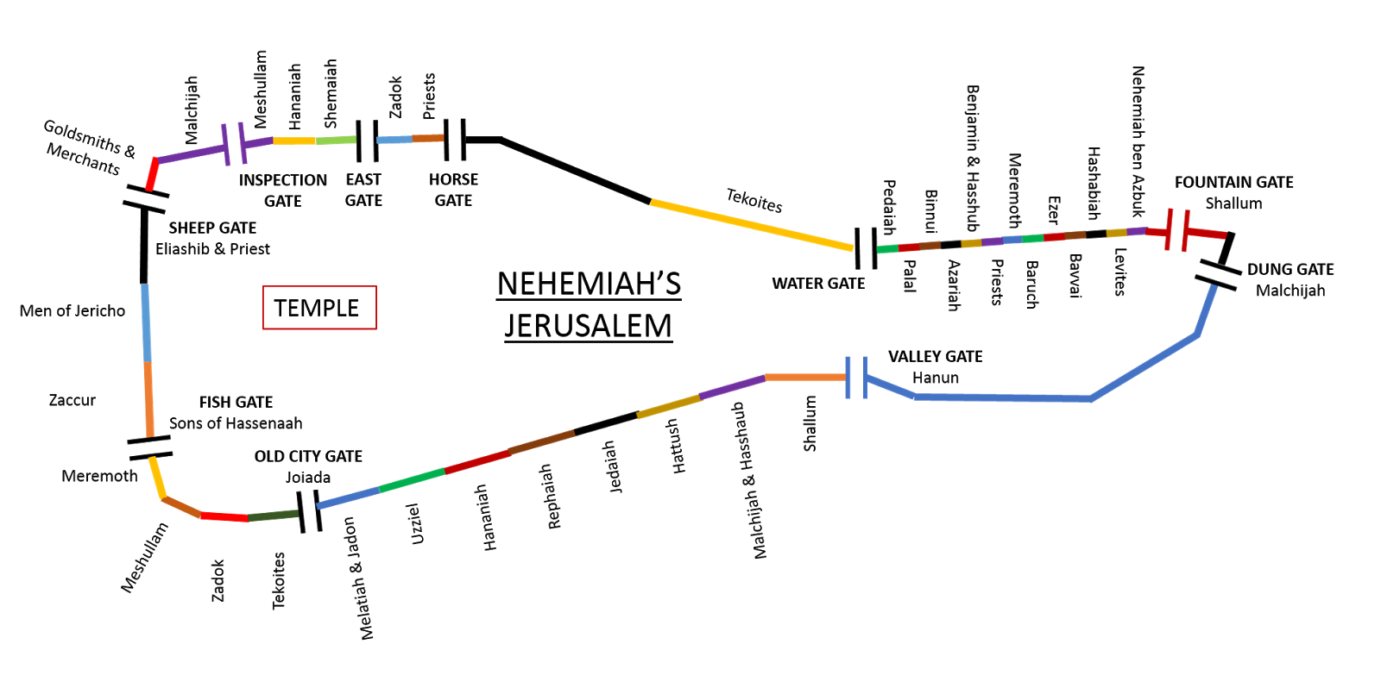

3-3, What can we learn from Shallum’s daughters? (12)

Shallum son of Hallohesh, ruler of a half-district of Jerusalem, repaired the next section with the help of his daughters.

- Women were willing to participate in the hard manual labor. They somehow helped the people such as by bringing drinking water.

3-4, How did each of the people fulfill his task with a sense of responsibility?

- For this building project, everyone was involved. God’s work cannot be done by one person.
- It is the work of cooperation among God’s people. Rebuilding the church and God’s work required everyone’s involvement.
- God’s work needs all kinds of people. Some may ask, “What could perfume makers do in repairing the wall. Could priests lift the hammer and properly handle it? But somehow God used them all.
- For building the church there is a job for everyone. Just as each person was assigned only a certain section of the wall, you and I are called to work in a certain part of work of God.
- When each of us works together for the each section, the rebuilding project will be done joyfully and effectively.

- By the way, all of them were volunteers. Some of them were eager to do more work after finishing their sections and went on to repair another sections.
- God uses all kinds of people, but they must have willingness and volunteer spirit. Always, God needs/wants volunteers who can give their best to God for his glory.

3-5, In what ways should co-working in the gospel ministry resemble this wall building work? (1 Cor 12:12-27)

Just as a body, though one, has many parts, but all its many parts form one body, so it is with Christ.13 For we were all baptized by one Spirit so as to form one body—whether Jews or Gentiles, slave or free—and we were all given the one Spirit to drink. 14 Even so the body is not made up of one part but of many.
15 Now if the foot should say, “Because I am not a hand, I do not belong to the body,” it would not for that reason stop being part of the body. 16 And if the ear should say, “Because I am not an eye, I do not belong to the body,” it would not for that reason stop being part of the body. 17 If the whole body were an eye, where would the sense of hearing be? If the whole body were an ear, where would the sense of smell be? 18 But in fact God has placed the parts in the body, every one of them, just as he wanted them to be. 19 If they were all one part, where would the body be? 20 As it is, there are many parts, but one body.
21 The eye cannot say to the hand, “I don’t need you!” And the head cannot say to the feet, “I don’t need you!” 22 On the contrary, those parts of the body that seem to be weaker are indispensable, 23 and the parts that we think are less honorable we treat with special honor. And the parts that are unpresentable are treated with special modesty, 24 while our presentable parts need no special treatment. But God has put the body together, giving greater honor to the parts that lacked it, 25 so that there should be no division in the body, but that its parts should have equal concern for each other. 26 If one part suffers, every part suffers with it; if one part is honored, every part rejoices with it.
27 Now you are the body of Christ, and each one of you is a part of it.

Ephesians 4:11-12 also reads,

“And He Himself gave some to be apostles, some prophets, some evangelists, and some pastors and teachers, for the equipping of the saints for the work of ministry,
for the edifying of the body of Christ,”

Conclusion

We thank God for giving us the rebuilding work of God in our church. For this work, let us come together. Let us execute this holy project for God’s glory, setting aside our differences and personal interest and seeking first His Kingdom.

One word: Let us rebuild the wall!

