BY REVELATION FROM JESUS CHRIST

Galatians 1:11-24
Key Verse 12

“I did not receive it from any man, nor was I taught it; rather, I received it by revelation from Jesus Christ.”

Introduction

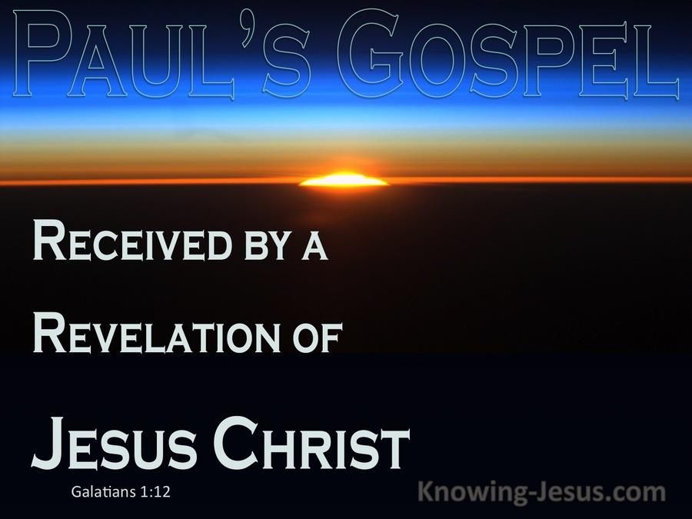

In the Galatian church some teachers confused the believers by mixing works with faith, and the law with the gospel. They wanted to please the Jews whom they wanted to keep on their side, avoiding their opposition. In his letter Paul states that both his mission and the gospel he preached were divine. This was to do away with the false charge brought on by his enemies. Paul was adamant about restoring the believers’ reliance upon the gospel which he had preached to them. Through Paul’s personal testimony, we can be sure that the gospel we received is the absolute truth originating from God. Also we can learn from his personal conviction about God’s unique calling and mission to preach to the Gentiles even though this idea was very unpopular in those days. It is amazing to see our God working in any and every generation. As Jesus meant business in raising a handful of disciples, God is working in raising His servants to defend and expand His gospel.

1. Read verses 11-14. What did Paul want the believers to know about the gospel? (11) How did Paul himself receive the gospel? (12) How did he persecute the church? (13) How passionate was he about Judaism and its traditions? (14)

1-1. Read verses 11-14.

I want you to know, brothers and sisters, that the gospel I preached is not of human origin. 12 I did not receive it from any man, nor was I taught it; rather, I received it by revelation from Jesus Christ. 13 For you have heard of my previous way of life in Judaism, how intensely I persecuted the church of God and tried to destroy it. 14 I was advancing in Judaism beyond many of my own age among my people and was extremely zealous for the traditions of my fathers.

1-2. What did Paul want the believers to know about the gospel? (11)

“The gospel I preached is not of human origin”

- About the way he received the gospel - He assured the believers that he received the gospel not merely from other men, but by revelation from heaven.
- Paul did not attend a seminary school, nor did he hear popular sermons to receive the gospel of Jesus Christ. He studied Judaism under his teacher Gamaliel who was a prominent scholar in Jerusalem.
- But Paul did not receive the gospel from any man or in any conventional way. Rather, this revelation was from God. Paul received the gospel by the direct revelation of Christ Jesus. The gospel of Jesus is not man made, nor designed by any human, but it comes directly from God.

1-3. How did Paul himself receive the gospel? (12)

“I did not receive it from any man, nor was I taught it; rather, I received it by revelation from Jesus Christ”

- Paul assured them that he received knowledge of the gospel directly from the Lord Jesus: the gospel which he preached was not from man; he neither received it of man, nor was he taught it by man, but by direct inspiration, or revelation from Christ himself.
- Paul had never received the gospel from someone even from Jesus’ disciples. Nobody helped him to understand the gospel.
- Rather he received the gospel directly from Jesus through revelation. Jesus chose Paul as his apostle to preach the gospel to the Gentiles and revealed the gospel to him directly.
- In short, Paul's message was not a man's attempt to understand God. Rather it was God's effort to stoop down and communicate with man.
- Men may have many things to teach us, but God's revelation teaches us all things pertaining to life and Godliness

2 Peter 1:3-4 reads,
“His divine power has given us everything we need for a godly life through our knowledge of him who called us by his own glory and goodness. 4 Through these he has given us his very great and precious promises, so that through them you may participate in the divine nature, having escaped the corruption in the world caused by evil desires.”
- We needs revelation from God rather than just good advice or wisdom coming from men.
- We have thankfully God’s complete revelation in and through the Bible. We know that the Bible is reliable, accurate and trustworthy.
- Jesus clarified in John 16 about how His disciples would be revealed or enlightened through the help of the Holy Spirit. Jesus had vision for them to grow as independent Bible teachers.
John 16:12-15 reads,
“I have much more to say to you, more than you can now bear. 13 But when he, the Spirit of truth, comes, he will guide you into all the truth. He will not speak on his own; he will speak only what he hears, and he will tell you what is yet to come. 14 He will glorify me because it is from me that he will receive what he will make known to you. 15 All that belongs to the Father is mine. That is why I said the Spirit will receive from me what he will make known to you.”

1-4. How did he persecute the church? (13)

“ how intensely I persecuted the church of God and tried to destroy it”

- Paul elaborated his personal story here. Paul had been exceedingly zealous for the traditions of the Jews. In his zeal, he not only rejected the gospel and the church, but had been a persecutor of them too.
- It was God’s amazing grace that caused such a persecutor to become an apostle.
- God’s calling for him must have been something extraordinary that it changed him so dramatically. It conquered the prejudices of his education and caused him even to preach the very gospel that he had once so vehemently opposed.
- In a wonderful manner he was turned from his wrong way to the faith of Christ and appointed to the mission to preach to the Gentiles.

1-5. How passionate had he been about Judaism and its traditions? (14)

“I was advancing in Judaism beyond many of my own age among my people and was extremely zealous for the traditions of my fathers.”

- Paul had been so zealous for Judaism more than anyone else even more than the false teachers who had been trying to promote Judaism in the church.
- But his great and dramatic change shows that he had an extraordinary experience. He was convicted so strongly about the truth of the gospel. It wa through the revelation from Jesus Christ.
- If he had not received the gospel so powerfully through this revelation, he could not have converted.
- Paul’s dramatic change, accomplished by God, only goes to prove that the gospel he preached came from God.

2. Read verses 15-17. What was the purpose of God’s calling for Paul? (15, 16a) Why might he choose to go to Arabia first after he was called? (16b, 17)

2-1. Read verses 15-17.

But when God, who set me apart from my mother’s womb and called me by his grace, was pleased 16 to reveal his Son in me so that I might preach him among the Gentiles, my immediate response was not to consult any human being. 17 I did not go up to Jerusalem to see those who were apostles before I was, but I went into Arabia. Later I returned to Damascus.

2-2. What was the purpose of God’s calling for Paul? (15, 16a)

“ But when God, who set me apart from my mother’s womb and called me by his grace, was pleased To reveal his Son in me so that I might preach him among the Gentiles”

- God had chosen him even from the time he was in his mother’s womb: the change that happened in him was in pursuance of a divine purpose concerning him. He was appointed to be an apostle, even before he came into the world.
- He was called by God’s grace. All who are converted are called by the grace of God; their conversion is put into effect by God’s power and grace working in them.
- His calling was rendered a more special and extraordinary instance of divine power and favor.
- God revealed the gospel to him with a clear purpose, which was to deliver the gospel of Jesus to the Gentiles.
- Paul didn’t volunteer to be an apostle. It was God’s divine plan. And God revealed his Son to fulfill his purpose for him.

2-3. Why might he choose to go to Arabia first after he was called? (16b, 17)

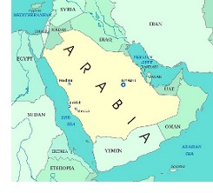
“but I went into Arabia”

- He did not consult men. He did not turn to anyone for advice or direction. He also didn’t go up to Jerusalem, to those that were apostles before him, as though he needed to be approved by them, or to receive any further instructions or authority from them. But, instead, he steered a completely different course, and went into Arabia for receiving further divine revelations.
- He wanted to receive further revelation from God through solitary, personal, fellowship with God and to make sure that the gospel was really God-originated. Also he might have wanted to receive the gospel directly from God instead of being taught from others.

- We shouldn't think that Paul is saying here that it is wrong to hear of the gospel through others or Bible teachers, or that those who do have an inferior salvation. The point is simply that the gospel Paul preached was not a gospel of man.

- People are dependent upon nice sermons or famous preachers. They need to read the Bible and grow as independent Bible teachers to discern the words of God.

2 Timothy 2:15 reads,

“Do your best to present yourself to God as one approved, a worker who does not need to be ashamed and who correctly handles the word of truth.”

- During this period of time, Paul prepared himself for his ministry to the Gentiles.
- He returned again to Damascus, where he had first begun his ministry, and where he had barely escaped the rage of his enemies

3. Read verses 18-24. Who were the only people whom Paul met in Jerusalem? (18, 19) What did he try to assure them about? (20) Why did the believers praise God because of Paul? (21-24)

3-1. Read verses 18-24.

Then after three years, I went up to Jerusalem to get acquainted with Cephas and stayed with him fifteen days. 19 I saw none of the other apostles—only James, the Lord’s brother. 20 I assure you before God that what I am writing you is no lie. 21 Then I went to Syria and Cilicia. 22 I was personally unknown to the churches of Judea that are in Christ. 23 They only heard the report: “The man who formerly persecuted us is now preaching the faith he once tried to destroy.” 24 And they praised God because of me.

3-2. Who were the only people whom Paul met in Jerusalem? (18, 19)

get acquainted with Cephas and stayed with him fifteen days. 19 I saw none of the other apostles—only James, the Lord’s brother.

- His visiting was not intended to get some approval or authority from men. He might have wanted to know more about Jesus and build up his relationship with brothers in the Lord.

- 2 Timothy 2:7-9 reads, “Consider what I am saying, for the Lord will give you insight into all things. 8 Remember Jesus Christ, raised from the dead, descended from David, as proclaimed by my gospel, 9for which I suffer to the extent of being chained like a criminal. But the word of God cannot be chained” Paul pointed out “my gospel”. Why? It was because he fought the good fight, to live in accordance with the gospel truth no matter what.
- What might have caused Paul to visit Jerusalem? Paul’s case was that God had given him a unique announcement for a unique part of the world — a unique gospel, because he was commanded by Jesus Christ to preach the gospel to the Gentiles.
- As a matter of fact, it was not a unique gospel. In a dream God had already asked Peter to kill and eat unclean animals. At the other side of the coin, God was working through a leader of the church, Peter, to accept the will of God for the Gentiles.
- At God’s due time, both of them were able to meet according to the help of the Holy Spirit. So Paul’s unique gospel to be accepted by the apostles and the church at large in order for it to have any authority.

- So Paul is going to build a case for the source, founding, and authority of his gospel. He is going to tell the story of how he received it, how he checked it, and how the leadership of the early church agreed that Paul’s gospel is in complete agreement with their understanding of what God is doing in His Kingdom through Jesus.
- It is like an auto mechanic doing alignment.

3-3. What did he try to assure them about? (20)

“what I am writing you is no lie”

- Paul declared, as in the presence of God, that what he had said was strictly true, and that he had not in the least falsified what he had said.

3-4. Why did the believers praise God because of Paul? (21-24)

“persecuted us is now preaching the faith he once tried to destroy”

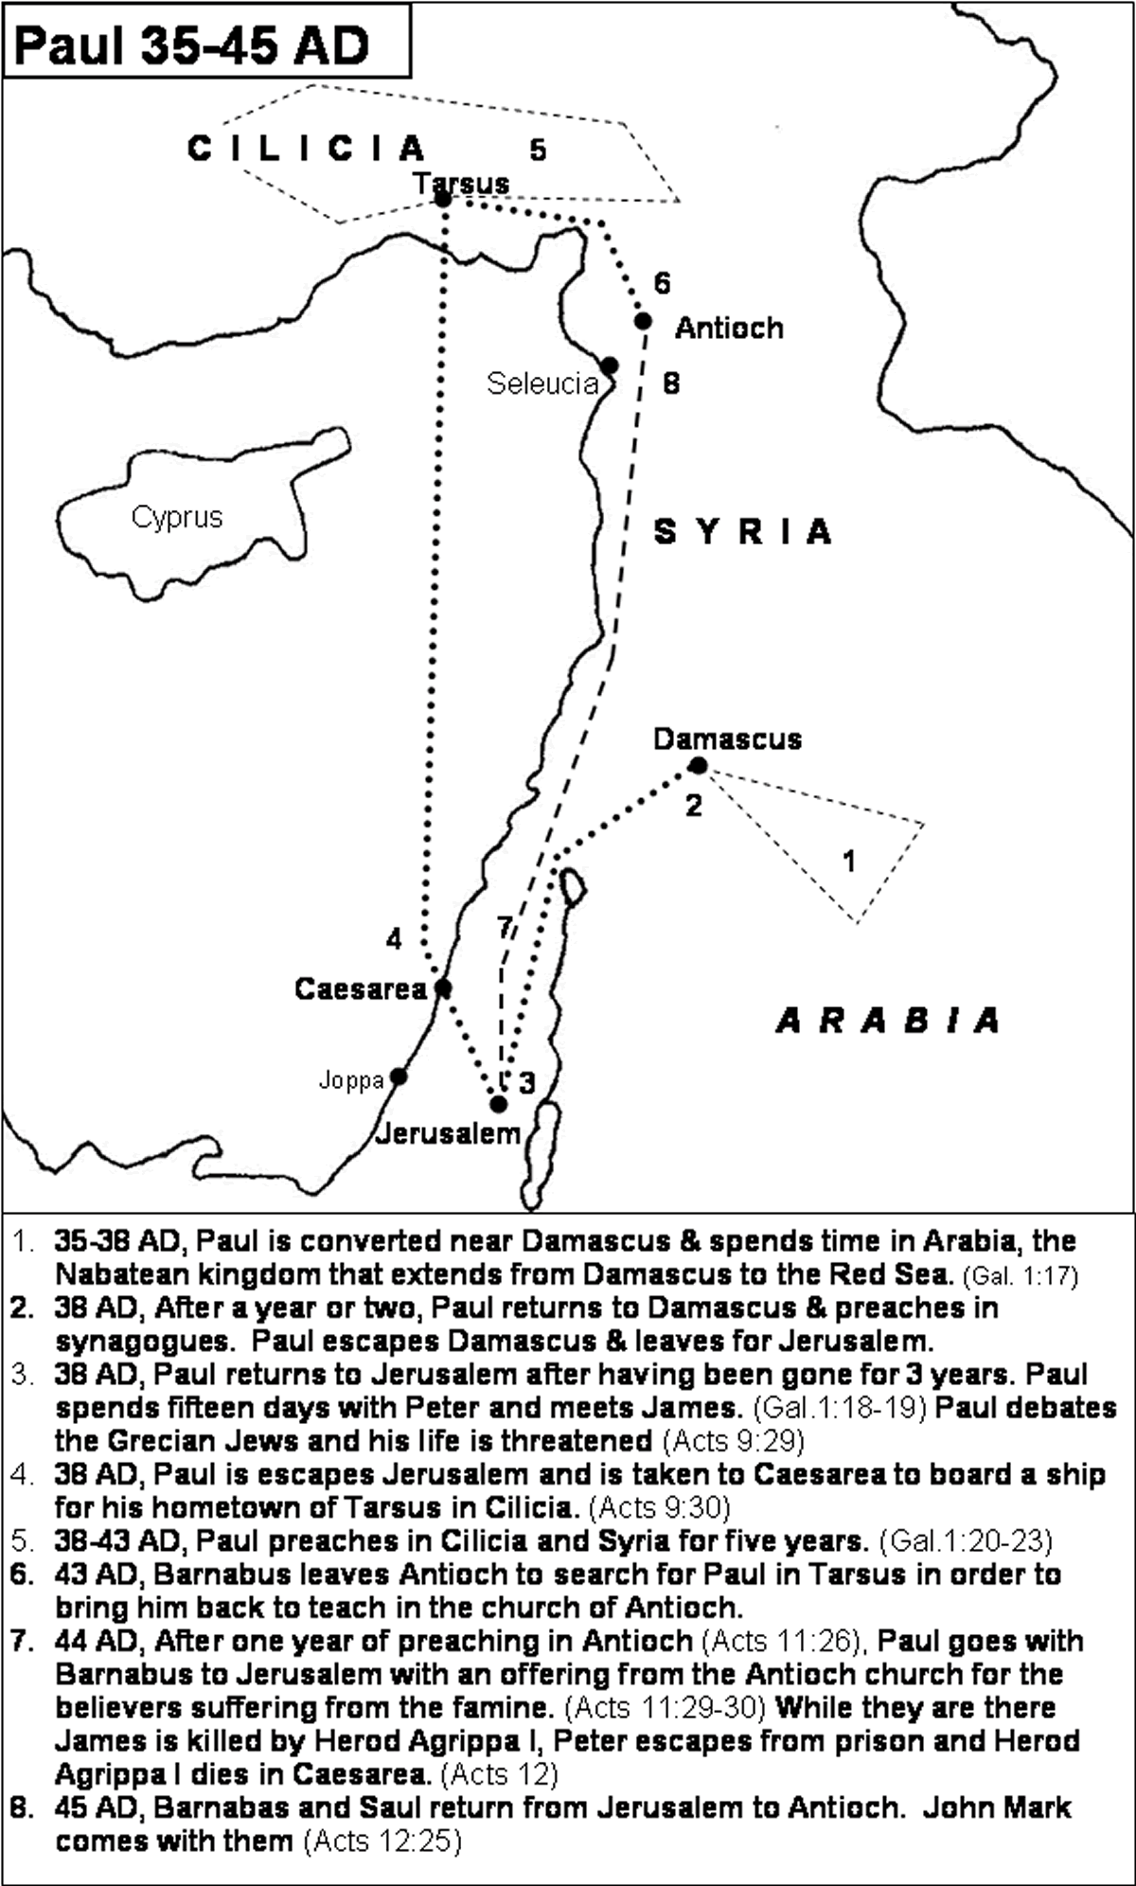
- Paul came into the regions of Syria and Cilicia: having made this short visit to Peter, he returns to his work again.
- He had no communication at that time with the churches of Christ in Judea, but, having heard that he who persecuted them in times past now preached the gospel, the believers glorified God because of him.
- Paul mentioned his change again to prove that everything that had happened to him was the work of God. He was changed through the gospel that he had received from Jesus directly.

Conclusion

Paul's whole point in the second part of this chapter is important. His gospel was true, and his experience was valid, because it really came from God. Only what comes from God can really save us and make a lasting difference in our lives. May the Lord raise up many Bible teachers who can discern the gospel truth in this evil and confusing generation. May the Lord richly bless our upcoming conference so that we may be enlightened with the living Words of Jesus Christ! Amen.

One word: by revelation from Jesus Christ

