THE FULL ARMOUR OF GOD

Ephesians 6:10-24
Key Verse: 13

“Therefore put on the full armor of God, so that when the day of evil comes, you may be able to stand your ground, and after you have done everything, to stand.”

Introduction

This passage is Apostle Paul’s final encouragement for Ephesian believers. Paul said that the believers are engaged in spiritual warfare against evil powers in this dark world. For this reason, he encouraged them to put on the full armor of God in preparing to fight this spiritual battle. He also asked the believers to pray for him to preach the gospel fearlessly. Through his exhortation, we can learn how to prepare ourselves to defeat Satan’s attacks and win the victory in doing God’s work.

1. Read verses 10- 12. What is Paul’s final encouragement for the believers? (10) What should we do to stand against the devil’s schemes? (11) What are we supposed to struggle against? (12)

1-1. Read verses 10- 12.

Finally, be strong in the Lord and in his mighty power. 11 Put on the full armor of God, so that you can take your stand against the devil’s schemes. 12 For our struggle is not against flesh and blood, but against the rulers, against the authorities, against the powers of this dark world and against the spiritual forces of evil in the heavenly realms.

1-2. What is Paul’s final encouragement for the believers? (10)

Finally,
- This comes at the end of the letter.
Be strong in the Lord and in his mighty power.

- If we are weak, we can barely stand. Though we wear the best armour, we could still be ineffective soldiers. Equipping each believer for Christian combat must begin with being strong in the Lord and in the power of His might.
- Before a soldier is given a gun or shown how to fire a missile, he goes through basic training. One great purpose for basic training is the build up the recruit's physical strength.
- This involves much spiritual struggle until we enter the kingdom of God. During our lives here on earth, we will undergo many of Satan’s attacks and face many problems. We should be strong to overcome all these, be strong for service, be strong for suffering, and be strong for the battle.
- We cannot rely merely on human strength and power, especially as we fight against evil powers and serve God’s work.
- Instead we must be truly strong in the Lord and in his mighty power. When we remain in the Lord and trust and rely on his power, we can be empowered to be strong enough to defeat any evil attack.
- God’s power is mighty. It is the only power that can overcome any form evil power. It is the only kind of power sufficient to help us do any kind of work. God gives us power through the Holy Spirit.

1-3. What should we do to stand against the devil’s schemes? (11)

Put on the full armor of God.

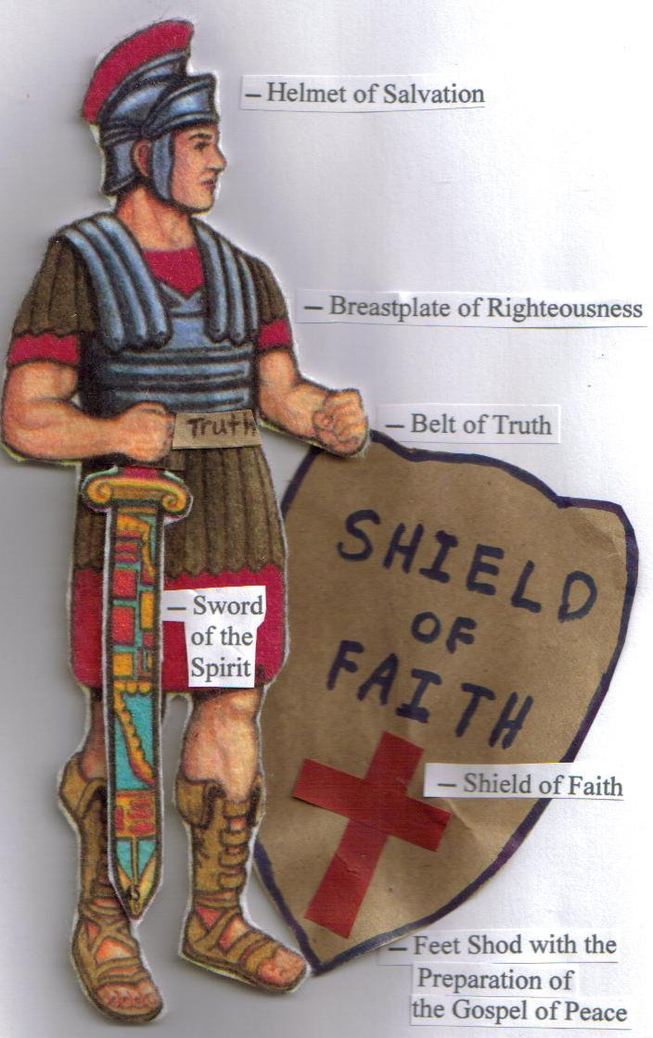
- Full armor : all the instruments and tools that a soldier needs to fight in battle, whether for defense or offence. A soldier needs full armor without missing anything and he needs to prepare these tools in advance.
- No part of us should be exposed. Rather the whole body should be fully covered.
- Armor of God : This is spiritual armor that God can provide. We need the armor of God because we are involved in spiritual a battle and war.
- This armour is prepared for us, but we must put it on; that is, we must pray for grace, we must use the grace God has given us, and draw it out, using it as there is need or occasion.

· We are Christian soldiers who were called to fight the spiritual battle in the army of Christ. Soldiers should have a strong heart with inner strength and be armed fully with the armor of God to win the victory. We should be strong in the Lord and armed with the armor of God.
· The devil’s schemes refers to all of Satan’s attempts to deceive. They are the temptations he uses to destroy believers and the church.
- We should stand and fight against the devil’s schemes. Satan never ceases his attack against the believers and the church. If we don’t fight, we would become victims of Satan’s attack. We cannot avoid this spiritual battle.
- We should figure out how Satan is attacking us with good spiritual insight and fight back to protect ourselves and the church.
- This battle will continue until Jesus comes back to win ultimate victory.

1-4. What are we supposed to struggle against? (12)

For our struggle is not against flesh and blood, but against the rulers, against the authorities, against the powers of this dark world and against the spiritual forces of evil in the heavenly realms.

· Struggle – fighting or battle, Paul does not ask us to come to battle, but simply reminds us that we are already amidst a battle taking place against the rulers, against the authorities, against the powers of this dark world and against the spiritual forces of evil in the heavenly realms.
· Flesh and blood : limited and weak human nature or strength
· The combat for which we are to be prepared is not against ordinary human enemies, not barely against men made of flesh and blood, nor against our own corrupt natures, but against the devil and his forces, who have a government which they exercise in this world.
· He is a powerful enemy: Principalities, and powers, and rulers. They are numerous. They are vigorous. They are all part of a spiritual army that is organized and established into ranks - and under the headship of Satan, the devil, who comes against us with his wiles.
· The dark parts of the world are the seat of Satan's empire. Satan's is a kingdom of darkness; whereas Christ's is a kingdom of light.
· They are spiritual enemies: The devil is a spirit, a wicked spirit; and our danger is greater from our enemies because they are unseen, and they assault us.
· These enemies are said to be in high places, or in heavenly places, even in the air where the devils assault us.
· Our enemies strive to prevent our ascent to heaven, to deprive us of heavenly blessings and to obstruct our communion with heaven.
· Therefore we have need to be on our guard against them.
· The rulers and authorities – evil spirits that are ruling over the world with evil power.
· The powers of this dark world – evil powers that are working through people and the corrupted systems in this world.
· The spiritual forces of evil in the heavenly realms – evil spirits that are working in the heavenly realms with power.
· We should know the target of our fighting. If we aim at the wrong target, our fighting is useless and we will fail in battle, gettinging damaged by our true enemies.
· In the battle and in war, knowing our enemy is crucial. But we are reminded of Ephesians 1:20-23 that Jesus is far above all rule and authority, power and dominion and every name...

“he exerted when he raised Christ from the dead and seated him at his right hand in the heavenly realms, 21 far above all rule and authority, power and dominion, and every name that is invoked, not only in the present age but also in the one to come. 22 And God placed all things under his feet and appointed him to be head over everything for the church, 23 which is his body, the fullness of him who fills everything in every way.”

Colossians 1:15-18 reads,

The Son is the image of the invisible God, the firstborn over all creation. 16 For in him all things were created: things in heaven and on earth, visible and invisible, whether thrones or powers or rulers or authorities; all things have been created through him and for him. 17 He is before all things, and in him all things hold together. 18 And he is the head of the body, the church; he is the beginning and the firstborn from among the dead, so that in everything he might have the supremacy.

Colossians 2:10 and 15 reads,

10 and in Christ you have been brought to fullness. He is the head over every power and authority. 15 And having disarmed the powers and authorities, he made a public spectacle of them, triumphing over them by the cross.

2. Read verses 13-17. How can we continually stand when the day of evil comes? (13) Describe the armour of God. (14-17) Describe the importance of each part of armour in fighting the spiritual battle.

2-1. Read verses 13-17.

Therefore put on the full armor of God, so that when the day of evil comes, you may be able to stand your ground, and after you have done everything, to stand. 14 Stand firm then, with the belt of truth buckled around your waist, with the breastplate of righteousness in place, 15 and with your feet fitted with the readiness that comes from the gospel of peace. 16 In addition to all this, take up the shield of faith, with which you can extinguish all the flaming arrows of the evil one. 17 Take the helmet of salvation and the sword of the Spirit, which is the word of God.

2-2. How can we continually stand when the day of evil comes? (13)

Therefore put on the full armor of God, so that when the day of evil comes, you may be able to stand your ground, and after you have done everything, to stand.

· It is necessary to put on the full armor of God, to fight the battle against evil power.
· The day of evil – special crisis or temptation, the days of suffering in the last days, the present days we are living. Satan is trying to attack us at every opportunity in order to weaken and corrupt us.

Stand. Stand firm then,

- It means that we are going to be attacked. We also must not be frightened. No self-pity is allowed. We do not give even a thought to retreat.

2-3. Describe the armour of God. (14-17)

14 Stand firm then, with the belt of truth buckled around your waist, with the
breastplate of righteousness in place, 15 and with your feet fitted with the readiness that comes from the gospel of peace. 16 In addition to all this, take up the shield of faith, with which you can extinguish all the flaming arrows of the evil one. 17 Take the helmet of salvation and the sword of the Spirit, which is the word of God.

· The belt of truth
· The breastplate of righteousness
· The gospel of peace

In addition to all this, take up (especially, in demanding/critical moments, we take up..)

· The shield of faith
· The helmet of salvation
· The sword of the Spirit – the word of God

2-4. Describe the importance of each part of armour in fighting the spiritual battle.

The belt of truth

- Before putting other armor, the belt should be buckled around waist first.
- We should keep and hold the truth tightly with faithfulness. If our heart is not buckled tightly with the truth we are not ready to fight and other armor would be loosened.

The breastplate of righteousness

- The breastplate protects the upper body including our heart.
- Righteousness: the righteous life before God and the righteousness that God gave us through Jesus.
- Satan attacks us through our sins and through accusation. Righteousness covers us from Satan’s attack.

The gospel of peace

- your feet fitted with the readiness that comes from the gospel of peace : to fight against evil power we should be ready with the gospel. Before we received the gospel we could not fight against Satan because of our sin.
- The gospel of peace: the gospel brought true peace between God and us with perfect reconciliation in Jesus removing all hostility.
- The gospel brings true and real peace to all sinners. By having a peaceful relationship with God in Jesus, we can fight against Satan’s attack.

The shield of faith

- Shield protects whole body.
- Faith is the shield that protects us from all kind different attacks from Satan.
- You can extinguish all the flaming arrows of the evil one.- Satan shoots us with flaming arrows such as persecution, doubts, despair, and temptation. We can defeat all of these attacks with faith.

The helmet of salvation

- A helmet protects our head, the most important part of our body
- Our faith and confidence about our salvation is the foundation of our relationship with God and foundation of our spiritual life. It is crucial for us to believe our salvation in Jesus in the spiritual battle against Satan’s attack.

Romans 8:31-34 reads,

31 What, then, shall we say in response to these things? If God is for us, who can be against us? 32 He who did not spare his own Son, but gave him up for us all—how will he not also, along with him, graciously give us all things? 33 Who will bring any charge against those whom God has chosen? It is God who justifies. 34 Who then is the one who condemns? No one. Christ Jesus who died—more than that, who was raised to life—is at the right hand of God and is also interceding for us.

The sword of the Spirit – the word of God

- The sword is our offensive weapon
- The Sword of the Spirit is the word of God. The word of God is given to us through the Holy Spirit.
- The word of God is the most powerful weapon that we can attack Satan with.
- Jesus defeated Satan with the word of God (Mt 4:1-11)

Luke 10:17-18 reads,

When Jesus’ disciples preached the word of God with the authority that Jesus gave to them, Satan fell down. 17 The seventy-two returned with joy and said, “Lord, even the demons submit to us in your name.”18 He replied, “I saw Satan fall like lightning from heaven.

3. Read verses 18-24. How should we pray and who should we pray for? (18) What did Paul ask the believers to pray for when they prayed for him? (19, 20) Why was Paul sending Tychicus? (21, 22) What is Paul’s final greeting? (23, 24)

3-1. Read verses 18-24.

And pray in the Spirit on all occasions with all kinds of prayers and requests. With this in mind, be alert and always keep on praying for all the Lord’s people. 19 Pray also for me, that whenever I speak, words may be given me so that I will fearlessly make known the mystery of the gospel, 20 for which I am an ambassador in chains. Pray that I may declare it fearlessly, as I should.21 Tychicus, the dear brother and faithful servant in the Lord, will tell you everything, so that you also may know how I am and what I am doing. 22 I am sending him to you for this very purpose, that you may know how we are, and that he may encourage you. 23 Peace to the brothers and sisters,[c] and love with faith from God the Father and the Lord Jesus Christ. 24 Grace to all who love our Lord Jesus Christ with an undying love.

3-2. How should we pray and who should we pray for? (18)

pray in the Spirit on all occasions with all kinds of prayers and requests. With this in mind, be alert and always keep on praying for all the Lord’s people.

· Pray in the Spirit – pray in the power of the Holy Spirit and with help of the Holy Spirit.
- When we pray in the Spirit, our prayer would be powerful and effective.
· On all occasions – we need to pray for all matters and situations
· Praying for all the Lord’s people – we should expand our prayer to pray for all others in the church. We should use every kind of prayer we can think of. Group prayer, individual prayer, silent prayer, shouting prayer, walking prayer, kneeling prayer, eloquent prayer, groaning prayer, constant prayer, fervent prayer - just pray.

3-3. What did Paul ask the believers to pray for when they prayed for him? (19, 20)

Pray also for me, that whenever I speak, words may be given me so that I will fearlessly make known the mystery of the gospel, 20 for which I am an ambassador in chains. Pray that I may declare it fearlessly, as I should

· I will fearlessly make known the mystery of the gospel : Paul asked the believers to pray for him to preach the gospel boldly.
- Paul received a lot of persecutions and went through a lot of difficulties and troubles. He could lose heart and passion, becoming fearful because of the challenges. Paul asked for prayer support that he might preach the gospel fearlessly with God’s help.
· I am an ambassador in chains – Paul recognized that he was called to preach the gospel and preaching the gospel was the duty that he had to carry out. He asked for prayer support that he would be able to serve his duty fearlessly despite all the challenges.
- Paul was not ashamed of becoming prisoner to preach the gospel. Rather he was proud of becoming an ambassador of God.

3-4. Why was Paul sending Tychicus? (21, 22)

· Tychicus, the dear brother and faithful servant in the Lord – Tychicus was a faithful coworker to Paul, keeping close relationship with him.
· so that you also may know how I am and what I am doing… that you may know how we are, and that he may encourage you.
- Ephesians might be discouraged hearing about Paul’s suffering in prison. Paul wanted to encourage them by letting them know his situation through Tychicus.
- Even though he was in prison, he still took care of other brothers.

3-5. What is Paul’s final greeting? (23, 24)

Peace to the brothers and sisters, and love with faith from God the Father and the Lord Jesus Christ. Grace to all who love our Lord Jesus Christ with an undying love.

- love with faith from God : when people have the same faith in God, they can be united in love
- love Jesus with undying love : Jesus loves the believers with undying love. In return we also should love him with undying love.

Conclusion

We are in a fierce spiritual battle against the power of darkness. We can win the victory only by putting on the spiritual armor God provides. May God help us to put on the armor of God daily and pray in the Holy Spirit on all occasions and for God’s people. May God also help us to preach the word of God to campus students fearlessly through the new year and beyond.

One word: Full armor of God!

