THAT IS WHY I AM SUFFERING

2 Timothy 1:1-14
Key verse 12

That is why I am suffering as I am. Yet this is no cause for shame, because I know whom I have believed, and am convinced that he is able to guard what I have entrusted to him until that day.

Introduction
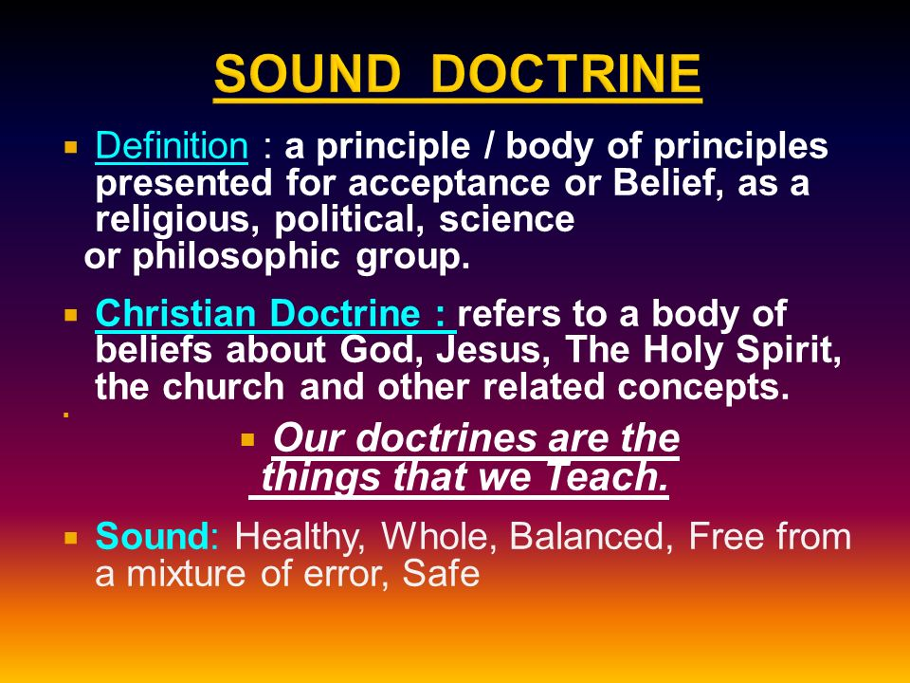
If you’re walking down the street and only have a quarter in your pocket, you probably won’t be very concerned about losing it. But if you’re given $3,000 in cash and told to guard it in your pocket, you’ll walk a bit differently than if you only had a quarter. You’ll be careful not to go to certain places, where you could get robbed. There are certain things that you just won’t do, for fear of losing that treasure. If you have deposited your life with Jesus Christ, then He has deposited the precious treasure of the gospel within you. He asks you to guard it by holding to sound doctrine and by Godly living. What shall we do as believers? Walk carefully! Invest our lives wisely by carefully choosing how you will spend each day. To invest your life successfully, deposit it with Christ and guard His deposit with you.

1. Read verses 1-5. How does Paul identify himself? (1) How does he greet Timothy? (2) How did Paul pray for Timothy, even while in prison? (3) What aspect of Timothy’s faith was Paul reminded of? (4, 5)

1-1, Read verses 1-5.

Paul, an apostle of Christ Jesus by the will of God, in keeping with the promise of life that is in Christ Jesus, 2 To Timothy, my dear son: Grace, mercy and peace from God the Father and Christ Jesus our Lord. 3 I thank God, whom I serve, as my ancestors did, with a clear conscience, as night and day I constantly remember you in my prayers. 4 Recalling your tears, I long to see you, so that I may be filled with joy. 5 I am reminded of your sincere faith, which first lived in your grandmother Lois and in your mother Eunice and, I am persuaded, now lives in you also.

1-2, How does Paul identify himself? (1)

Background

2 Timothy was written by Apostle Paul for his sheep and successor Timothy in about A.D. 66. At that time Paul was in Roman prison arrested for the second time for preaching the gospel. He was waiting to be martyred. It was the time when Nero was emperor of Rome. Nero persecuted the children of God mercilessly. As such persecution persisted, and their shepherd Paul was imprisoned, many Christians in Asia left the gospel faith and the church. Satan was attacking Paul in his old age. But Paul did not yield to the situation. Instead, he wrote a letter to Timothy.

Paul, an apostle of Christ Jesus by the will of God, in keeping with the promise of life that is in Christ Jesus,

- Paul overcame his own situation. He believed in the promise of life that is in Christ Jesus. He was sure that he was an apostle of Christ by the will of God.
- The phrase, “By the will of God” shows his absolute faith in God’s good will. Paul was sure that his present and near death were all in God’s good hands.

1-3, How does he greet Timothy? (2)

2 To Timothy, my dear son: Grace, mercy and peace from God the Father and Christ Jesus our Lord.

- He prayed earnestly that Timothy might enjoy God’s peace being assured of God’s good will, grace, and mercy.

1-4, How did Paul pray for Timothy, even while in prison? (3)

I thank God, whom I serve, as my ancestors did, with a clear conscience, as night and day I constantly remember you in my prayers.

- Paul prayed remembering Timothy day and night without seizing. He dearly loved Timothy who took the heavy responsibility of serving the church in Ephesus.

1-5, What aspect of Timothy’s faith was Paul reminded of? (4, 5)

Recalling your tears, I long to see you, so that I may be filled with joy. 5 I am reminded of your sincere faith, which first lived in your grandmother Lois and in your mother Eunice and, I am persuaded, now lives in you also.

- Paul thanked God for his sincere faith. Many people followed Paul when he was very successful. But after he was imprisoned, they chose to leave the life of faith.
- But Timothy was faithful to God’s mission and loyal to Paul just like a son would be to his father.
- Paul knew that his faith was largely influenced by and inherited from his grandmother Lois and mother Eunice.

2. Read verses 6-8. What does he remind Timothy of? (6) What does the Spirit give us? (7) What does Paul encourage Timothy to do? (8a) How can we also do the same? (8b)

2-1, Read verses 6-8.

For this reason I remind you to fan into flame the gift of God, which is in you through the laying on of my hands. 7 For the Spirit God gave us does not make us timid, but gives us power, love and self-discipline. 8 So do not be ashamed of the testimony about our Lord or of me his prisoner. Rather, join with me in suffering for the gospel, by the power of God.

2-1, What does he remind Timothy of? (6)

6 For this reason I remind you to fan into flame the gift of God, which is in you through the laying on of my hands.

- Paul did not teach Timothy about any skill or method. Rather he simply reminded him that he was to fan into flame the gift of God.
- The gift of God is God’s spiritual gift given to a person to serve the work of the gospel.
- When God called Timothy, God gave him necessary gifts that he needed in serving God’s work.
- Especially God gave him a gift of preaching and teaching of the scripture. (1 Tim 4:13-16)
- Timothy was a man in his mid-thirties. There were also older and mature deacons in the Ephesians’ church.
- Due to Shepherd Paul’s imprisonment, many young co-workers left the church at this time..
- As the persecution grew more intense, Timothy became fearful.

- In such a time as this, Paul encouraged him to rekindle the flame of the gift of God, which is the Holy Spirit. Here, we learn that we must fan into flame our God-given gifts so that they may burn strongly like a fire.

2-2, What does the Spirit give us? (7)

For the Spirit God gave us does not make us timid, but gives us power, love and self-discipline.

- Paul then addresses Timothy’s timidity or fear. It is not natural to have fear in our hearts. Rather it is a spirit that Satan plants within us. This is the spirit that makes people easily become fearful and shaky.
- The spirit that God gave us is not a spirit of timidity but a spirit of power, of love and of self-discipline.
- Let us not grow weary, but fan into flame our God-given gifts, depending on God’s spirit of power, of love, and of discipline.

2-3, What does Paul encourage Timothy to do? (8a)

So do not be ashamed of the testimony about our Lord or of me his prisoner. Rather, join with me in suffering for the gospel,

- In Paul’s time, the Romans considered the followers of Jesus who were crucified on a cross as foolish people. The Jews were also ashamed of them.
- As the worldly power despised Christians and persecuted them severely, many believers began to be ashamed of Paul who was imprisoned for his preaching of the gospel.
- But Paul said, “Join with me in suffering for the gospel, by the power of God.”
- This is the suffering that we get in the course of preaching the gospel to the campus students.
- Sometimes when we are rejected time and again, we feel that going to campus seems to be of no use and we only anticipate people’s rejections.
- But it is worthwhile to positively join in suffering for the gospel, regardless of rejections and outcome.

2-4, How can we also do the same? (8b)

by the power of God.

- When we depend on the power of God we can live great lives of suffering for the gospel.

3. Read verses 9-14. What grace has God given to us? (9) How has this grace been revealed to us? (10a) What did Jesus do for us through the gospel? (10) What mission was Paul given? (11) What made Paul boldly suffer for the Gospel? (12) What did Paul ask Timothy to do? (13) How could he guard the good deposit entrusted to him? (14)

3-1, Read verses 9-14.

He has saved us and called us to a holy life—not because of anything we have done but because of his own purpose and grace. This grace was given us in Christ Jesus before the beginning of time, 10 but it has now been revealed through the appearing of our Savior, Christ Jesus, who has destroyed death and has brought life and immortality to light through the gospel. 11 And of this gospel I was appointed a herald and an apostle and a teacher. 12 That is why I am suffering as I am. Yet this is no cause for shame, because I know whom I have believed, and am convinced that he is able to guard what I have entrusted to him until that day.
13 What you heard from me, keep as the pattern of sound teaching, with faith and love in Christ Jesus.14 Guard the good deposit that was entrusted to you—guard it with the help of the Holy Spirit who lives in us.

3-2, What grace has God given to us? (9)

9 He has saved us and called us to a holy life—not because of anything we have done but because of his own purpose and grace. This grace was given us in Christ Jesus before the beginning of time,
- We come to God as a response to His call in our lives. We did not initiate the search; we do not "find" God, He finds us; so we must respond to His call.
- God calls us, not according to our works, but according to His own purpose. It wasn't because of who we were or anything great that we had done, but only because it fit in with His purpose - because He wanted to, God chose to find us.
- This is the grace which was given to us in Christ Jesus before time began: God directed His gracious work towards us

3-3, How has this grace been revealed to us? (10a)

10 but it has now been revealed through the appearing of our Savior, Christ Jesus,
- God's purpose and grace were revealed by the appearing of our Savior Jesus Christ: He fulfilled the eternal plan of God in and through Jesus. Jesus truly shows us what God and His plan are all about.
- God has revealed Himself to us all in the person of Jesus Christ. That is why Paul expressed his desire in Philippians 3:10, “I want to know Christ…”

3-4, What did Jesus do for us through the gospel? (10)

who has destroyed death and has brought life and immortality to light through the gospel.

- What Jesus did: He brought life and immortality to light through the gospel. Jesus brought the truth about our immortal state to life through His own resurrection.
- He showed us what our own immortal bodies would be like, and assured us that we would in fact have the same body according to his example.
- Especially for Paul who was about to die in Jesus must have known whom he had believed in. He put his trust in the final victory which was won by Jesus.
- God's eternal plan of salvation began for us before time. It continued with the appearing of our Savior Jesus Christ, and came to us when He saved us and called us. It will continue as we live according to His holy calling, until one day it shows itself in immortality - eternal life!
- When we consider the greatness of this message, no wonder Paul calls it the gospel - Good News!
- It is good news that God thought of us and loved us even before we existed; good news that Jesus came to perfectly show us God, It is good news that He called us and saved us, It is good news that He gives us His holy calling, And it is good news that He shows us and gives us eternal life.
- No wonder Paul was willing to go to prison and even die, rather than being silent about this great message!

- Paul positively suffer for the gospel and encouraged Timothy to join with him in suffering for the gospel. It was because he appreciated the value of the gospel.
- Only Jesus, the Son of God has power to save us from sin, death, and eternal punishment. Only the gospel has power to save and sanctify us.
- The gospel is the answer to all problems of mankind. This gospel cannot be exchanged with anything in this universe. The gospel is the greatest and the most glorious blessing.
- This gospel not only gives us eternal life. It also gives us access to the kingdom of God in our resurrection bodies.
- Paul, who was in the line of execution, sang a song of victory, “Jesus has destroyed death and has brought life and immortality to light through the gospel!”

3-5, What mission was Paul given? (11)

And of this gospel I was appointed a herald and an apostle and a teacher.

- We can almost sense Paul growing in strength as he pens these words; he understands what a privilege it is to suffer for such a great gospel - rather than being ashamed, he is honored!
- Looking back on the sermons he had preached (a preacher), the churches he had served (an apostle), and the Gentile nations he had brought to Jesus Christ (a teacher of the Gentiles) - As he considered each one, surely he must have said, "Thank you Jesus!" despite his own situation in a dungeon.

3-6, What made Paul boldly suffer for the Gospel? (12)

That is why I am suffering as I am. Yet this is no cause for shame, because I know whom I have believed, and am convinced that he is able to guard what I have entrusted to him until that day.

- We must know what we believe; but it is even more important to know whom we have believed in..
- When Paul knew what and in whom he had believed, he was more than willing to suffer for Christ. He was not ashamed of his suffering at all.
- Paul could also be so bold, because he was persuaded that God was able to keep what Paul had committed to Him until that Day. Paul gave Jesus his life, and knew Jesus was fully able to keep it!
- Paul had entrusted his life to Jesus because he knew he could not keep his own life. He knew that only God could keep it. God was able. Paul was not. Knowing this made Paul very bold. It was through his confidence in God, that Paul could be so bold!
- But it wasn't only his life that Paul had committed to God. Paul had committed everything to Jesus such as all pioneered churches and growing believers.
- That Day - the day Paul would see Jesus in all His glory.
- How precious is that Day to you? It probably depends on how much you have committed to Him!

3-7, What did Paul ask Timothy to do? (13)

What you heard from me, keep as the pattern of sound teaching, with faith and love in Christ Jesus.

- After speaking of the importance of boldness, Paul now calls Timothy to old fast the pattern of sound teaching.
- What you have heard from me: The sound words Timothy was to hold fast to came to him from a man - Paul the apostle.
- Timothy, and all Godly ministers, are called to be faithful to the truth. “Keep” suggests someone or something will try to take the truth from us. In other words, unless we hold on in faithfulness, it will be snatched away from us.
- What really counts is if we keep the pattern of sound teachings. The pattern of sound words suggests that true teaching, according to God's truth, has a certain "pattern" to it - a pattern that can be detected by the discerning heart.
- Timothy's faithfulness has to be held together by faith and love which are in Christ Jesus. Some people take God's word only intellectually, and leave out faith and love.
- Faith and love describe how the truth is to be held. We hold it in faith, truly believing it and putting our lives on it; and we hold it in love, not in pride, arrogance, or self-seeking superiority.

3-8, How could he guard the good deposit entrusted to him? (14)
Guard the good deposit that was entrusted to you—guard it with the help of the Holy Spirit who lives in us.

- Timothy had something committed to him - Paul calls it the good deposit. It is not one of many good things we might have. It is THE good deposit. No doubt in the flow of the context, it indicates the gospel of God entrusted to Paul and Timothy and ALL believers. We need to have faithfulness to keep that good deposit.
- We live in a time where faithfulness is only expected so long as it serves our own interests. But this is not honoring to God.
- Being faithful to God means having the heart and will to what is right even when it might seem crazy to do so. God honors those who fear the LORD.

Psalm 15:4 reads,
who despises a vile person but honors those who fear the Lord; who keeps an oath even when it hurts, and does not change their mind;
Habakkuk 3:17-19 reads,
Though the fig tree does not bud and there are no grapes on the vines, though the olive crop fails and the fields produce no food, though there are no sheep in the pen and no cattle in the stalls, 18 yet I will rejoice in the Lord, I will be joyful in God my Savior. 19 The Sovereign Lord is my strength; he makes my feet like the feet of a deer, he enables me to tread on the heights.

- God is faithful with what we commit to Him (2 Timothy 1:12). Will we be faithful with what He has committed to us?
- Guarded with the help of the Holy Spirit who dwells in us - we can fulfill it not by our own resources, but by the help of the Spirit.

Conclusion
God is faithful and capable enough to keep what he has promised. We know whom we have believed. So we do not have to fear anything. Rather we are thankful to the Lord God who had His perfect and good purpose before the creation and fulfilled it through His son, Jesus Christ. His purpose was to bring life and immortality to light through the gospel. We are now entrusted with the good news. We don’t want to compromise with this gospel, even though it may require our suffering at times. May the Lord help us to be faithful to the end. May we guard what we were entrusted with to the end, by the help of the Spirit residing in us. Amen.

One word: The gospel entrusted to us all!

