PREACH THE WORD

2 Timothy 4:1-22
Key Verse: 4:2

“Preach the Word; be prepared in season and out of season; correct, rebuke and encourage—with great patience and careful instruction.”

Introduction

Today’s passage is the last part of the letter which is like his will to Timothy. Have you ever thought about the last words you would like give your beloved ones? You will give them what is most important in life, won’t you? Paul gives Timothy his last words: “Preach the word.” As we study today’s passage, let us recognize what we are in the presence of God and understand the importance of preaching the word. Through this passage, let us newly make a decision to preach the word.

- Read verse 1-5. What solemn charge did Paul give to Timothy? (1, 2) Why are people eager to listen to false doctrine? (3, 4) What shall we do in all situations? (5)

1-1, Read verse 1-5.

In the presence of God and of Christ Jesus, who will judge the living and the dead, and in view of his appearing and his kingdom, I give you this charge: 2 Preach the word; be prepared in season and out of season; correct, rebuke and encourage—with great patience and careful instruction. 3 For the time will come when people will not put up with sound doctrine. Instead, to suit their own desires, they will gather around them a great number of teachers to say what their itching ears want to hear. 4 They will turn their ears away from the truth and turn aside to myths. 5 But you, keep your head in all situations, endure hardship, do the work of an evangelist, discharge all the duties of your ministry.

1-2, What solemn charge did Paul give to Timothy? (1, 2)

In the presence of God and of Christ Jesus, who will judge the living and the dead, and in view of his appearing and his kingdom, I give you this charge:

- Imagine that you limited time on earth due to a malignant brain cancer like Arizona Senator, John McCain, what would you say or write on a letter?
- Paul was very solemn here. In the presence of God and of Christ Jesus, he gave his last words to Timothy.
- In other words, this charge was not from Paul, but from God and Christ Jesus.

2 Preach the word;
- “Preach the word!” That was the solemn command from God and Christ Jesus. Before his ascension, the risen Jesus also commanded his disciples.

Mark 16:15 reads,

“Go into all the world and preach the gospel to all creation.”

- The word “preaching” means “herald.” In ancient times, a king’s messenger went to the public, opened a scroll and proclaimed the king’s words.
- Likewise, our preaching means that we proclaim on behalf of Jesus our eternal King.

- The word “word” in Greek is “logos”. Apostle John declares that Jesus is the “logos”—the Word in John 1.
- Therefore, preach the word means in short to proclaim and teach Jesus and his gospel.
- Why did Paul solemnly command us to preach Jesus and his gospel? It is because only in Jesus and His words can we be saved from sin and eternal condemnation.
- We are now the messengers of our eternal King Jesus. As the King’s messengers, we now have a mandate to preach the word.
- We know that we have no power to change others, even ourselves, let alone to save people from their sin and eternal condemnation.
- But at least, we can tell about Jesus to others so that they could come to Jesus and hear his good news. That was why he preached the word without ceasing even in Roman prison.

be prepared in season and out of season;

- Now then how should we preach the word? RSV translates, “be urgent in season and out of season.”
- Paul urged Timothy to preach the word with urgency (be prepared) and at all times (in season and out of season), because so many people were perishing.
- Paul was always ready to preach the word anywhere, anytime and to anyone. He taught the word always whether people listen or not listen, thin or thick.

1 Corinthians 9:16 reads,

“For when I preach the gospel, I cannot boast, since I am compelled to preach. Woe to me if I do not preach the gospel.”

- In fact, we became God’s children because somebody preached to us with great care and prayers.
- Today, we hear and listen to the word through this message and know the way of salvation.

Romans 10:14b-17 says,

“And how can they believe in the one of whom they have not heard? And how can they hear without someone preaching to them? And how can anyone preach unless they are sent? As it is written, ‘How beautiful are the feet of those who bring good news!’….Consequently, faith comes from hearing the message, and the message is heard through the word about Christ.”

- Most students in North American campuses are in urgent need of hearing the word.
- May we be compelled to preach the word in season and out of season so that many students on campus may hear the good news Jesus, believe in him and be saved from sin and death.
1 Timothy 2:4 says,

“who wants all men to be saved and come to a knowledge of the truth.”

- Jesus doesn’t want anyone to perish and wants all men to hear the word preached and come to him in faith.

- Again Paul was about to die and he should have been writing what seemed urgent! He chose to write about the Word.
- The word was beautifully prepared by God with a single purpose; the word reveals God’s Son and salvation by faith in Jesus.
- It is like a personal love letter written to us showing God’s love and sacrifice for each of us.
- In the darkest times, what is truly inside a man comes out. At this time, the deep grace of Jesus and the love of the word of God came out of Paul.
- Preaching the Word is powerful because the word alone leads us to faith and salvation in Jesus Christ.
- Through faith in Jesus Christ we can be saved from sin and death. May the Lord bless each of us with the same desire that he had!

correct, rebuke and encourage—with great patience and careful instruction.
- Paul wrote this to Timothy because the word of God makes us wise unto salvation (1 Tim 3:15). “Correct, rebuke, and encourage” - Here Paul tells us about attitude of preaching the word.
- Preaching involves patience and instruction too. Paul’s emphasis, “great” patience and “careful” instruction. In order to have great patience and careful instruction, we must have listening ears and carefully thought-out words spoken in love.
- Jesus showed us a good example. Jesus’ disciples took a long time to have faith in Jesus. With great patience and careful instruction again and again, Jesus preached the word of God to them.
- The messengers of Jesus Christ therefore must have great patience and very careful instruction to teach the gospel to campus students.

1-3, Why are people eager to listen to false doctrine? (3, 4)

For the time will come when people will not put up with sound doctrine. Instead, to suit their own desires, they will gather around them a great number of teachers to say what their itching ears want to hear. 4 They will turn their ears away from the truth and turn aside to myths.

- In the last days people would abandon sound doctrine and turn their ears to what their itching ears wanted to hear.
- I almost feel that Paul’s foretelling about people in the last days points to people of today.

1-4, What shall we do in all situations? (5)

But you, keep your head in all situations, endure hardship, do the work of an evangelist, discharge all the duties of your ministry.

- We must keep our head, and endure hardship. Moreover, we must keep on doing the work of evangelists that is to preach the gospel with great patience and careful instruction to people.
- We Christians are the messengers of our King Jesus. Our mandate is to do the work of evangelists, preaching the word in season and out of season.

- Read verses 6-8. What can we learn from Paul’s remarks in regard to his view of his life? (6, 7) What are Paul’s hope? (8)

2-1, Read verses 6-8.

For I am already being poured out like a drink offering, and the time for my departure is near. 7 I have fought the good fight, I have finished the race, I have kept the faith. 8 Now there is in store for me the crown of righteousness, which the Lord, the righteous Judge, will award to me on that day—and not only to me, but also to all who have longed for his appearing.

2-2, What can we learn from Paul’s remarks in regard to his view of his life? (6, 7)

For I am already being poured out like a drink offering, and the time for my departure is near.
- Paul set a good example in preaching the word earnestly as an evangelist. Now his martyrdom was imminent.
- But there was no hint of sorrow and fear. Rather he passed the baton of preaching the word to Timothy.
- Paul preached the word to the end of his life. “For I am already being poured out like a drink offering, and the time for my departure is near.”
- Paul didn’t see his martyrdom as a horrible thing. Rather he regarded it as a drink offering to God.
- Some might think that Paul’s life was being wasted. But Paul offered his whole life as a drink offering to God.
- A drink offering was wine added to a burnt offering; its fragrance pleased the Lord

Numbers 28:6-7 reads,
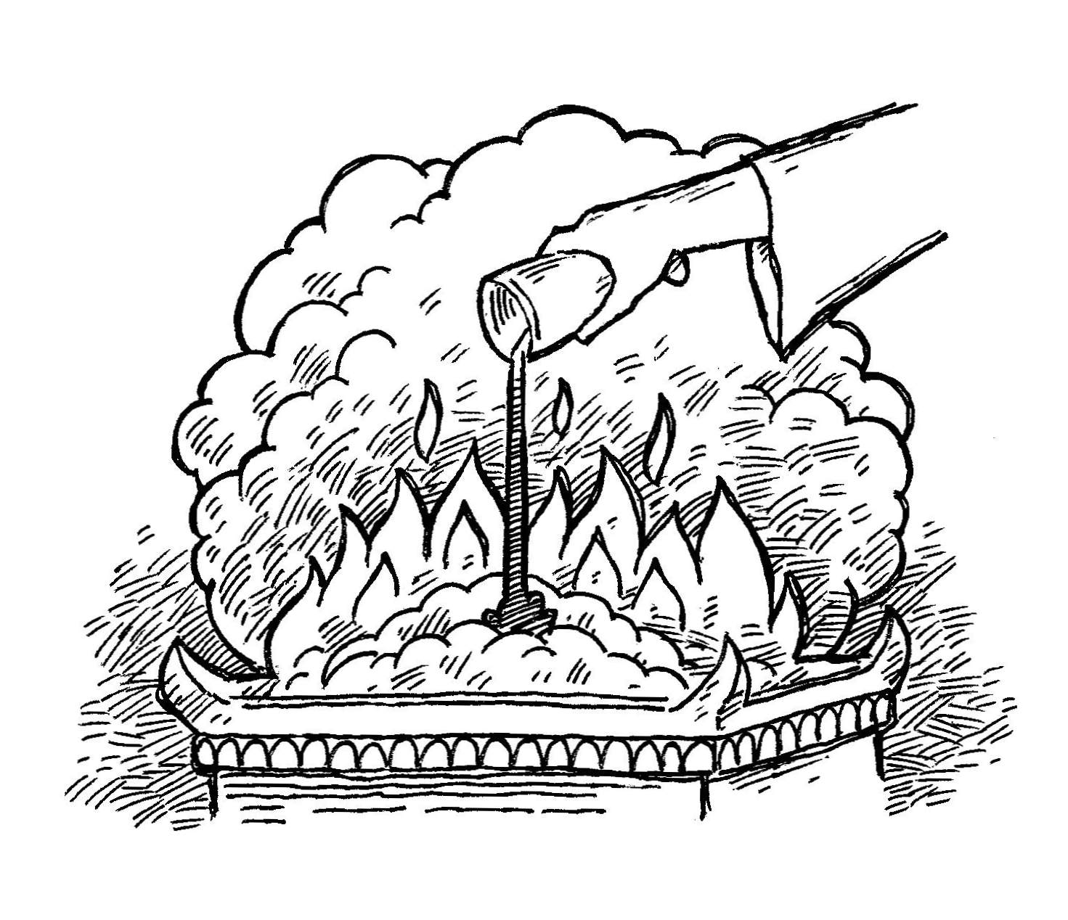
This is the regular burnt offering instituted at Mount Sinai as a pleasing aroma, a food offering presented to the Lord. 7 The accompanying drink offering is to be a quarter of a hin of fermented drink with each lamb. Pour out the drink offering to the Lord at the sanctuary.

- Paul lived for the glory of God by preaching the word to the end of his life and now it was time for him to enter the kingdom of heaven.

7 I have fought the good fight, I have finished the race, I have kept the faith.

- Paul had lived as a soldier and a runner by faith to the end. He had fought the spiritual battles against his own sinful nature and against Satan who tempted him to live an easy-going life.

2-3, What are Paul’s hope? (8)

8 Now there is in store for me the crown of righteousness, which the Lord, the righteous Judge, will award to me on that day—and not only to me, but also to all who have longed for his appearing.

- He had also run the race of faith to the end in order to win the prize for which God had called him heavenward in Christ Jesus (Php 3:14).
- For most marathoners the last 10-K is the toughest. They call it “the wall.” As they hit the wall they felt like giving it up.
- But to finish the race, they have to break through the wall. Paul had run to the end of his life, and now he was looking forward to the crown of righteousness, which the Lord would award to him.

Acts 20:24 reads,

“However, I consider my life worth nothing to me; my only aim is to finish the race and complete the task the Lord Jesus has given me—the task of testifying to the good news of God’s grace.”

- Let’s us fight the good fight and finish the race and keep the faith until we see Christ face to face who will award the crown of righteousness to us.

- Read verses 9-22. Who left Paul and who stayed with Paul? (9-12) What did he ask Timothy to bring? (13) Why did he warn Timothy about Alexander? (14, 15) What can we learn from Paul’s faith while on trial? (16-18) Who else did Paul gave his final greetings in the Lord? (19-22)

3-1, Read verses 9-22.

Do your best to come to me quickly, 10 for Demas, because he loved this world, has deserted me and has gone to Thessalonica. Crescens has gone to Galatia, and Titus to Dalmatia. 11 Only Luke is with me.Get Mark and bring him with you, because he is helpful to me in my ministry. 12 I sent Tychicus to Ephesus. 13 When you come, bring the cloak that I left with Carpus at Troas, and my scrolls, especially the parchments.
14 Alexander the metalworker did me a great deal of harm. The Lord will repay him for what he has done. 15 You too should be on your guard against him, because he strongly opposed our message.
16 At my first defense, no one came to my support, but everyone deserted me. May it not be held against them. 17 But the Lord stood at my side and gave me strength, so that through me the message might be fully proclaimed and all the Gentiles might hear it. And I was delivered from the lion’s mouth.18 The Lord will rescue me from every evil attack and will bring me safely to his heavenly kingdom. To him be glory for ever and ever. Amen.
19 Greet Priscilla and Aquila and the household of Onesiphorus. 20 Erastus stayed in Corinth, and I left Trophimus sick in Miletus. 21 Do your best to get here before winter. Eubulus greets you, and so do Pudens, Linus, Claudia and all the brothers and sisters. 22 The Lord be with your spirit. Grace be with you all.

3-2, Who left Paul and who stayed with Paul? (9-12)

Do your best to come to me quickly, 10 for Demas, because he loved this world, has deserted me and has gone to Thessalonica. Crescens has gone to Galatia, and Titus to Dalmatia. 11 Only Luke is with me. Get Mark and bring him with you, because he is helpful to me in my ministry. 12 I sent Tychicus to Ephesus.

- Paul asked Timothy to come to him quickly. Paul was not a superman. He needed comfort and must have felt alone.
- Many people left and deserted him. Even Demas who was once Paul’s fellow worker(Colossians 4:14 and Philemon 24) deserted Paul.
- Paul must have been painful to see some coworkers’ desertion like Demas who loved the world and deserted Paul and had gone to Thessalonica.

- Luke, who had traveled with Paul on many of his missionary journeys, remained with Paul.
- Get Mark and bring him with you - This is evidence of a restoration of trust in Mark from Paul. Before Paul had wanted nothing to do with him in Acts 15:36-40.
- Tychicus seemed to be faithful and stayed with Paul.

3-3, What did he ask Timothy to bring? (13)

13 When you come, bring the cloak that I left with Carpus at Troas, and my scrolls, especially the parchments.

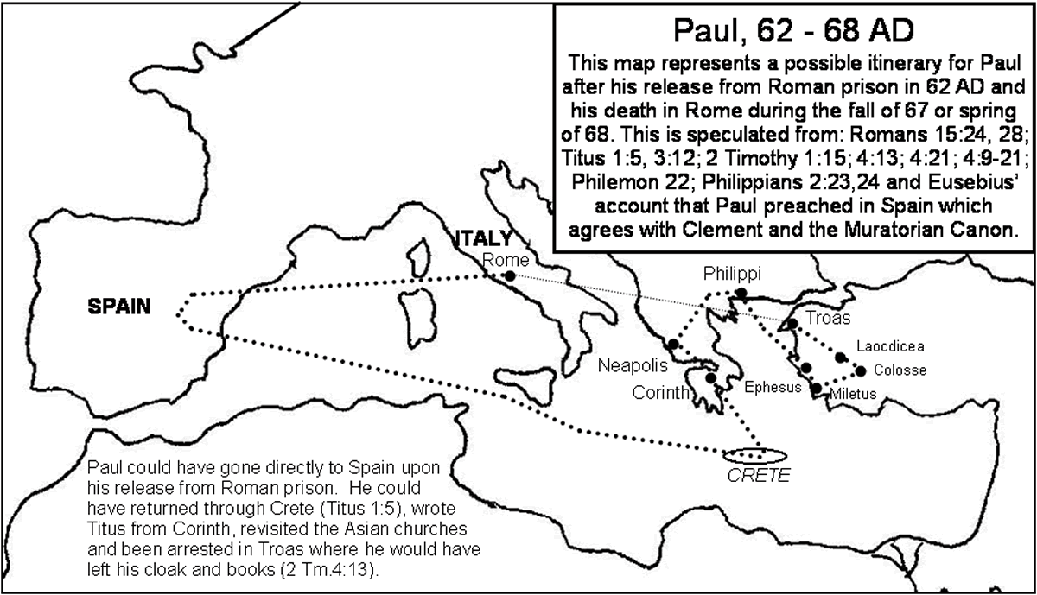
- It is likely that Paul was arrested at Troas, resulting in this second imprisonment at Rome.
- In those days the arresting soldiers had claim to any extra garments in the possession of the one arrested.
- It may be that Paul committed his few books and this cloak – an outer garment – to the care of an honest man named Carpus.
- Paul gave up everything to serve Jesus (all he had at the end of his life was a cloak and a few books).
- Paul was almost completely forsaken by his friends (he apparently had no friends to lend or obtain a cloak for him in Rome).
- Paul had a very independent mind (he would not beg for a cloak). Paul did not care much for how he was dressed (he could have asked for more or for different articles of clothing).
- Paul was indeed an ordinary man with ordinary needs.
- But he asked his scrolls, especially the parchments, which were portions of the Old Testament.
- We can learn here that Paul loved to read the Bible to the end of his life instead of expecting extra signs or miracles. What a Bible teacher he was as a role model!

3-4, Why did he warn Timothy about Alexander? (14, 15)
Alexander the metalworker did me a great deal of harm. The Lord will repay him for what he has done. 15 You too should be on your guard against him, because he strongly opposed our message.

- During his missionary life, many people opposed him and harmed him. One of them is a metalworker Alexander who did Paul a great deal of harm.
- Paul didn’t retaliate against him physically, but just entrusted him to God.

3-5, What can we learn from Paul’s faith while on trial? (16-18)

At my first defense, no one came to my support, but everyone deserted me. May it not be held against them. 17 But the Lord stood at my side and gave me strength, so that through me the message might be fully proclaimed and all the Gentiles might hear it. And I was delivered from the lion’s mouth.18 The Lord will rescue me from every evil attack and will bring me safely to his heavenly kingdom. To him be glory for ever and ever. Amen.

- Paul was all alone, but Jesus stood by him and Paul served God faithfully during his first defense.
- And I was delivered out of the mouth of the lion - God had delivered Paul before so he had no doubt about God’s power or goodness.
- Paul just didn’t know if this time his fate would end with be delivered out of the mouth of the lion or being preserved for His heavenly kingdom.
- To Him be glory forever and ever - Paul was not obsessed with his uncertain fate, but he is concerned about God’s glory.

3-6, Who else did Paul gave his final greetings in the Lord? (19-22)

Greet Priscilla and Aquila and the household of Onesiphorus. 20 Erastus stayed in Corinth, and I left Trophimus sick in Miletus. 21 Do your best to get here before winter. Eubulus greets you, and so do Pudens, Linus, Claudia and all the brothers and sisters.

- On the other hand Paul also had faithful co-workers who served God and his work so faithfully and diligently in different places.
- They were Priscilla, Aquila, Onesiphorus, Erastus, Trophimus, Eubulus, Pudens, Linus, Claudia, and many faithful brothers and sisters.
22 The Lord be with your spirit. Grace be with you all.
- Paul maintained his intimate love relationship with the Lord, Jesus Christ and overflow such love to others to the end.

Conclusion
Like our senior Paul who was more than willing to obey to our Lord and King Jesus Christ, may we preach the word in season and out of season and with great patience and careful instruction. In this way, let us fight the good fight to the end and finish the race of faith. Our Lord will give us strength to preach the word and bring us safely to his heavenly kingdom and award the crown of righteousness to us.

One Word: Preach the Word!

