He Has Risen!

Luke 24:1-35
Key Verse 6

“He is not here; he has risen! Remember how he told you, while he was still with you in Galilee....”

Introduction

Jesus has risen! This event did not happen suddenly out of the clear blue. On the contrary, it was an event that was planned by God and foretold by Jesus while He was alive. Jesus had spoken of his own resurrection at various stages of His ministry and life. Luke 9:22 reads, “And he said, “The Son of Man must suffer many things and be rejected by the elders, the chief priests and the teachers of the law, and he must be killed and on the third day be raised to life.” John 2:19 also says, “Jesus answered them, “Destroy this temple, and I will raise it again in three days.” Praise Jesus who fulfilled these very words. Jesus’ words were always truthful. When the women remembered Jesus’ words, faith came alive in their hearts. Jesus prepared faithful and humble women as His witnesses while His disciples were in great sorrow and fear, being slow to believe. May the Lord help us to take deep root in Jesus’ Words so that we would be more than conquerors and powerful witnesses in this confusing and dark generation. Amen!

1. Read verses 1-8. Why had the women come to the tomb? (1, 10) What did they find? (2-4) What were they told by two angels? (5-7) How did their message confirm Jesus’ resurrection? (8; 9:22, 44)

1-1, Read verses 1-8.

On the first day of the week, very early in the morning, the women took the spices they had prepared and went to the tomb. 2 They found the stone rolled away from the tomb, 3 but when they entered, they did not find the body of the Lord Jesus. 4 While they were wondering about this, suddenly two men in clothes that gleamed like lightning stood beside them. 5 In their fright the women bowed down with their faces to the ground, but the men said to them, “Why do you look for the living among the dead? 6 He is not here; he has risen! Remember how he told you, while he was still with you in Galilee: 7 ‘The Son of Man must be delivered over to the hands of sinners, be crucified and on the third day be raised again.’ ” 8 Then they remembered his words.

1-2, Why had the women come to the tomb? (1, 10)

On the first day of the week, very early in the morning, the women took the spices they had prepared and went to the tomb.

10 It was Mary Magdalene, Joanna, Mary the mother of James, and the others with them who told this to the apostles.

After the Sabbath, at dawn on the first day of the week, Mary Magdalene and the other Mary went to look at the tomb. (Matthew 28:1)

When the Sabbath was over, Mary Magdalene, Mary the mother of James, and Salome bought spices so that they might go to anoint Jesus’ body. (Mark 16:1)
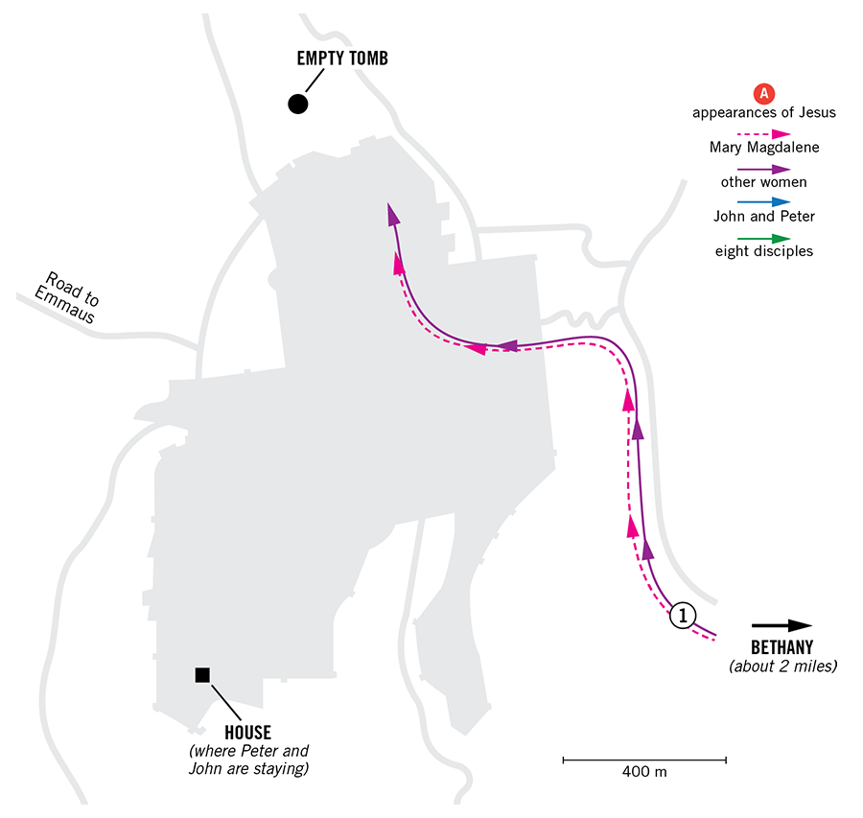
- The earliest the women could go to the tomb and properly embalm the body of Jesus was on Sunday morning, for there might not have been enough time on Friday night.
- The Sabbath was over at the start of Saturday evening, but it wasn't light enough to do the work until Sunday morning.
- Here women have proved themselves to be the most devoted followers of Jesus. They were also blessed to be the first to proclaim His resurrection.
- They were mentioned first in Luke 8.

After this, Jesus traveled about from one town and village to another, proclaiming the good news of the kingdom of God. The Twelve were with him, 2 and also some women who had been cured of evil spirits and diseases: Mary (called Magdalene) from whom seven demons had come out; 3 Joanna the wife of Chuza, the manager of Herod’s household; Susanna; and many others. These women were helping to support them out of their own means.

- Especially Mary Magdalene was rescued from 7 demons thanks to Jesus. She must have been thankful to Jesus and loved Jesus more than anyone, for she had received Jesus’ abundant grace and mercy.
- In fact John’s gospel only described Mary, when there could have been more women at the scene.

1-3, What did they find? (2-4)

They found the stone rolled away from the tomb, 3 but when they entered, they did not find the body of the Lord Jesus. 4 While they were wondering about this, suddenly two men in clothes that gleamed like lightning stood beside them.

- When the women saw the stone rolled away and the tomb empty, their immediate reaction was that of surprise and wonder.
- Their reaction shows they didn’t expect to find an empty tomb. This shows that the accounts of the resurrection cannot be the product of wishful thinking. No one was even expecting that it could happen.
- The stone was not rolled away to for Jesus to come out, but as evidence that Jesus had risen from the dead.

1-4, What were they told by two angels? (5-7)

In their fright the women bowed down with their faces to the ground, but the men said to them, “Why do you look for the living among the dead? 6 He is not here; he has risen! Remember how he told you, while he was still with you in Galilee:

- The two men must have been angels, sent as messengers of God.
- They helped the women to remember what Jesus had told them before His crucifixion, when they had been with Him in Galilee.
- At the time of Jesus’ birth, angels appeared to share the good news with a few faithful shepherds out in the fields.
- Likewise, at the time of Jesus’ resurrection, God sent angels to share the good news with a few faithful women.
- Most importantly, they reminded the women of Jesus’ words.

“Why do you look for the living among the dead? 6 He is not here; he has risen!

- Jesus is not in the grave because he is no longer dead; he has risen! The Greek verb indicates that the action was performed by another.
- God raised Jesus from the dead (Ac 2:24a) after Jesus died in obedience to God’s will and God’s justice was fully satisfied.
- Until that time death had kept its hold on everyone who had died. Death was like an undefeated heavyweight wrestler.
- But Jesus was different. Jesus was sinless and holy. So there was nothing for death to hold of in Jesus. The grip of death was broken by Jesus Christ.
- Moreover, Jesus is in very nature God. Death was no match for the Son of God. Jesus won complete victory over the power of death. Through His death and resurrection, Jesus completely disarmed the power of death.
- Death has now lost its terror for those who believe in Jesus. “Death has been swallowed up in victory” (1 Cor 15:55).
- Jesus’ resurrection proves that God is the Almighty God. It foretells the restoration of God’s reign over all creation.
- God's kingdom of peace and love and eternal life comes through the resurrection of Christ. This is the best news.
- Our greatest sorrows and pains, our greatest heartaches and disappointments, are all rooted in the power of sin, death, and Satan.
- But these enemies have all been defeated by the Risen Christ. Christ gives this victory to all who believe in him. Thanks and glory be to God!

7 ‘The Son of Man must be delivered over to the hands of sinners, be crucified and on the third day be raised again.’ ”

- The word “must” indicates that the Son of Man must be raised from the dead according to God’s word of promise.

1-5, How did their message confirm Jesus’ resurrection? (8; 9:22, 44)

8 Then they remembered his words.

- The first notes of hope are sounded in the hearts of the women when they are reminded of Jesus' words.
- The empty tomb, the presence of angels, the words of the angels - all of these combined could not change these women’s heart. It was Jesus’ Words that had power to change their hearts.

2. Read verses 9-12. What did the women do when they remembered Jesus’ words? (9) How did the apostles respond? (11) What did Peter do? (12)

2-1, Read verses 9-12.

When they came back from the tomb, they told all these things to the Eleven and to all the others.10 It was Mary Magdalene, Joanna, Mary the mother of James, and the others with them who told this to the apostles. 11 But they did not believe the women, because their words seemed to them like nonsense. 12 Peter, however, got up and ran to the tomb. Bending over, he saw the strips of linen lying by themselves, and he went away, wondering to himself what had happened.

2-2, What did the women do when they remembered Jesus’ words? (9)

When they came back from the tomb, they told all these things to the Eleven and to all the others.

2-3, How did the apostles respond? (11)

But they did not believe the women, because their words seemed to them like nonsense.

- The disciples felt that Jesus’ death was the end of it all. They were grieving over their own failures and broken dreams.
- It must have been difficult to believe good news after experiencing such trauma. In addition, they might have thought that women were not credible witnesses. So in their hearts, they might have refused to believe.

2-4, What did Peter do? (12)

Peter, however, got up and ran to the tomb. Bending over, he saw the strips of linen lying by themselves, and he went away, wondering to himself what had happened.

- In John 20, both Peter and John ran to the tomb together. They saw Jesus’ grave clothes lying in perfect order. It looked as if a Jesus’ body had just miraculously passed through them.
- They had not seen the risen Jesus, but they must have sensed that something powerful had just happened. There was no logical way to explain Jesus’ grave clothes being left in such a manner.
- Peter analyzed the situation, but he had forgotten the words of Jesus. (John 20:9) Because of this, he too had yet to understand.
- Anyone can possess knowledge that Jesus rose from the dead, but unless one has and believes the Word of Jesus, even visible evidence and facts will not make sense.
- The apostle John pointed out that he and the other disciples were later able to recall what Jesus had said about his resurrection. This happened later, at God’s time.

John 2:22 reads,
“After he was raised from the dead, his disciples recalled what he had said. Then they believed the scripture and the words that Jesus had spoken.”

3. Read verses 13-24. Where were two disciples going? (13) What were they talking about? (14-15) How did Jesus help them when they didn’t recognize Him? (16-18) What facts did they know about Jesus? (19-24)

3-1, Read verses 13-24.

Now that same day two of them were going to a village called Emmaus, about seven miles[a] from Jerusalem. 14 They were talking with each other about everything that had happened. 15 As they talked and discussed these things with each other, Jesus himself came up and walked along with them; 16 but they were kept from recognizing him.
17 He asked them, “What are you discussing together as you walk along?”
They stood still, their faces downcast. 18 One of them, named Cleopas, asked him, “Are you the only one visiting Jerusalem who does not know the things that have happened there in these days?”
19 “What things?” he asked. “About Jesus of Nazareth,” they replied. “He was a prophet, powerful in word and deed before God and all the people. 20 The chief priests and our rulers handed him over to be sentenced to death, and they crucified him; 21 but we had hoped that he was the one who was going to redeem Israel. And what is more, it is the third day since all this took place. 22 In addition, some of our women amazed us. They went to the tomb early this morning 23 but didn’t find his body. They came and told us that they had seen a vision of angels, who said he was alive. 24 Then some of our companions went to the tomb and found it just as the women had said, but they did not see Jesus.”

3-2, Where were two disciples going? (13)

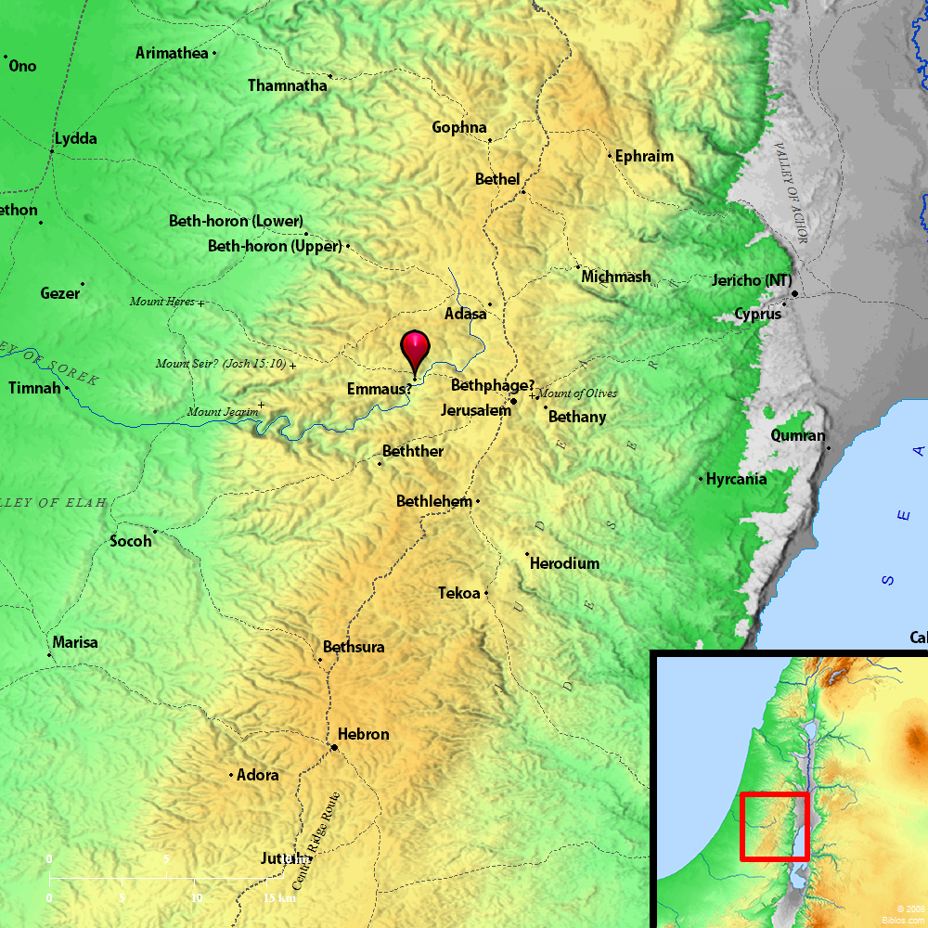

Now that same day two of them were going to a village called Emmaus, about seven miles from Jerusalem.

- These two were leaving Jerusalem for Emmaus, a village about seven miles away.
- There is no mention about whether they are two men or women.
- According to verse 9, two were disciples of Jesus, not necessarily among 11 disciples.

3-3, What were they talking about? (14-15)

They were talking with each other about everything that had happened. 15 As they talked and discussed these things with each other, Jesus himself came up and walked along with them;

- Most likely they were very sad about what had happened in Jerusalem.
- Although they discussed among themselves what they had just witnessed, they didn’t yet have understanding as to why things had to happen as they did.
- In the same way when we just converse with each other about what’s going on, without considering what the Scripture has to say about Jesus Christ, we can also lack understanding as to why such things are happening.
- Yet, while they were wondering and talking with each other about these things, Jesus did not abandon them or leave them in darkness.
- Instead, He himself appeared and walked alongside with them. He did this out of His compassion and mercy.

3-4, How did Jesus help them when they didn’t recognize Him? (16-18)

16 but they were kept from recognizing him.
17 He asked them, “What are you discussing together as you walk along?”
They stood still, their faces downcast. 18 One of them, named Cleopas, asked him,
- Cleopas was one of them.

John 19:25 reads,

Near the cross of Jesus stood his mother, his mother’s sister, Mary the wife of Clopas, and Mary Magdalene.

- We are not completely sure but it’s been suggested that Clopas or Cleopas might have been the same person.
- Probably, Mary(Jesus’ aunt) and her husband, Cleopas were the two on the way to Emmaus.
- Just as Mary Magdalene was blessed to meet Jesus because of her love and commitment to Jesus, Jesus whose love never fails, helped these two faithful servants.
- At the end of this passage, this couple were very blessed to be witnesses of Jesus to others.

- Jesus’ appearance here was in some ways, very ordinary, like a friend. Jesus did not start by lecturing them, but instead, listened to them first.
- He urged them to share what was on their hearts.

“Are you the only one visiting Jerusalem who does not know the things that have happened there in these days?”

3-5, What facts did they know about Jesus? (19-24)

19 “What things?” he asked.
“About Jesus of Nazareth,” they replied. “He was a prophet, powerful in word and deed before God and all the people. 20 The chief priests and our rulers handed him over to be sentenced to death, and they crucified him; 21 but we had hoped that he was the one who was going to redeem Israel. And what is more, it is the third day since all this took place. 22 In addition, some of our women amazed us. They went to the tomb early this morning 23 but didn’t find his body. They came and told us that they had seen a vision of angels, who said he was alive. 24 Then some of our companions went to the tomb and found it just as the women had said, but they did not see Jesus.”

- Jesus wisely inquired of them, allowing them to reveal what was in their hearts. Jesus longs for us to reveal to Him what is in our hearts, even though He already knows.
- They knew about Jesus of Nazareth. They knew His name and where He was from. They knew He was a Prophet. They knew He was mighty in deed and word.
- They knew He was crucified. They knew He promised to redeem Israel. They knew others had said He rose from the dead.
- These disciples had hope. But their hope was just wishful thinking, for they lacked understanding of how God’s promise had been fulfilled.
- They were slow to believe. The report of the women and the report of Peter and John who had seen the grave clothes meant little to them.
- They wanted to believed based on what they saw. They needed to see in order to believe.

4. Read verses 25-35. How did the Risen Jesus rebuke them? (25-26) What did he teach them from the Bible? (27-28) When did they recognize him? (29-32) What good news did they share when they returned to Jerusalem? (33-35)

4-1, Read verses 25-35.

He said to them, “How foolish you are, and how slow to believe all that the prophets have spoken!26 Did not the Messiah have to suffer these things and then enter his glory?” 27 And beginning with Moses and all the Prophets, he explained to them what was said in all the Scriptures concerning himself.
28 As they approached the village to which they were going, Jesus continued on as if he were going farther. 29 But they urged him strongly, “Stay with us, for it is nearly evening; the day is almost over.” So he went in to stay with them.
30 When he was at the table with them, he took bread, gave thanks, broke it and began to give it to them. 31 Then their eyes were opened and they recognized him, and he disappeared from their sight.32 They asked each other, “Were not our hearts burning within us while he talked with us on the road and opened the Scriptures to us?”
33 They got up and returned at once to Jerusalem. There they found the Eleven and those with them, assembled together 34 and saying, “It is true! The Lord has risen and has appeared to Simon.” 35 Then the two told what had happened on the way, and how Jesus was recognized by them when he broke the bread.

4-2, How did the Risen Jesus rebuke them? (25-26)

He said to them, “How foolish you are, and how slow to believe all that the prophets have spoken! 26 Did not the Messiah have to suffer these things and then enter his glory?”

- Jesus told them that the problem with their belief was more in their hearts than in their minds. We often think the main obstacles to belief are in our minds, but usually such barriers and obstacles come from our hearts.
- They needed to repent. So Jesus rebuked them. It was like a cardio shock treatment to restore their spiritual heartbeat. Jesus’ rebuke gives life.

4-3, What did he teach them from the Bible? (27-28)

27 And beginning with Moses and all the Prophets, he explained to them what was said in all the Scriptures concerning himself.
28 As they approached the village to which they were going, Jesus continued on as if he were going farther.

- Jesus taught the Scriptures to them in a special way. Beginning with Moses and all the Prophets, he explained what had been prophesied in the Scriptures concerning himself.
- There were many strands of Scripture which Jesus fulfilled through his life, death, and resurrection.
- He is the seed of the woman who crushed Satan’s head (Gen 3:15). He is the promised offspring of Abraham and David who establishes an eternal kingdom of peace and love (Gen 12:3; 1 Sa 7:12).
- He is the Lamb of God who takes away the sins of the world, as well as the great High Priest who offers it (Ex 12:3; Jn 1:29; Heb 4:14).
- He is the prophet like Moses (Dt 18:15; Ac 3:22). He is the suffering servant mentioned in Isaiah. He is the One who establishes the new covenant foretold by Jeremiah. He is the good shepherd seen by Ezekiel. He is the Son of Man prophesied by Daniel (Isa 53; Jer 31:31- 34; Eze 34:16; Da 7:12-13).
- Jesus tied together all the Scriptures which he fulfilled as the Messiah.
- These men must have been amazed at Jesus' ability to teach and understand the Scriptures-even though, at this point, they still did not know who He was!
- In the same way we must be familiar with all things in the Scriptures concerning Jesus, so that we may have conviction to teach our Bible students.
- May the Lord bless our fishing and one-to-one ministry abundantly this fall semester.

4-4, When did they recognize him? (29-32)

29 But they urged him strongly, “Stay with us, for it is nearly evening; the day is almost over.” So he went in to stay with them.
30 When he was at the table with them, he took bread, gave thanks, broke it and began to give it to them. 31 Then their eyes were opened and they recognized him, and he disappeared from their sight.

- Thanks to Jesus’ love and mercy, their hearts were moved as He served them and ate with them.
- Sometimes we also need to share such intimate fellowship with our Bible students. After a formal Bible study on campus or at the church, we can invite them to a more intimate fellowship at our homes. Then our Bible students may not doubt our motive and come to know true friendship in Jesus.
- Then their eyes would be opened to recognize Jesus.

32 They asked each other, “Were not our hearts burning within us while he talked with us on the road and opened the Scriptures to us?”

- God's word can have the same effect on our hearts, even when we don't know that it is Jesus doing His work.
- Even when they didn't recognize Jesus nor believe that He was risen from the dead, their heart still burned because of the ministry of God's Word through Jesus, the Living Word of God.
- God's Word contains God’s power, but man's human words and wisdom does not.
- Neither of them knew that the other’s hearts was burning until Jesus left. After that, they could have a fellowship of flaming hearts together.
- One reason Jesus left was so that they would love one another, and minister to one another.

4-5, What good news did they share when they returned to Jerusalem? (33-35)

They got up and returned at once to Jerusalem. There they found the Eleven and those with them, assembled together 34 and saying, “It is true! The Lord has risen and has appeared to Simon.” 35 Then the two told what had happened on the way, and how Jesus was recognized by them when he broke the bread.

- Jesus disappeared from their sight. Finally, Jesus communicated his love by feeding his disciples. This convinced them and they were changed.
- They got up and went back to Jerusalem. There were ready now to take up their mission as his disciples again.

Conclusion

This passage may reminds us of 1 Corinthians 15:1-4a. “Now, brothers and sisters, I want to remind you of the gospel I preached to you, which you received and on which you have taken your stand. 2 By this gospel you are saved, if you hold firmly to the word I preached to you. Otherwise, you have believed in vain. 3 For what I received I passed on to you as of first importance: that Christ died for our sins according to the Scriptures, 4 that he was buried, that he was raised on the third day according to the Scriptures,” May the Lord help us to pass on this truth to young souls on the campus. May the Words of Jesus burn in their hearts through Bible study. Amen!

One Word: Remember Jesus’ words of resurrection

