Father, Not My Will but Yours

Luke 22:39-46
Key Verse 42
“Father, if you are willing, take this cup from me; yet not my will, but yours be done.”

Introduction

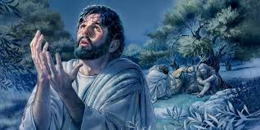
In today’s passage, Jesus reveals his prayer life. What do we do when life seems too difficult to bear? Jesus teaches us to pray. Prayer is the way to spiritual victory. Peter and the disciples did not pray and failed in the time of crisis. Let's learn more about Jesus, and how to pray.

- Read verses 39-40. Why did Jesus go with His disciples to the Mount of Olives? (39) What do the words "as usual" suggest? (21:37-38) What did Jesus say before He withdrew? (40) What can we learn from Jesus’ exhortation?

1-1, Read verses 39-40.

Jesus went out as usual to the Mount of Olives, and his disciples followed him. 40 On reaching the place, he said to them, “Pray that you will not fall into temptation.”

1-2, Why did Jesus go with His disciples to the Mount of Olives? (39)
1-3, What do the words "as usual" suggest? (21:37-38)

Jesus went out as usual to the Mount of Olives, and his disciples followed him.

- After Jesus observed the Passover in order to establish a new covenant in his blood with his disciples, Jesus prayed as usual.

Luke 21:37-38 reads,

“Each day Jesus was teaching at the temple, and each evening he went out to spend the night on the hill called the Mount of Olives, 38 and all the people came early in the morning to hear him at the temple.”

- Jesus went there to pray. In doing so, he made himself vulnerable to arrest.
- The Mount of Olives is located east of Jerusalem, across the Kidron Valley.

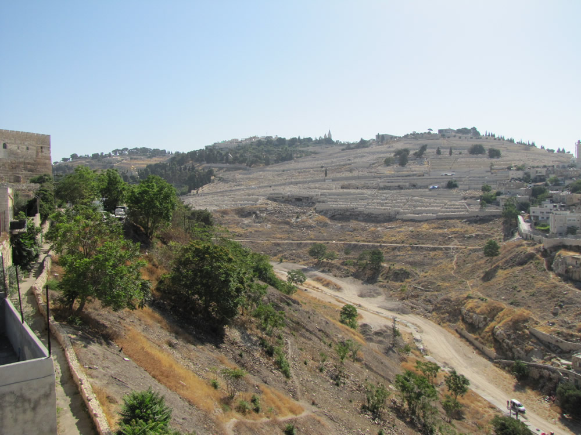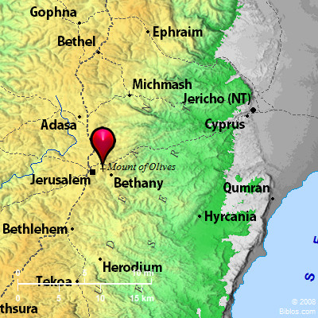

- This shows that Jesus had a habit going to a place to pray on a regular basis. Jesus prayed in the early morning and in the evening.

Mark 1:35 reads,

“Very early in the morning, while it was still dark, Jesus got up, left the house and went off to a solitary place, where he prayed.”

1-4, What did Jesus say before He withdrew? (40)

On reaching the place, he said to them, “Pray that you will not fall into temptation.”

- So far, Jesus had not directly told his disciples to pray. But Jesus had always set an example for them through his own habit of regular prayer.
- Jesus had taught them how to pray. Jesus had taught them to pray persistently. (chapter 19)
- But this time, Jesus directly told them to pray. He had not done this before.
- Now was a critical time and temptation was about to come upon them.
- Satan would attack their fellowship. The only way for them to overcome the devil's power was to pray.

1-5, What can we learn from Jesus’ exhortation?

- Though Jesus was facing the most difficult time of his life, his concern was for the the spiritual condition of his disciples too.
- So he warned them, “Pray that you will not fall into temptation.” Not only did Jesus pray, but he also encouraged his disciples to pray.
- At this critical time, they were in danger of denying Jesus. Jesus knew this very well. They needed God’s help through prayer.
- Jesus encouraged them to pray that they might not fall into temptation. Prayer would protect them and encourage them to be faithful to the end.
- Only by prayer, we can remain faithful to our mission and persevere under any trial.

- Read verses 41-44. Describe the way Jesus prayed. (41) What did He pray for? (42) What did Jesus mean by "this cup"? (Mk 10:38-39) What was God's will? (Lk 9:22) Who helped Jesus? (43) How did Jesus struggle to deny His will? (44) What can we learn from His prayer?

2-1, Read verses 41-44.

He withdrew about a stone’s throw beyond them, knelt down and prayed, 42 “Father, if you are willing, take this cup from me; yet not my will, but yours be done.” 43 An angel from heaven appeared to him and strengthened him. 44 And being in anguish, he prayed more earnestly, and his sweat was like drops of blood falling to the ground.[c]

2-2, Describe the way Jesus prayed. (41)

He withdrew about a stone’s throw beyond them, knelt down and prayed,

- To prepare himself, Jesus withdrew from his disciples about a stone's throw away from them. At this time, Jesus alone needed to fight a spiritual battle.
- Jesus knelt down and prayed. Kneeling is a symbol of humility. Jesus was humble before God.
- Jesus was submissive to God, though he knew that the moment of great trial was coming upon him.
- Even at the moment of his passion, he maintained humble reverence for the Father in Heaven.

2-3, What did He pray for? (42)

“Father, if you are willing, take this cup from me; yet not my will, but yours be done.”

- Jesus called God “Father.” Jesus, as an obedient son, honored God. Jesus did not doubt God’s love in the hour of agony.
- Jesus trusted the love of God for him. In this way Jesus shows us how to come to God with humble reverence and absolute trust in the love of God.

“Father, if you are willing, take this cup from me; yet not my will, but yours be done.”
- Although Jesus went resolutely to Jerusalem (9:51), Jesus now revealed his agony as he was about to face death.
- Jesus did not want to suffer and die. So Jesus prayed that his Father might take the cup from him. But that was not all.

“Father, if you are willing, take this cup from me; yet not my will, but yours be done.”
- Although pressure was heavy upon him, Jesus was submissive to God’s will.
- Jesus set a perfect example as a human being in terms of what true submission is all about. Praise Jesus who showed the perfect example for us!

2-4, What did Jesus mean by "this cup"? (Mk 10:38-39)

“You don’t know what you are asking,” Jesus said. “Can you drink the cup I drink or be baptized with the baptism I am baptized with?” 39 “We can,” they answered. Jesus said to them, “You will drink the cup I drink and be baptized with the baptism I am baptized with,40 but to sit at my right or left is not for me to grant. These places belong to those for whom they have been prepared.”

- ‘This cup’ referred to his suffering and death at the hands of sinful men.
- Jesus had been predicting his suffering, death and resurrection for a long time. He also shared this repeatedly with His disciples (9:22; 9:44; 18:31-33).

2-5, What was God's will? (Lk 9:22)

And he said, “The Son of Man must suffer many things and be rejected by the elders, the chief priests and the teachers of the law, and he must be killed and on the third day be raised to life.”

- Jesus would die a shameful and painful death while still in His early 30s. No one wants to be rejected. But Jesus would be utterly rejected.
- No one wants to die, especially at the young age of 30. But Jesus had to die.
- When Jesus said, "take this cup from me," he honestly admitted that he wanted to avoid the terrible ordeal which was about to come upon Him.

2-6, Who helped Jesus? (43)

An angel from heaven appeared to him and strengthened him.

- God understood Jesus’ pain. But instead of taking the cup from Jesus, God sent an angel to Jesus.
- The angel came to strengthen Jesus to take the cup. Then Jesus must have known what God's indirect answer was: "Take this cup."
- And Jesus did not ask God again to take the cup from him. Instead, Jesus changed his prayer topic.

2-7, How did Jesus struggle to deny His will? (44)

And being in anguish, he prayed more earnestly, and his sweat was like drops of blood falling to the ground.

- Prayer begins with coming to God and presenting our requests to him. Prayer progresses with listening to God’s answer with willing submission.
- The essence of prayer is to deny our human desires by God’s help. Prayer results in a decision to obey God’s will.
- We must each struggle in prayer to obey the will of God personally.
- May God help each of us listen to his voice and obey his will through earnest prayer, like Jesus did.

- Jesus prayed so intensely that his sweat became like drops of blood falling to the ground.
- As a physician Luke must have described this with medical observation.
- This rare condition which involves sweating blood, is called Hematohidrosis.
- It is also called Hematidrosis, haematidrosis, hemidrosis or blood-sweat.
- Hematohidrosis is a rare condition in which a human being sweats blood. Leonardo Da Vinci described a soldier who sweated blood before battle.
- Jesus Christ experienced hematohidrosis while praying in the garden of Gethsemane.
- It may be that the capillaries of Jesus' blood vessels were bursting at the intensity of his struggle, and blood was literally mixed with his sweat.
- In this way, through a bloody struggle of prayer, Jesus overcame his fear, stress, agony and was determined to obey the will of God.
- Through prayer, Jesus won the victory even before going to actually fight the battle.

2-8, What can we learn from His prayer?

- Jesus’ prayer may reminds us of Hebrew 2:5-18, which is titled in NIV as “Jesus Made Fully Human”.
5 It is not to angels that he has subjected the world to come, about which we are speaking. 6 But there is a place where someone has testified: “What is mankind that you are mindful of them, a son of man that you care for him? 7 You made them a little lower than the angels; you crowned them with glory and honor 8 and put everything under their feet.” In putting everything under them, God left nothing that is not subject to them. Yet at present we do not see everything subject to them. 9 But we do see Jesus, who was made lower than the angels for a little while, now crowned with glory and honor because he suffered death, so that by the grace of God he might taste death for everyone. 10 In bringing many sons and daughters to glory, it was fitting that God, for whom and through whom everything exists, should make the pioneer of their salvation perfect through what he suffered. 11 Both the one who makes people holy and those who are made holy are of the same family. So Jesus is not ashamed to call them brothers and sisters. 12 He says, “I will declare your name to my brothers and sisters; in the assembly I will sing your praises.” 13 And again, “I will put my trust in him.” And again he says, “Here am I, and the children God has given me.” 14 Since the children have flesh and blood, he too shared in their humanity so that by his death he might break the power of him who holds the power of death—that is, the devil— 15 and free those who all their lives were held in slavery by their fear of death. 16 For surely it is not angels he helps, but Abraham’s descendants. 17 For this reason he had to be made like them, fully human in every way, in order that he might become a merciful and faithful high priest in service to God, and that he might make atonement for the sins of the people. 18 Because he himself suffered when he was tempted, he is able to help those who are being tempted.

- Here we learn God’s way of helping us. God did not remove Jesus’ cup of suffering. Rather, he strengthened Jesus to take the cup.
- Christ was made perfect in Gethsemane, not only by prayer, but also by the suffering.
- The cup could not pass because the suffering must go on and yield its fruit of perfection.
- God purifies and perfects our faith through many sufferings. Suffering has meaning and purpose in our life.
- When we see God’s sheep’s (including His children entrusted with us as guardians) suffering, we are tempted to remove their cup of sufferings.
- We sympathize with their sufferings and often want to take up their crosses for them.
- But that does not help sheep or our children. We have to strengthen their faith by helping them to take up their crosses and follow Jesus to the end.
- Let us detach ourselves from the human love that we have for them and put trust in the work of the Holy Spirit. We will surely see God’s victory through offering prayers and through fighting the spiritual battle continually.

Hebrews 5:7 reads,
During the days of Jesus’ life on earth, he offered up prayers and petitions with fervent cries and tears to the one who could save him from death, and he was heard because of his reverent submission.

- Read verses 45-46. What did Jesus’ disciples do while He prayed? (45) What does this show about them? How did Jesus help them? (46)

3-1, Read verses 45-46.

When he rose from prayer and went back to the disciples, he found them asleep, exhausted from sorrow. 46 “Why are you sleeping?” he asked them. “Get up and pray so that you will not fall into temptation.”

3-2, What did Jesus’ disciples do while He prayed? (45)
3-3, What does this show about them?

When he rose from prayer and went back to the disciples, he found them asleep, exhausted from sorrow.
- When Jesus rose from prayer and went back to his disciples, he found them asleep, exhausted from sorrow.
- Their dreams of an earthly messianic kingdom would not be fulfilled. Instead, hardship and suffering awaited them.
- It was too much for them to bear. They became very sorrowful. Jesus had told them to pray, but they were not used to struggling in prayer.
- They could only wrestle with sorrow until they were exhausted. Then they closed their eyes and slept. Many of us are like this.
- When we must struggle in prayer, we escape by sleeping, gaming, watching Youtube, or eating excessively.

3-4, How did Jesus help them? (46)

“Why are you sleeping?” he asked them. “Get up and pray so that you will not fall into temptation.”

- Temptation is real when we try to follow Jesus. Temptation comes in different forms like addiction to video games, love of money, pleasure-seeking or so on.
- Let’s listen to Jesus’ words and pray!

Conclusion

Prayer is our spiritual breath. Most men of God were men of prayer. Jesus teaches us how to overcome temptations and obey the will of God through his prayer on the Mount of Olives. Though Jesus is the Son of God, he was also fully human. In his humanness, he needed to pray. In his agony, he prayed until he submitted to the will of God. It was the time of the devil’s temptation. Through prayer, Jesus triumphed over his suffering and the devil. He was ready to obey the will of God. But his disciples did not pray. So they depended on their human loyalty. As a result, they failed miserably, especially Peter. Today let’s learn from Jesus how to pray so that we may submit ourselves to the will of God. May God bless us to prepare our summer ministry with many prayers.

One Word: Jesus prayed!

