They Will See the Son of Man Coming

Luke 21:20-38
Key Verse 27
“At that time they will see the Son of Man coming in a cloud with power and great glory.”

Introduction
This passage may be divided into a couple of parts. The first part is about the desolation of Jerusalem from verses 20-24, making a transition that God’s favor was moved from the Jews to the Gentiles. The second part is about the signs of the end times. God has a plan according to his redemptive history. Help us to have a clear perspective through this passage and live by faith.

1. Read verses 20-24. What sign will indicate the desolation of Jerusalem and how can people survive from it? (20, 21) Why would Jerusalem be desolated? (22) How dreadful would those days be? (23, 24) What warning can we learn from the desolation of Jerusalem?

1-1, Read verses 20-24.
“When you see Jerusalem being surrounded by armies, you will know that its desolation is near.21 Then let those who are in Judea flee to the mountains, let those in the city get out, and let those in the country not enter the city. 22 For this is the time of punishment in fulfillment of all that has been written. 23 How dreadful it will be in those days for pregnant women and nursing mothers! There will be great distress in the land and wrath against this people. 24 They will fall by the sword and will be taken as prisoners to all the nations. Jerusalem will be trampled on by the Gentiles until the times of the Gentiles are fulfilled.

1-2, What sign will indicate the desolation of Jerusalem and how can people survive from it? (20, 21)
“When you see Jerusalem being surrounded by armies, you will know that its desolation is near. 21 Then let those who are in Judea flee to the mountains, let those in the city get out, and let those in the country not enter the city.

- From verse 20, Jesus speaks very specifically about Jerusalem. It was to warn his people of the coming judgment so they could flee from it.
- Foreign armies would surround Jerusalem. This would be the sign that terrible and complete destruction was near.
- The temple would be demolished, making Jerusalem desolate. All of her inhabitants would either be killed or taken prisoner.
- The city would be given over to the Gentiles and the people of Israel would be dispersed among the nations.

1-3, Why would Jerusalem be desolated? (22)

For this is the time of punishment in fulfillment of all that has been written.
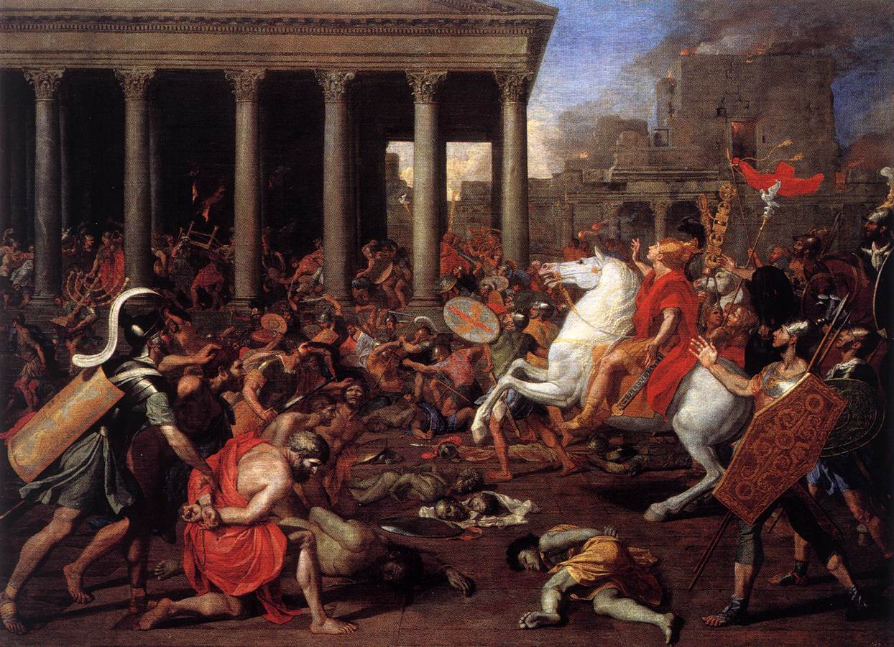
- This was God’s punishment upon the city and the nation in fulfillment of Scripture. This was literally fulfilled. In A.D. 70, Roman General Titus invaded the city.
- He demolished the temple, just seven years after it was finished, leaving no stone on another.
- Practically, it was to get gold out from between the stones. Spiritually, it fulfilled Jesus’ prophecy precisely.
- The Roman army killed over one million people and took another 100,000 captive.

1-4, How dreadful would those days be? (23, 24)

How dreadful it will be in those days for pregnant women and nursing mothers! There will be great distress in the land and wrath against this people. 24 They will fall by the sword and will be taken as prisoners to all the nations. Jerusalem will be trampled on by the Gentiles until the times of the Gentiles are fulfilled.

- Jerusalem was completely destroyed. Some zealous Jews made a last stand in the Jerusalem temple, thinking it was a sacred place.
- Titus totally destroyed the temple, tearing stone from stone until not one stone was left on another.
- The destruction was without mercy, even for pregnant women and nursing mothers. This was God’s punishment upon Jerusalem’s unbelief and failure to maintain God’s blessing.

1-5, What warning can we learn from the desolation of Jerusalem?

- As they were punished for their sins, so can any other city or nation be punished also.
- This is a powerful demonstration of God’s righteous judgment.
- The judgment of Jerusalem also served God’s redemptive purpose. It liberated Christianity from the bonds of Judaism.
- Gentile nations could embrace and live out gospel faith in forms suited to their own cultures.
- The Gentiles have enjoyed God’s favor for 2,000 years.
- But such favor on the Gentiles are not the end of the story. This time of favor will end according to God’s schedule. From verse 25, Jesus moved on to the end times.
- We believe that God has made North America a kingdom of priests and a holy nation.
- We must bear this privilege with holy reverence before God.

2. Read verses 25-28. What signs will appear in the heavenly bodies and in the earth, and how will people respond? (25, 26) How will the Son of Man come? (27) What did Jesus tell the believers to do on the day of his coming? (28) What can we learn from Jesus’ words?

2-1, Read verses 25-28.

“There will be signs in the sun, moon and stars. On the earth, nations will be in anguish and perplexity at the roaring and tossing of the sea. 26 People will faint from terror, apprehensive of what is coming on the world, for the heavenly bodies will be shaken. 27 At that time they will see the Son of Man coming in a cloud with power and great glory. 28 When these things begin to take place, stand up and lift up your heads, because your redemption is drawing near.”

2-2, What signs will appear in the heavenly bodies and in the earth, and how will people respond? (25, 26)

“There will be signs in the sun, moon and stars. On the earth, nations will be in anguish and perplexity at the roaring and tossing of the sea. 26 People will faint from terror, apprehensive of what is coming on the world, for the heavenly bodies will be shaken.

- Jesus describes the world situation just before his Second Coming. The signs that precede his Second Coming are unmistakable.
- The heavenly bodies will be shaken. On earth men will faint from terror, apprehensive of what is coming.
- Humans will be overcome with fear. The Son of Man’s return comes next.

2-3, How will the Son of Man come? (27)

At that time they will see the Son of Man coming in a cloud with power and great glory.

- The term of “the Son of Man” is shown for the first time in the book of Daniel 7.

Daniel 7:13-14 reads,
“In my vision at night I looked, and there before me was one like a son of man, coming with the clouds of heaven. He approached the Ancient of Days and was led into his presence. 14 He was given authority, glory and sovereign power; all nations and peoples of every language worshiped him. His dominion is an everlasting dominion that will not pass away, and his kingdom is one that will never be destroyed.

- Here the Son of Man refers to Jesus. When Jesus mentions the coming of the Son of Man, he is referring to this royal figure who receives kingdom authority from God.
- Jesus says that the Son of Man will be seen coming on the clouds. Jesus Christ, will come again in power and great glory.
- This is where history is heading. Many godless people think that history is a bunch of chance events that are going nowhere. But this is not true.
- All of history is heading toward the Second Coming of Jesus Christ in power and great glory.
- The words “in power and great glory” explain the nature of his second coming. It will be quite different than his first coming.
- When Jesus was born, he came as a humble and gentle baby in a manger. But when he comes again, it will be with power and great glory.
- He comes as King and Judge.

Matthew 24:30 says,
“At that time the sign of the Son of Man will appear in the sky, and all the nations of the earth will mourn. They will see the Son of Man coming on the clouds of the sky, with power and great glory. And he will send his angels with a loud trumpet call, and they will gather his elect from the four winds, from one end of the heavens to the other.”

2-4, What did Jesus tell the believers to do on the day of his coming? (28)

When these things begin to take place, stand up and lift up your heads, because your redemption is drawing near.”

- Jesus’ second coming is the time of final victory and redemption for his people. They were mistreated by God-haters and sometimes hung their heads in humiliation for his name’s sake.
- Now is the high time for them to stand up and lift up their heads.
- But when he comes again, final victory is given to them. The redeemed church will rise and join Jesus and those who are living will meet him in the air.
- What a great day it will be when we see Christ and live forever with him!

1 Thessalonians 4:16-18 reads,
“For the Lord himself will come down from heaven, with a loud command, with the voice of the archangel and with the trumpet call of God,and the dead in Christ will rise first. 17 After that, we who are still alive and are left will be caught up together with them in the clouds to meet the Lord in the air. And so we will be with the Lord forever. 18 Therefore encourage one another with these words.”

Revelation 21:1-4 reads,
“Then I saw “a new heaven and a new earth,” for the first heaven and the first earth had passed away, and there was no longer any sea. 2 I saw the Holy City, the new Jerusalem, coming down out of heaven from God, prepared as a bride beautifully dressed for her husband. 3 And I heard a loud voice from the throne saying, “Look! God’s dwelling place is now among the people, and he will dwell with them. They will be his people, and God himself will be with them and be their God. 4 ‘He will wipe every tear from their eyes. There will be no more death’ or mourning or crying or pain, for the old order of things has passed away.”
- There will be weeping and crying among unbelievers. God-haters and evil doers will be punished.

2-5, What can we learn from Jesus’ words?

- Though there are many trials and tribulations that Christians will go through in this world, our great comfort and hope is this: Jesus gives final victory when he comes again.
- Jesus will wipe every tear from our eyes and crown us with everlasting glory. This is such good news!
- In order to help us believe, Jesus gives us assurance and warnings in the rest of this passage.
- Jesus assures us through the fulfillment of the signs. Once we have been enlightened by Jesus’ teachings, our eyes open to the true spiritual meaning of the events in our world.
- Dreadful events do not frighten us. Rather, we see how God is working to fulfill his good will.

3. Read verses 29-33. What did Jesus want his disciples to understand through this parable? (29-31) How did Jesus assure us that these things that would happen? (32,33) What kind of faith should we have concerning Jesus’ words? (33)

3-1, Read verses 29-33.

He told them this parable: “Look at the fig tree and all the trees. 30 When they sprout leaves, you can see for yourselves and know that summer is near. 31 Even so, when you see these things happening, you know that the kingdom of God is near. 32 “Truly I tell you, this generation will certainly not pass away until all these things have happened.33 Heaven and earth will pass away, but my words will never pass away.

3-2, What did Jesus want his disciples to understand through this parable? (29-31)

He told them this parable: “Look at the fig tree and all the trees. 30 When they sprout leaves, you can see for yourselves and know that summer is near. 31 Even so, when you see these things happening, you know that the kingdom of God is near.

- Just as sprouting leaves on a fig tree tell us that summer is near, so the fulfillment of these signs tells us that the kingdom of God is near.

3-3, How did Jesus assure us that these things that would happen? (32, 33)
3-4, What kind of faith should we have concerning Jesus’ words? (33)

“Truly I tell you, this generation will certainly not pass away until all these things have happened. 33 Heaven and earth will pass away, but my words will never pass away.

- Jesus is in very nature God, who made the heavens and the earth by his word.
- The fulfillment of Jesus' word is more certain than the ground we walk on or the air we breathe.
- Because Jesus promised to come and bring final victory, we can be sure of it. Jesus also gave us warnings.

Heaven and earth will pass away, but my words will never pass away.

4. Read 34-38. What warning did Jesus give his disciples regarding the last day? (34, 35) What did Jesus tell his disciples to do in preparation for the last day when they stand before him? (36) What did Jesus do each day at the temple and where did he spend time at night?(37). Why did people come to the temple early in the morning? (38)

4-1, Read 34-38.
“Be careful, or your hearts will be weighed down with carousing, drunkenness and the anxieties of life, and that day will close on you suddenly like a trap. 35 For it will come on all those who live on the face of the whole earth. 36 Be always on the watch, and pray that you may be able to escape all that is about to happen, and that you may be able to stand before the Son of Man.” 37 Each day Jesus was teaching at the temple, and each evening he went out to spend the night on the hill called the Mount of Olives, 38 and all the people came early in the morning to hear him at the temple.

4-2, What warning did Jesus give his disciples regarding the last day? (34, 35)
“Be careful, or your hearts will be weighed down with carousing, drunkenness and the anxieties of life, and that day will close on you suddenly like a trap. 35 For it will come on all those who live on the face of the whole earth.

- People who don’t believe in Jesus’ promise cannot face the distressing terror of this world.
- So they get drunk, use drugs, go to parties, and play video games endlessly in order to cope with their mental stress.
- While they try to escape reality in these ways, they will be caught in virtual reality.
- They become like an animal in a trap. Jesus’ people must be careful not to fall into such attempts at escapism. What then can we do?

4-3, What did Jesus tell his disciples to do in preparation for the last day when they stand before him? (36)

Be always on the watch, and pray that you may be able to escape all that is about to happen, and that you may be able to stand before the Son of Man.”

- This is Jesus’ call to heed universal judgment. Jesus’ discourse ends with a practical exhortation, a final call to faithfulness in the midst of pressure.
- Constant watch is necessary since the time of his return is unknown.
- With constant watch comes the call to pray for strength because it is easy to grow weary and tired while enduring temptation and hardships.
- Without prayer we cannot overcome false messiahs and the temptation of Satan.
- People are enjoying the night culture but we are retiring early at night in order to wake up early and go to the place of personal prayer and Bible verse meditation.
- In this way, we can gain strength to serve campus mission until Jesus comes again.

4-4, What did Jesus do each day at the temple and where did he spend time at night?(37).

Each day Jesus was teaching at the temple, and each evening he went out to spend the night on the hill called the Mount of Olives,

- Jesus set a perfect example for us to follow.
- When Jesus spent the night in the hill where nobody bothered Him, He prepared to serve God’s will by intimate prayer.
- Spiritual battle could begin at night and be confirmed in the morning if one’s condition is good while we sleep.
- May the Lord help us to conquer the time of both night and day so that we may overcome any temptation in this world to please the Lord God until we meet Him.

4-5, Why did people come to the temple early in the morning? (38)
and all the people came early in the morning to hear him at the temple.

Conclusion

The Son of Man, Jesus Christ, is coming again in power and great glory. This is the climax of human history. This is the day of victory and redemption for those who believe in him. May God help us to have living hope about the Second Coming of Christ and may we live accordingly for his glory.

One word: The Son of Man is coming!

