Produce Fruit in Keeping with Repentance

Luke 3:1-20
Key Verse 8

“Produce fruit in keeping with repentance. And do not begin to say to yourselves, ‘We have Abraham as our father.’ For I tell you that out of these stones God can raise up children for Abraham.”

Introduction)

Luke the historian depicts the ministry of John the baptist in today’s passage. We can learn about what the world was like and how he prepared the way for the Messiah. His message to the people was to produce fruit in keeping with repentance. Such a message was not easy to deliver. Speaking about repentance in our times can be a difficult thing as many people may not want to hear something that requires them to change. May the Lord help us to grow into God’s servants like John the baptist.

1. Read verses 1-6. Who were those in power when the word of God comes to John? (1-2a) Where was he when it came to him? (2b, 1:80) Why do you think the word of God came to John instead of a powerful political or religious leader? What does John begin doing? (3) What had the prophet Isaiah foretold John would tell the people? (4-6, Isa 40:3-5, Matt 3:3, Mark 1:2, John 1:23) What do you think this means? (Malachi 3:1a)

1-1) Read verses 1-6.

In the fifteenth year of the reign of Tiberius Caesar—when Pontius Pilate was governor of Judea, Herod tetrarch of Galilee, his brother Philip tetrarch of Iturea and Traconitis, and Lysanias tetrarch of Abilene— 2 during the high-priesthood of Annas and Caiaphas, the word of God came to John son of Zechariah in the wilderness. 3 He went into all the country around the Jordan, preaching a baptism of repentance for the forgiveness of sins. 4 As it is written in the book of the words of Isaiah the prophet:
“A voice of one calling in the wilderness,
‘Prepare the way for the Lord,
make straight paths for him.
5 Every valley shall be filled in,
every mountain and hill made low.
The crooked roads shall become straight,
the rough ways smooth.
6 And all people will see God’s salvation.’”

1-2) Who were those in power when the word of God comes to John? (1-2a)

In the fifteenth year of the reign of Tiberius Caesar—when Pontius Pilate was governor of Judea, Herod tetrarch of Galilee, his brother Philip tetrarch of Iturea and Traconitis, and Lysanias tetrarch of Abilene— 2 during the high-priesthood of Annas and Caiaphas,

Luke identifies the political and religious leaders during the time of John the baptist.
He recounts events that occurred throughout history as follows;

In the fifteenth year of the reign of Tiberius Caesar
Roman Emperor from 14 AD to 37 AD. Born Tiberius Claudius Nero, a Claudian, Tiberius was the son of Tiberius Claudius Nero and Livia Drusilla. His mother divorced Nero and married Augustus in 39 BC, making him a step-son of Octavian.
Tiberius would later marry Augustus' daughter Julia the Elder (after being forced to divorce from his marriage to Scribonia) and even later be adopted by Augustus, by which act he officially became a Julian, bearing the name Tiberius Julius Caesar. The subsequent emperors after Tiberius would continue this blended dynasty of both families for the next forty years; historians have named it the Julio-Claudian dynasty. In relations to the other emperors of this dynasty, Tiberius was the stepson of Augustus, grand-uncle of Caligula, and great-grand uncle of Nero.
But he came to be remembered as a dark, reclusive, and sombre ruler who never really desired to be emperor; Pliny the Elder called him tristissimus hominum, "the gloomiest of men."
After the death of Tiberius’ son Drusus Julius Caesar in 23 AD, he became more reclusive and aloof. In 26 AD, against better judgement, Tiberius exiled himself from Rome and left administration largely in the hands of his unscrupulous Praetorian Prefects Lucius Aelius Sejanus and Quintus Naevius Sutorius Macro. It was during the government of Tiberius that, in the Roman province of Judea, Jesus was crucified by Pontius Pilate. - from wikipedia

Pontius Pilate
Judea was under the control of Pontius Pilate. People considered him to be a sneaky individual.
For instance he washed his hands in order to avoid any negative response from any party concerning the guilt of condemning Jesus to death.
The “fifteenth year of Tiberius Caesar” means about 29 AD. Due to the fact that Tiberius ruled the whole Roman world at a remote island called Capri through written letters, Pontius Pilate was cautious about how to be reported to him from the people.
So Pilate had to satisfy the Jewish people politically in order to avoid any complaints being reported to the Emperor, Tiberius. He was very skillful in dealing with so many sects such as Pharisees, Sadducees, and Herod the Tetrarch .
Herod tetrarch of Galilee, his brother Philip(II) tetrarch of Iturea and Traconitis, and Lysanias tetrarch of Abilene(Debatable) 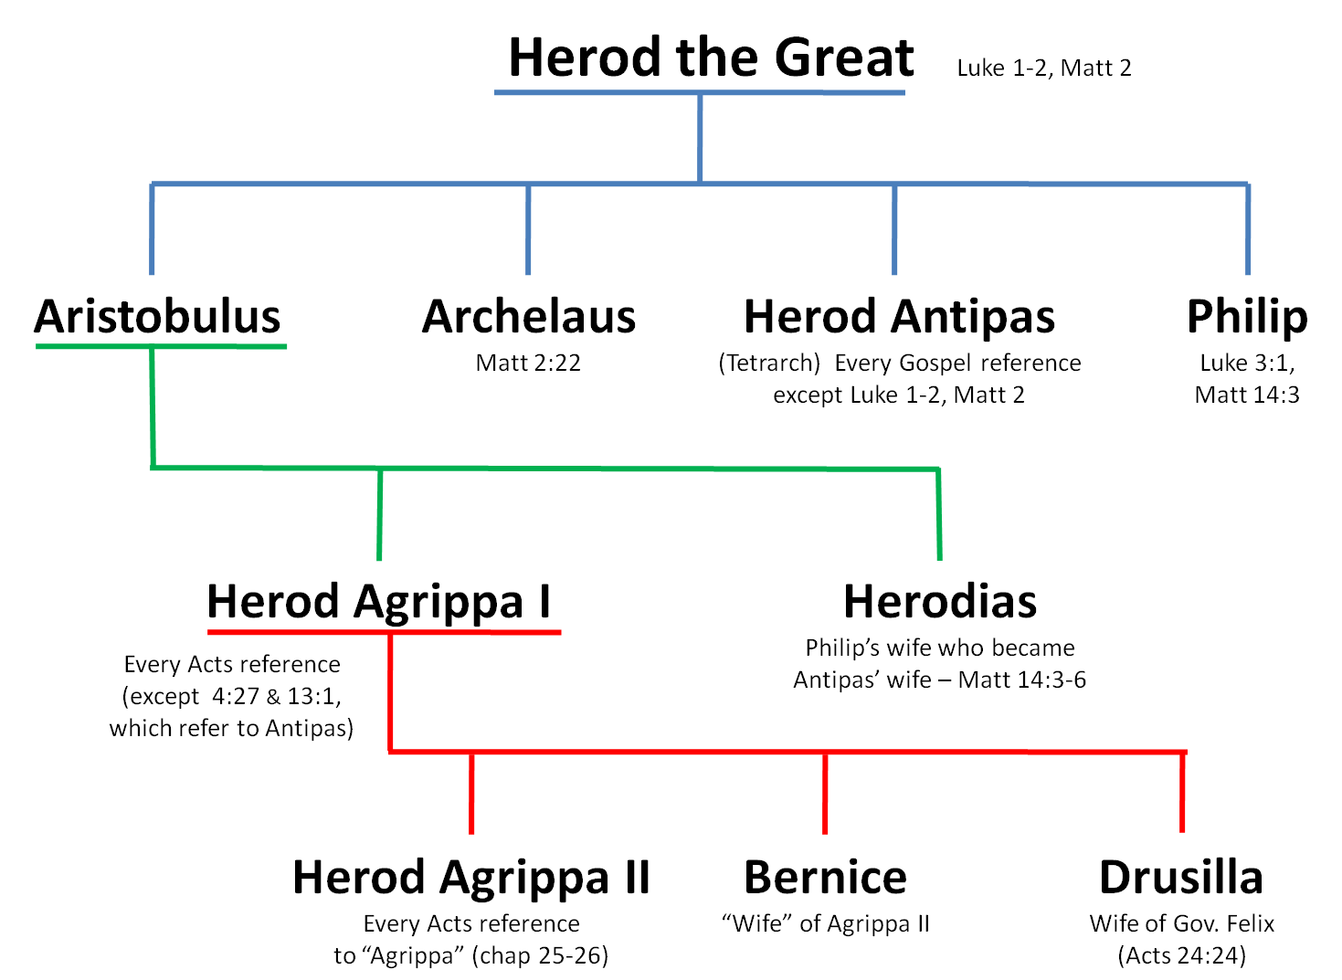

Ruled by Herod family until 6AD
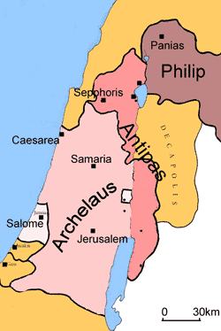
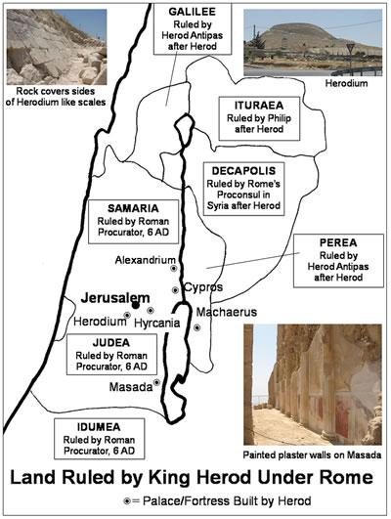
---- Land ruled by Herod family and Roman procurator after 6AD

Herod Antipas took his own brother Philip’s wife, Herodias(Mark 6:18), provoking his anger.
The division of the kingdom was the cause of a power struggle among the brothers.
It victimized the lives of innocent people in all their respective territories.

Annas and Caiphas
The high priest should have been a servant and a messenger of God. However in those days there were two high priests.
1. Annas
Annas had been high priest from A.D. 6 to 15. The Romans had removed him from office yet he still held considerable power. Five of his sons succeeded him as high priest. He was the father-in-law of Caiaphas - the high priest who was in office at the time of John the baptist as well as Jesus ministry.
Annas was still called "high priest" even though he was not serving in that capacity at the time.
His power was apparent. When Jesus was arrested He was brought to Annas first rather than Caiaphas.
12 Then the detachment of soldiers with its commander and the Jewish officials arrested Jesus. They bound him 13 and brought him first to Annas, who was the father-in-law of Caiaphas, the high priest that year. 14 Caiaphas was the one who had advised the Jewish leaders that it would be good if one man died for the people. (John 18:13,14).
19 Meanwhile, the high priest questioned Jesus about his disciples and his teaching.
20 “I have spoken openly to the world,” Jesus replied. “I always taught in synagogues or at the temple, where all the Jews come together. I said nothing in secret. 21 Why question me? Ask those who heard me. Surely they know what I said.”
22 When Jesus said this, one of the officials nearby slapped him in the face. “Is this the way you answer the high priest?” he demanded.
23 “If I said something wrong,” Jesus replied, “testify as to what is wrong. But if I spoke the truth, why did you strike me?” 24 Then Annas sent him bound to Caiaphas the high priest.
(John 18:19-24).
2. Caiaphas
Caiaphas was the ruling High Priest at the time of Jesus ministry (A.D. 18-36). He was the son-in-law of Annas.
Therefore many of the Jews who had come to visit Mary, and had seen what Jesus did,believed in him. 46 But some of them went to the Pharisees and told them what Jesus had done. 47 Then the chief priests and the Pharisees called a meeting of the Sanhedrin.
“What are we accomplishing?” they asked. “Here is this man performing many signs. 48 If we let him go on like this, everyone will believe in him, and then the Romans will come and take away both our temple and our nation.”
49 Then one of them, named Caiaphas, who was high priest that year, spoke up, “You know nothing at all! 50 You do not realize that it is better for you that one man die for the people than that the whole nation perish.”
51 He did not say this on his own, but as high priest that year he prophesied that Jesus would die for the Jewish nation, 52 and not only for that nation but also for the scattered children of God, to bring them together and make them one. 53 So from that day on they plotted to take his life.
54 Therefore Jesus no longer moved about publicly among the people of Judea. Instead he withdrew to a region near the wilderness, to a village called Ephraim, where he stayed with his disciples. (John 11:45-54).

1-3) Where was he when it came to him? (2b, 1:80)

the word of God came to John son of Zechariah in the wilderness.

And the child grew and became strong in spirit ; and he lived in the wilderness until he appeared publicly to Israel.

When John was in the wilderness preparing himself to do the work as the forerunner of the Messiah by living a pure and holy life before God, the living word of God came to him.

When the word of God came to him, he was empowered to break his silence and began to cry out to the people to repent of their sins.

1-4) Why do you think the word of God came to John instead of a powerful political or religious leader?

John’s life was drastically changed when the word of God came to him, he was filled with the Spirit of God, delivering the message of God.

Luke 1:74b, 75 says,

“to enable us to serve him without fear
75 in holiness and righteousness before him all our days.”

Jeremiah 5:1 reads,

"Go up and down the streets of Jerusalem, look around and consider, search through her squares. If you can find but one person who deals honestly and seeks the truth, I will forgive this city.

Jeremiah had a similar story to John the baptist, being a son of a priestly family and having the Spirit of God come upon him. When the word of God came to him in person, he was filled with the Spirit and preached the message of God’s impending judgment.

May the Lord grant us His Spirit to enable us to speak His word and His truth.

The word of God came to John

When John prepared himself before God, the word of God from above came upon him.

The word of God changed his heart.

The word of God can change history through a single person because it is living and active (Hebrews 4:12)

God’s Spirit and His word was the source of John’s power!

The Spirit of God enabled him to not fear any man including the cruel king Herod Antipas.

He stood boldly as a shepherd; the forerunner of Jesus Christ.

1-5) What does John begin doing? (3)

3 He went into all the country around the Jordan, preaching a baptism of repentance for the forgiveness of sins.

John was between 20 and 30 years old. As a young man he preached a baptism of repentance for the forgiveness of sins.

He was a true servant of God because he preached a message of repentance, judgment, and salvation.

1-6) What had the prophet Isaiah foretold John would tell the people? (4-6, Isa 40:3-5, Matt 3:3, Mark 1:2, John 1:23)

4 As it is written in the book of the words of Isaiah the prophet:
“A voice of one calling in the wilderness,
‘Prepare the way for the Lord,
make straight paths for him.
5 Every valley shall be filled in,
every mountain and hill made low.
The crooked roads shall become straight,
the rough ways smooth.
6 And all people will see God’s salvation.’”

Isaiah 40:3-5 read,

A voice of one calling:
“In the wilderness prepare
the way for the Lord;
make straight in the desert
a highway for our God.
4 Every valley shall be raised up,
every mountain and hill made low;
the rough ground shall become level,
the rugged places a plain.
5 And the glory of the Lord will be revealed,
and all people will see it together.
For the mouth of the Lord has spoken.”

Matthew 3:3 reads,
This is he who was spoken of through the prophet Isaiah:
“A voice of one calling in the wilderness,
‘Prepare the way for the Lord,
make straight paths for him.’”

Mark 1:2-3 read,
as it is written in Isaiah the prophet:
“I will send my messenger ahead of you,
who will prepare your way”—
3 “a voice of one calling in the wilderness,
‘Prepare the way for the Lord,
make straight paths for him.’”
John 1:23 reads,
23 John replied in the words of Isaiah the prophet, “I am the voice of one calling in the wilderness, ‘Make straight the way for the Lord.’”

1-7) What do you think this means? (Malachi 3:1a)

“I will send my messenger, who will prepare the way before me.

All people will see God’s salvation(Verse 6)

All people will see God’s salvation.

Through Jesus alone, all mankind can see God’s salvation.

All men fall short of the glory of God due to their sins.

Praise the Lord Jesus Christ who enabled us to see God’s salvation.

5 Every valley shall be filled in,
every mountain and hill made low.
The crooked roads shall become straight,
the rough ways smooth.
Valley, mountain, crooked roads, and rough ways are indicating the troubled conditions our hearts may be in before meeting God personally.
John the baptist became a voice of one calling in the wilderness and had a vision to prepare the hearts of the people to accept the Messiah.

May the Lord help us to see the same great vision for all people in our times.
May the Lord help us to serve people with the word of God so that they may see God’s salvation!

2. Read verses 7-14. What does John say to the crowds that come out to him to be baptized? (7-9) What does John tell the crowd to do? (10-11) What does he say to the tax collectors? (12-13) What does he say to the soldiers? (14) What do you think producing fruit in keeping with repentance means in your life?

2-1) Read verses 7-14.

7 John said to the crowds coming out to be baptized by him, “You brood of vipers! Who warned you to flee from the coming wrath? 8 Produce fruit in keeping with repentance. And do not begin to say to yourselves, ‘We have Abraham as our father.’ For I tell you that out of these stones God can raise up children for Abraham. 9 The ax is already at the root of the trees, and every tree that does not produce good fruit will be cut down and thrown into the fire.”
10 “What should we do then?” the crowd asked.
11 John answered, “Anyone who has two shirts should share with the one who has none, and anyone who has food should do the same.”
12 Even tax collectors came to be baptized. “Teacher,” they asked, “what should we do?”
13 “Don’t collect any more than you are required to,” he told them.
14 Then some soldiers asked him, “And what should we do?”
He replied, “Don’t extort money and don’t accuse people falsely—be content with your pay.”

2-2) What does John say to the crowds that come out to him to be baptized? (7-9)

7 John said to the crowds coming out to be baptized by him, “You brood of vipers! Who warned you to flee from the coming wrath? 8 Produce fruit in keeping with repentance. And do not begin to say to yourselves, ‘We have Abraham as our father.’ For I tell you that out of these stones God can raise up children for Abraham. 9 The ax is already at the root of the trees, and every tree that does not produce good fruit will be cut down and thrown into the fire.”
Matthew 3:7-10 read,

But when he saw many of the Pharisees and Sadducees coming to where he was baptizing, he said to them: “You brood of vipers! Who warned you to flee from the coming wrath?8 Produce fruit in keeping with repentance. 9 And do not think you can say to yourselves, ‘We have Abraham as our father.’ I tell you that out of these stones God can raise up children for Abraham. 10 The ax is already at the root of the trees, and every tree that does not produce good fruit will be cut down and thrown into the fire.

We see that the crowds refer to the Pharisees and Sadducees mainly.

When evangelizing we may encounter people who identify themselves as Christians. Some of these people may believe that their salvation comes from some sort of cultural association just as the Jews in the time of John the Baptist who felt that they would be accepted by God because they were “Sons of Abraham.”

But John harshly said that they are vipers and they must produce fruit in keeping with repentance.
John told them that their empty spiritual lives were useless to God who could raise up children for Abraham out of stones.

Unless they repent before God, the judgment of God is inevitable.

John’s message of repentance was very serious!

2-3) What does John tell the crowd to do? (10-11)

10 “What should we do then?” the crowd asked.
11 John answered, “Anyone who has two shirts should share with the one who has none, and anyone who has food should do the same.”
Thankfully the crowd asked with a contrite heart.
What should we do then?
We see through the people’s heart desire to be holy regardless of the difficult times.
When the word of God came to them through John, they were able to listen the shepherd’s voice and be ready to repent of their sins.
John’s answer was simple.
“Anyone who has two shirts should share with the one who has none, and anyone who has food should do the same.”

2-4) What does he say to the tax collectors? (12-13)

12 Even tax collectors came to be baptized. “Teacher,” they asked, “what should we do?”
13 “Don’t collect any more than you are required to,” he told them.

2-5) What does he say to the soldiers? (14)

14 Then some soldiers asked him, “And what should we do?”
He replied, “Don’t extort money and don’t accuse people falsely—be content with your pay.”

2-6) What do you think producing fruit in keeping with repentance means in your life?

3. Read verses 15-18. Who were people thinking John might be? (15) How does John answer them regarding this? (16, 17) What does John continue to do? (18) How do you think this message of repentance and judgment can be good news to them? (18b)

3-1) Read verses 15-18.

15 The people were waiting expectantly and were all wondering in their hearts if John might possibly be the Messiah. 16 John answered them all, “I baptize you with[b] water. But one who is more powerful than I will come, the straps of whose sandals I am not worthy to untie. He will baptize you with[c] the Holy Spirit and fire. 17 His winnowing fork is in his hand to clear his threshing floor and to gather the wheat into his barn, but he will burn up the chaff with unquenchable fire.” 18 And with many other words John exhorted the people and proclaimed the good news to them.

3-2) Who were people thinking John might be? (15)

15 The people were waiting expectantly and were all wondering in their hearts if John might possibly be the Messiah.

3-3) How does John answer them regarding this? (16, 17)

16 John answered them all, “I baptize you with water. But one who is more powerful than I will come, the straps of whose sandals I am not worthy to untie. He will baptize you with the Holy Spirit and fire. 17 His winnowing fork is in his hand to clear his threshing floor and to gather the wheat into his barn, but he will burn up the chaff with unquenchable fire.”

baptized with water vs baptized with the Holy Spirit and fire

John immediately took people’s attention away from himself and focused it on Jesus.

He introduced Jesus and pointed out that Jesus is more powerful than himself. John said that he was not worthy to untie the thongs of Jesus’ sandals.

John drew the line about what he could do for the people in terms of preparation for Jesus.

He clearly knew that the water could not wash their sins away.

Their sins were washed away when Jesus baptized them with the Holy Spirit.

Also John introduced Jesus as the very Judge at the day of judgment.

His judgment will come with fire.

3-4) What does John continue to do? (18)

18 And with many other words John exhorted the people and proclaimed the good news to them.
John continues to preach the word of God.

3-5) How do you think this message of repentance and judgment can be good news to them? (18b)

Good news has to do with repentance, judgment, and salvation for God’s day is coming.

It reminds of recent daily bread passage, Joel 2:1-14.

Blow the trumpet in Zion;
sound the alarm on my holy hill.
Let all who live in the land tremble,
for the day of the Lord is coming.
It is close at hand—
2 a day of darkness and gloom,
a day of clouds and blackness.
Like dawn spreading across the mountains
a large and mighty army comes,
such as never was in ancient times
nor ever will be in ages to come.
3 Before them fire devours,
behind them a flame blazes.
Before them the land is like the garden of Eden,
behind them, a desert waste—
nothing escapes them.
4 They have the appearance of horses;
they gallop along like cavalry.
5 With a noise like that of chariots
they leap over the mountaintops,
like a crackling fire consuming stubble,
like a mighty army drawn up for battle.
6 At the sight of them, nations are in anguish;
every face turns pale.
7 They charge like warriors;
they scale walls like soldiers.
They all march in line,
not swerving from their course.
8 They do not jostle each other;
each marches straight ahead.
They plunge through defenses
without breaking ranks.
9 They rush upon the city;
they run along the wall.
They climb into the houses;
like thieves they enter through the windows.
10 Before them the earth shakes,
the heavens tremble,
the sun and moon are darkened,
and the stars no longer shine.
11 The Lord thunders
at the head of his army;
his forces are beyond number,
and mighty is the army that obeys his command.
The day of the Lord is great;
it is dreadful.
Who can endure it?
12 “Even now,” declares the Lord,
“return to me with all your heart,
with fasting and weeping and mourning.”
13 Rend your heart
and not your garments.
Return to the Lord your God,
for he is gracious and compassionate,
slow to anger and abounding in love,
and he relents from sending calamity.
14 Who knows? He may turn and relent
and leave behind a blessing—
grain offerings and drink offerings
for the Lord your God.

4. Read verses 19-20. Why does John rebuke Herod (Antipas) the tetrarch? (19, Luke 13:32) What does Herod do in response to this? (20) Who takes up preaching the good news of God’s kingdom after John is put in prison? (Mark 1:14, 15)

4-1) Read verses 19-20.

19 But when John rebuked Herod the tetrarch because of his marriage to Herodias, his brother’s wife, and all the other evil things he had done, 20 Herod added this to them all: He locked John up in prison.

4-2) Why does John rebuke Herod (Antipas) the tetrarch? (19, Luke 13:32)

19 But when John rebuked Herod the tetrarch because of his marriage to Herodias, his brother’s wife, and all the other evil things he had done,

4-3) What does Herod do in response to this? (20)

20 Herod added this to them all: He locked John up in prison.

4-4) Who takes up preaching the good news of God’s kingdom after John is put in prison? (Mark 1:14, 15)

14 After John was put in prison, Jesus went into Galilee, proclaiming the good news of God. 15 “The time has come,” he said. “The kingdom of God has come near. Repent and believe the good news!”

Jesus continues to preach of the good news of the Kingdom of God..

God’s work continued after John was put in prison due to Herod’s lack of repentance,.

In Conclusion)

Today we had a chance to learn of the spirit of our ancestor of faith, John the baptist who lived for the glory of God. May the Lord help us to grow as a godly people who serve God in our lives with the same power and spirit in preaching the message of repentance, judgment, and salvation. May the Lord help us to receive His word through preparing our hearts in the wilderness where we meet our Lord Jesus Christ in person. Amen.

One word: The word God came to John!

