UBF PANAMA
2025 Christmas Sunday Worship Service
“Jesus Placed in a Manger”
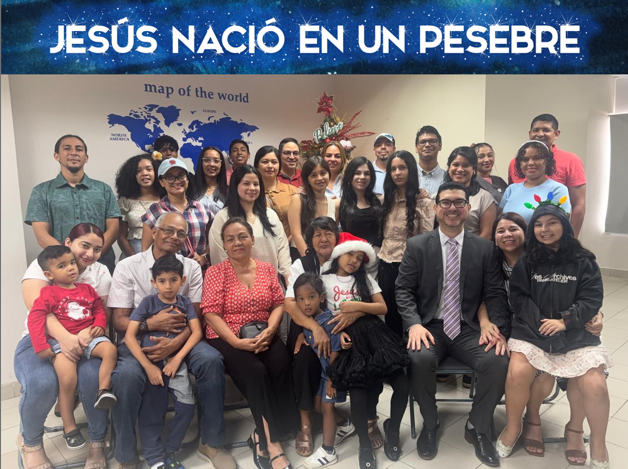
Luke 2:7: “and she gave birth to her firstborn, a son. She wrapped him in cloths and placed him in a manger, because there was no guest room available for them.”

On Sunday, December 21, 2025, Panama UBF held its 2025 Christmas Sunday Worship Service at the Bible Center, entitled: “Jesus Placed in a Manger”, based on Luke 2:1-7. Despite limited time for special preparations—due to the recent Bible Conference (Nov. 28–30) and Mother’s Day celebration (Dec. 7), along with our small number of coworkers— M. Joshua delivered a heart-moving message from this passage. The service was deeply touching, especially the video presentation of a heartfelt 'letter from Jesus' during Christmas: https://youtu.be/AYkiEV_IUPg?si=2EIDGwn4txZwtSOg [In Spanish]. God blessed us richly even in our simplicity!
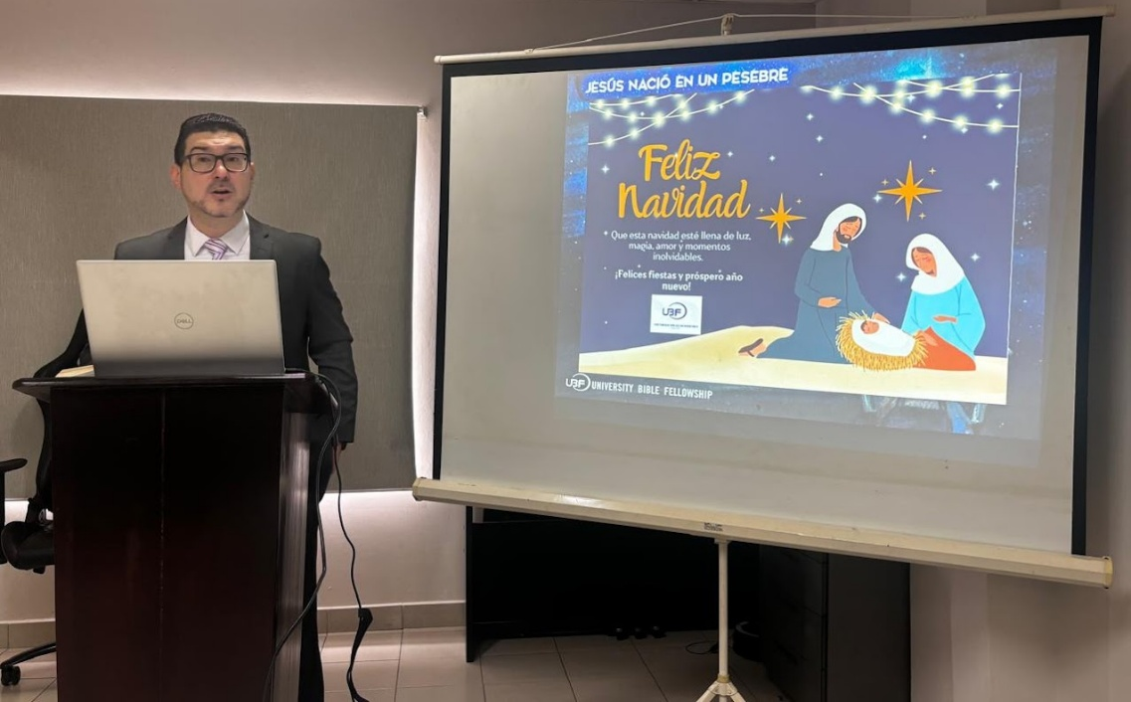
In the message, we learned the profound and heart-melting meaning of Jesus being placed in a manger. This humble beginning revealed the depths of Christ's humility: the King of kings chose not a palace but a feeding trough, entering the world in vulnerability and poverty to identify with the lowly and marginalized. It was a powerful sign of God's love—He did not come to be served but to serve, extending an open invitation to anyone, regardless of status or circumstance, to come to Him. The manger became a throne of grace, reminding us that Jesus welcomes all who seek Him, offering salvation and rest to every weary soul.

The video presents a heartfelt, first-person narration from Jesus' perspective, addressing humanity on the true meaning of Christmas. Jesus expresses nostalgia for simpler times when families gathered to share meals, sing carols, and resolve to live better lives, remembering His birth and allowing Him to be reborn in their hearts. He gently laments how modern celebrations have become superficial—filled with parties, jokes, drinking, and consumerism—while forgetting the sacred reason for the day and sidelining Him as the Guest of Honor. He reminds viewers of His humble birth in a manger due to no room in the inn, His rejection, and His willing sacrifice on the cross out of immense love for humanity. The video culminates in a warm invitation: to reflect on life, let go of grudges and pride, share with others, be grateful, and return to His path. Jesus promises open arms, eternal companionship, and the chance to start anew this Christmas, ending with the tender words: "With love, Jesus. Merry Christmas." We were all deeply moved to tears, reminded once again of the true reason for the season: the humble birth of Jesus in a manger, His sacrificial love, and his ultimate death on the cross for our salvation.
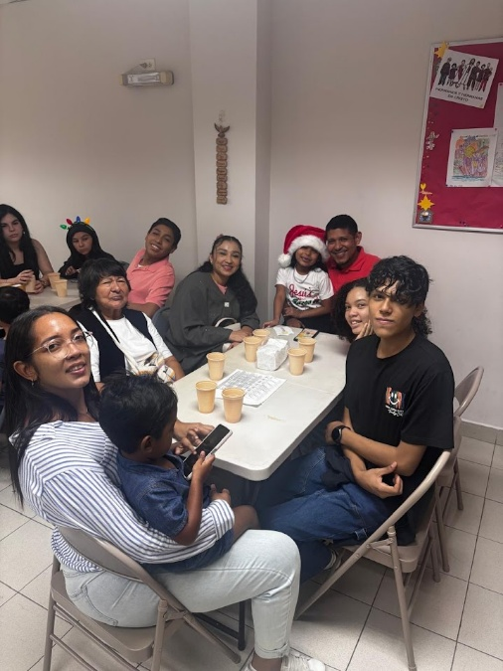
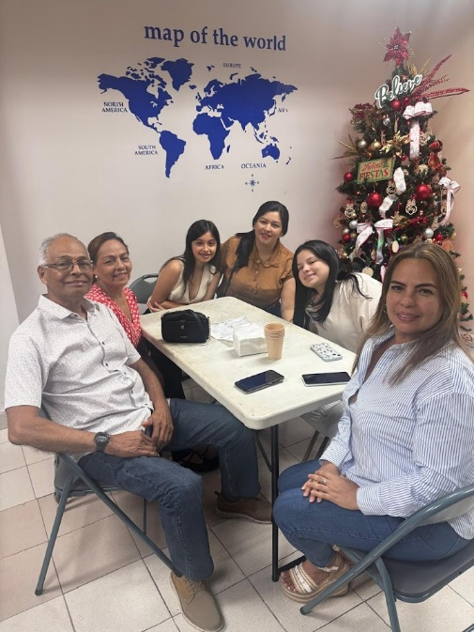
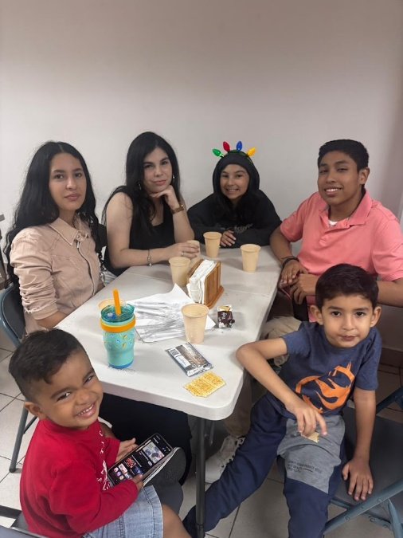
We concluded our Christmas Sunday Worship Service with a traditional Panamanian Christmas meal featuring turkey, glazed ham, and pernil (roasted pork leg). Sharing this delicious food, we enjoyed a truly precious time of fellowship. Laughter, stories, and heartfelt conversations filled the room as we celebrated the birth of our Savior together.

This coming Sunday, we will hold one more special Christmas lecture based on Luke 2:8-20, continuing to reflect on the shepherds' joyful response to the angels' announcement of Christ's birth. In January, we plan a series of special New Year lectures to prepare our hearts for the new year ahead. At the same time, we continue praying earnestly that M. Joshua will receive the visa to attend the Latin America Director’s Conference in Santiago, Chile (January 23-25, 2026). May God grant the visa, guide his travel and bless the entire ministry through these upcoming events!
Reported by M. Joshua Gutierrez (maikerg@gmail.com)

