UBF PANAMA
2025 Panama Bible Conference
“You Will Fish for People”
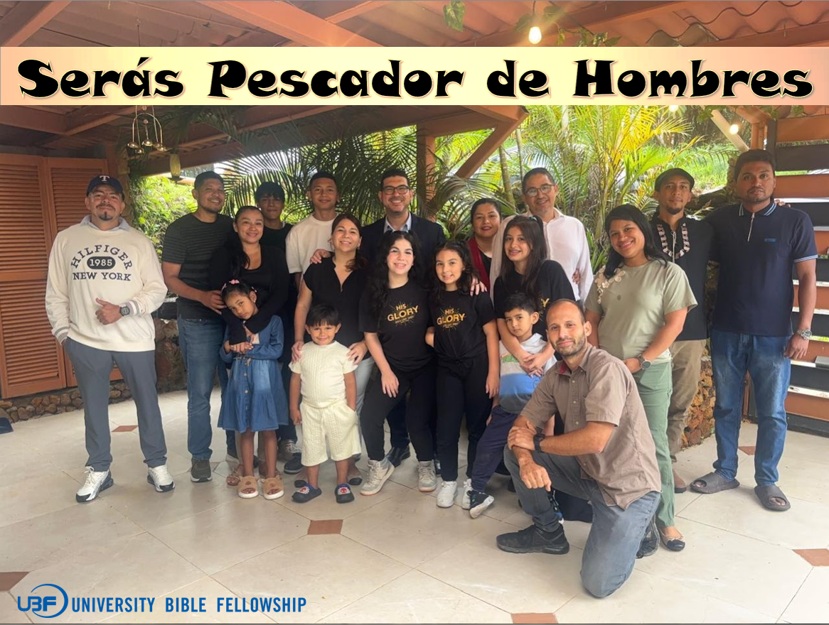
Luke 5:10b: “Then Jesus said to Simon, ‘Don’t be afraid; from now on you will fish for people.’”

On Nov. 28-30, Panama UBF held its 2025 Bible Conference amid the stunning mountains just outside Panama City, in the serene area of Cerro Azul ("Blue Hill"), with the theme: “You Will Fish for People”. We had prayed for 30 attendees, but with several cancellations just a week prior, we welcomed 23 participants. Unfortunately, three had to depart early on the second night due to pressing family matters.
The conference's start was indeed challenging. A car accident on the road, combined with heavy traffic from Panama's Independence Day parade, delayed most groups for hours. We had planned to begin at 4:00 PM, but the first arrivals trickled in around that time, while the van carrying our equipment and food didn't arrive until nearly 7:00 PM. This forces us to change the whole program on the spot.
Through these trials, I was reminded of the vital need for fervent prayer in our conferences. Our spiritual enemy clearly works to hinder the cause of salvation, but these obstacles only deepened our reliance on God's sovereignty.
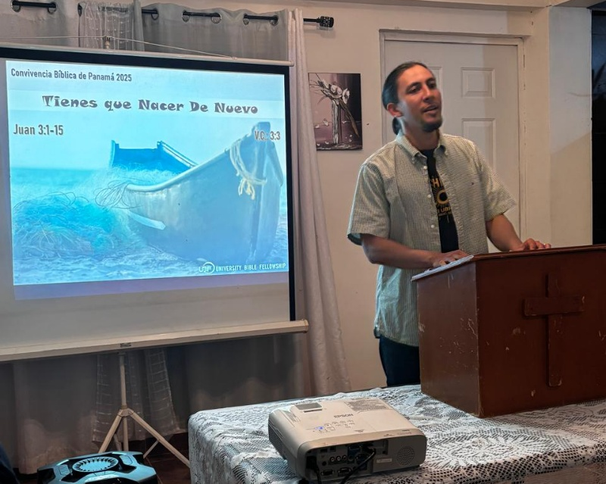
As soon as the van arrived, we quickly prepared and shared dinner. We then launched into the conference with the opening message, delivered by Dario: "You Must Be Born Again", drawn from John 3:1–15. Through it, we were reminded that we are all sinners, unable to enter God's kingdom unless born again. Just as the Israelites looked up to the bronze snake in the wilderness for healing, we too must fix our eyes on Jesus on the cross for salvation.
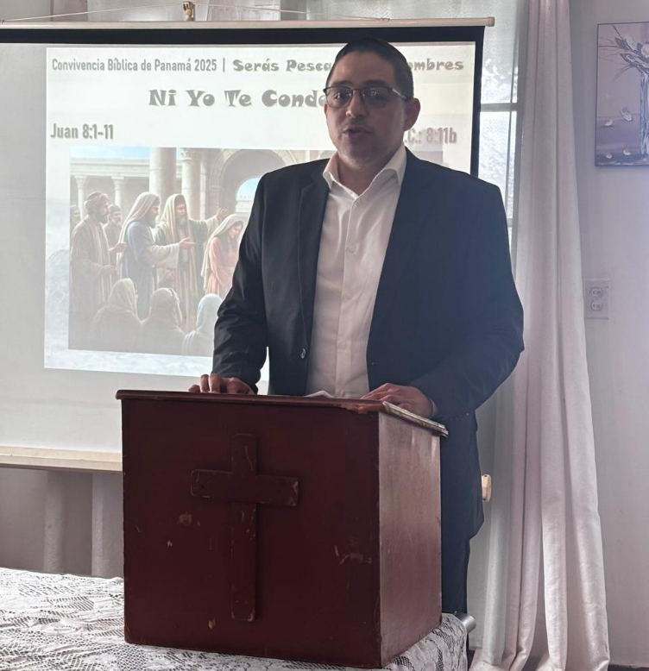
The second day began with the Daily Bread devotional. M. Joshua offered a brief reflection on that day's passage, entitled "Amaziah: Right but Not Wholeheartedly." He challenged us to cultivate a close relationship with God by seeking Him wholeheartedly, rather than relying solely on our own efforts to obey the Bible.
After breakfast, Yael delivered Lecture 1: “Neither Do I Condemn You” based on John 8:1-11. In this story of amazing grace, we saw Jesus extend mercy to the guilty woman—and to us, fellow wayward sinners—granting us a fresh direction for life. As He commanded her, so He calls us: “Go now and leave your life of sin.”
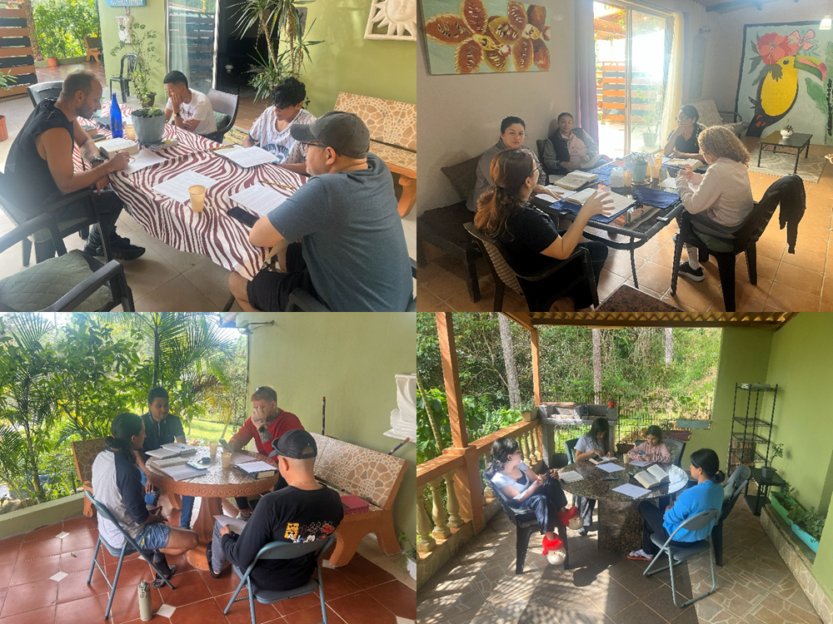
Later, we gathered for our first Group Bible Study, entitled "Father, Forgive Them", based on Luke 23. There, we drew near to the cross, witnessing the sufferings of our Lord—sufferings borne to forgive our sins and grant us new life. We heard Him cry out, "Father, forgive them," and in response, we asked for His forgiveness, acknowledging that He was pierced for our transgressions and crushed for our iniquities (Isaiah 53:5). We then broke for lunch.

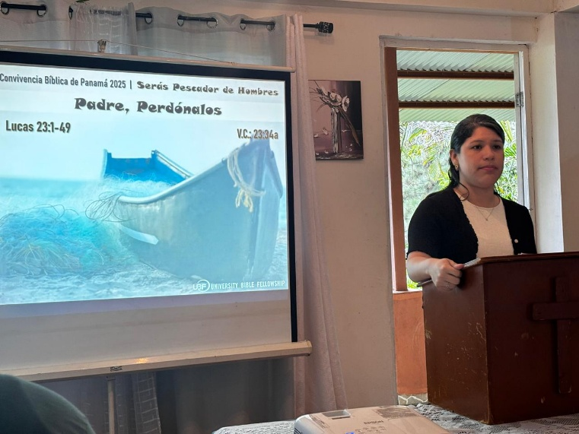
After lunch, Karen delivered Lecture 2, based on the same passage Luke 23 and with the same title. With wholehearted vulnerability, she shared how she encountered Jesus at the cross and received forgiveness for her sinful life. Her message moved us all to tears, prompting us to write personal reflections seeking Jesus' forgiveness and our own rebirth, which we shared in the evening after dinner.
Once we shared our reflections, we gathered together to watch the movie The Forge, which further stirred our hearts and challenged us to reflect on discipleship and new life in Christ.
The third day dawned at 7:00 a.m. with the Daily Bread devotional. M. Joshua offered a brief reflection on that day's passage, entitled "The Fall of Amaziah." We meditated on the grave consequences of halfhearted obedience to God's Word, praying fervently to sidestep Amaziah's pitfalls in our own lives.
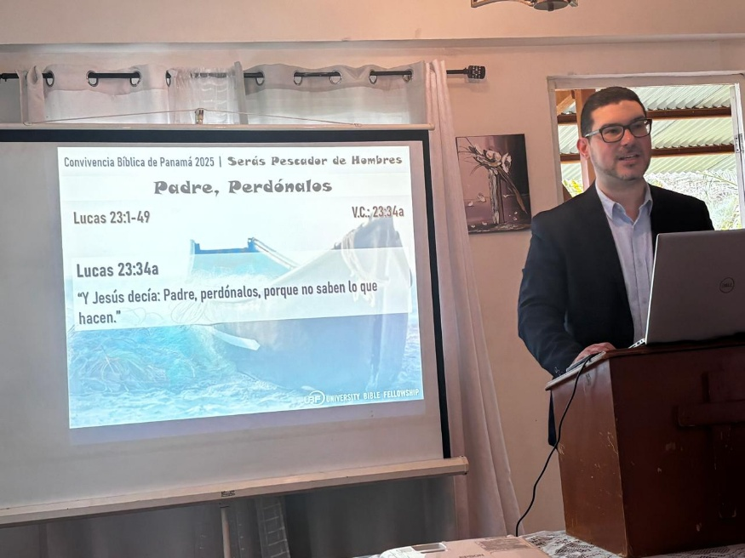
After breakfast, we gathered for our second Group Bible Study, entitled “You Will Fish for People”, based on Luke 5:1-11. Afterwards, M. Joshua delivered Lecture 3 based on the passage and theme. We explored how Peter, confronted by his sinfulness, fell to his knees before the Lord—having once abandoned Jesus' initial calling for a selfish life—yet now receiving, alongside him, the Lord's call to fish for people. This inspired us to venture to the National University of Panama: to fish for students by inviting them to Bible study and confessing Jesus as Lord.
We then closed the conference with a delicious lunch and time of fellowship. Joyful and renewed, we all departed with a fervent desire for personal relationship with Jesus and the resolve to live as His disciples.
Mother’s Day in Panama
The following Sunday, we celebrated the Mother’s Day in advance (Official date is Dec. 8th). Seven mothers attend the Sunday Worship Service, one of them for the first time. M. Joshua delivered a special lecture entitled: “Hannah, Mother of Faith and Prayer”, based on 1 Samuel 1. We were inspired her beautiful example of devotion, faith and sacrifice, surrendering her firstborn son to the Lord. Several mothers were moved to tears, praising God for the life of their children and praying for them to live as Samuel did. M. Joshua prayed for all of them to become mothers of faith and prayer like Hannah, not only for their children, but for Panama to rise as a Kingdom of Priests and a Holy Nation. Afterward, we presented gifts to the mothers, honoring them with heartfelt celebration.
We will hold our Christmas Sunday Worship Service on Dec. 21st, titled: “Jesus Was Born in a Manger” based on Luke 2:1-7. Please pray for M. Joshua’s message and for and for good attendance from our church families and Bible students.
Prayer Topics:
- May Panama become a Kingdom of Priests and a Holy Nation.
- May God raise up Abraham and Sarah of faith among us.
- May M. Joshua be filled with the Holy Spirit to prepare and deliver the Sunday messages with special lectures during the upcoming Christmas and New Year season.
- May Dario, Karen, and Yael grow as shepherds and Bible Teachers.
- May God bless our campus fishing ministry, establishing Bible studies among the students.
- May M. Joshua receive his Chilean visa to attend the Latin America Directors’ Conference.
- May M. Joshua’s family receive provision to attend the World Mission Congress in Korea.
- May the Lord bless M. Maria’s new business with more clients.
Reported by M. Joshua Gutierrez (maikerg@gmail.com)

