Henry Park’s eulogy for Pauline Park
M Pauline Park’s key verse is John 10:11. “I am the good shepherd. The good shepherd lays down his life for the sheep.”
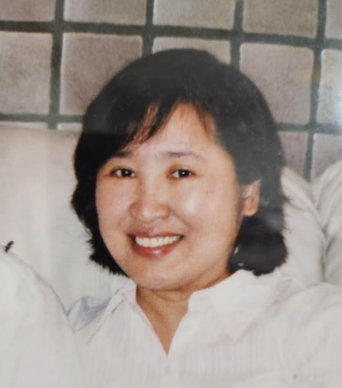
- M. Pauline was a dreamer.
Pauline was born March 25, 1954. Pauline wanted to be a news reporter and go to Paris. Her older sister entered SNU. So she wanted to enter SNU as well. Since the cutline to enter Journalism and French was too high for her, she chose a Nursing major which prepared her to become a missionary.

- She accepted Jesus as her true husband – M. Sweety Rhee invited her to Bible study. During her college days, she loved mountain-climbing and joined not just one, but two mountain climbing clubs.

When she attended the Jeju SBC, she climbed Mt. Halla during the day but listened to Dr. Samuel Lee’s message in the evening. Dr. Samuel Lee’s message on Jesus, the heavenly prince, and a Samaritan woman moved her to accept Jesus as her true husband.

- She was a good Bible student and teacher -- After her graduation, she wanted to go to Boston and pioneer a ministry at Harvard.
Dr. Lee invited her to just drop by Chicago. She did and stayed in Chicago for 20 years. She studied the Bible with Dr. Samuel Lee one-to-one. She testified how Dr. Lee taught her the Bible so wonderfully, sometimes performing a monodrama, in her testimony, “My good shepherd Dr. Samuel Lee.” Through this, she grew to be an excellent Bible teacher.

- She was a fruitful disciple maker -- At NU, God raised P. Kevin Albright; At UIC, God raised P. Steve Stasinos; At Columbus, God raised Jeff Gathergood.

Through one-to-one Bible studies with Pauline, God also raised Little Sarah and Esther Kim (Toronto) as fruitful Bible teachers. In that sense, Pauline was very successful in raising girl students as disciples as well.

- Pauline was a wonderful wife to me, a wonderful mother to our two daughters and a wonderful grandmother to Joshua, Jenna and Liam.
Our marriage had some ups and downs. Once I told her that I was born again and again because of her. To my surprise, she answered, “Me too.” Then I said, “Well, overall, I think it was a happy and fruitful one.” Then she said, “Me too.”

She was my message trainer. Every Saturday she would ask me, “Do you have one clear point?” Then I answered her, “My point is Jesus.” Then she would say, “You should be more specific. You need to pray more until one clear point arises like a morning star in your heart.”

- She entered into eternal rest at the age of 71. On February 2022, She was found to have a stage 4 colon cancer and has been battling against it. On May 25, 2025, she died peacefully on her bed, falling asleep. At the end of her life, she used to say, “I need rest.” At the time of her death, I was sorry but felt that her soul was soaring high to the glorious kingdom of God through her faith in our Lord Jesus Christ. Now she is free from all kinds of pain and has eternal rest. She may be climbing the mountain of God every day, shouting, “Yeah Huh, Hallelujah.”

- Pauline, I will see you up there. Let us climb the mountain of God and praise God together.

