THE CROSS AND THE RESURRECTION
2025 Montreal UBF Easter Celebration (April 18-20)

What a wonderful Easter celebration with the Risen Jesus and sharing Jesus with family, friends and students. This Easter was celebrated on during the three-day Easter weekend (Friday-Sunday) at our Montreal church. Through this Easter celebration, we meditated on the cross of Jesus and his resurrection through messages on John 1:29 (Look the Lamb of God), John 19:38 (Paid in full), and Acts 2:24 (Jesus raised to life, Jesus is alive!).

Good Friday evening programs included a message by Steven Giesbrecht on Jesus the Lamb of God, spoke on the two truths about Jesus: 1) the identity of Jesus as Lamb of God and 2) his mission to take away the sins of the world. Steven also shared his life testimony together with his message, a “two-for-one” deal where we could a message of truth and a testimony of grace. The message was followed by a life testimony by Peter Lee, who accepted Jesus’ words through Luke 5:5 as his life key verse. “Because you say so I will let down the nets.” May God grow both Steven and Peter who are living in the brothers house together, to grow as shepherds, Bible teachers and messengers of God’s word. Our Good Friday evening was closed out by watching a movie together – “Bonhoeffer” and learning about the Spirit of Christ and his passion.
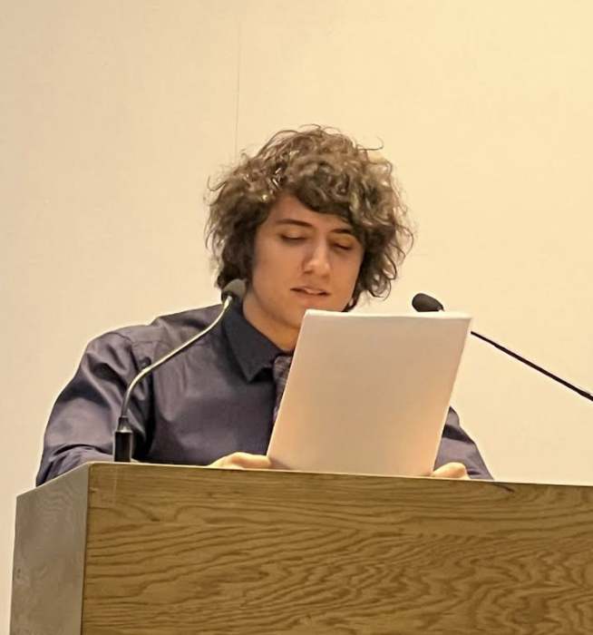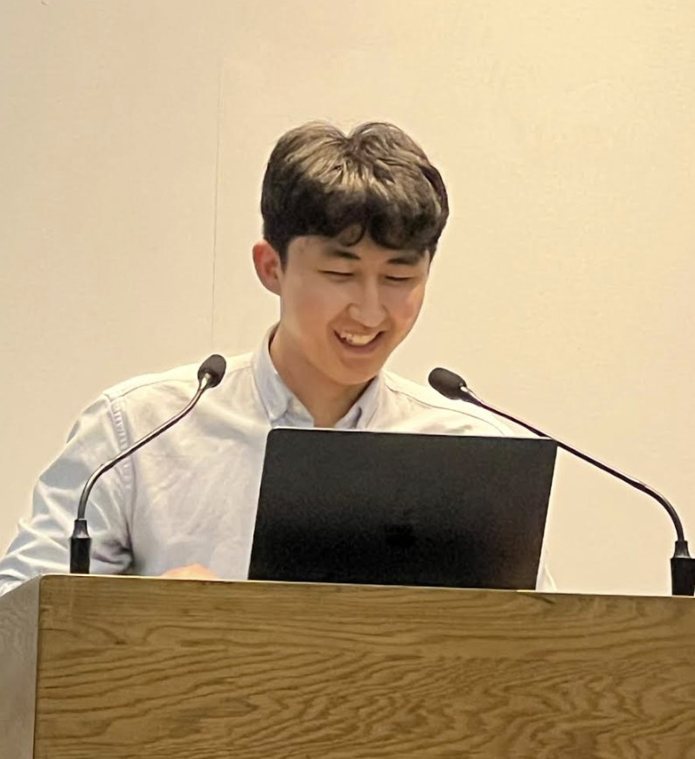

Saturday was time for home group Bible studies. All our church members were divided into five groups (led by our senior leaders David, John, Stephen, Philip, and Luke) with old and young people mixed together to study the second part of Peter’s message in Acts 2:22-41. In the evening, everyone gathered once again to here the message of the cross “Paid in Full” delivered by Samuel Bonne. As a medical student, Sam explained all the technical aspects of the anatomy of the body and how the crucifixion was invented to create the greatest amount of pain for the longest amount of time. Jesus suffered the full extent of the crucifixion in order to pay the full price for our debt of sin. All glory to Jesus who gave himself fully for the forgiveness of our sin. The message was followed by a life testimony from Annael Bonne (Sam’s wife). Her testimony was a full of grace to reveal how God brought her as a pastor’s kid who loathed serving in her parents church and establishing her house church to joyfully serve her Lord and Saviour Jesus Christ. May God bless the Bonne family to be a blessing for his ministry. Saturday program was ended with a one-hour night of praise and worship full of songs to exalt our Lord Jesus.
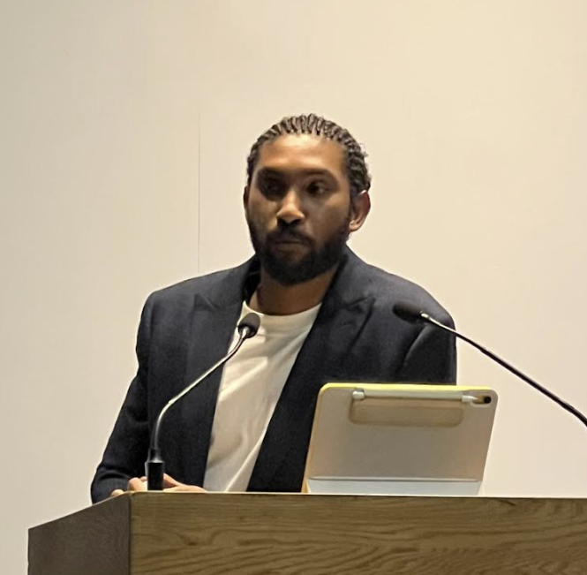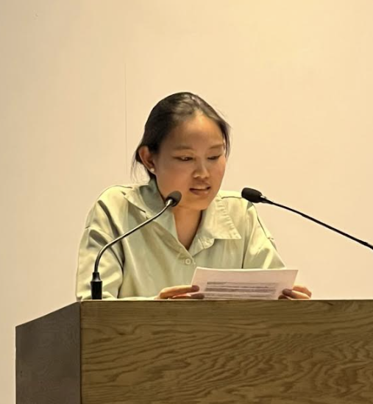

Finally, on Easter Sunday, brought nearly 80 people – family, friends and students – to come celebration resurrection day. The resurrection message as given on Acts 2:22-41 by Philip Wong: Jesus raised to life, Jesus is alive! Because by his Almighty power, God raised Jesus from the dead and we are also raised to live by the power of the resurrection. God’s message called us to repent and be baptized, and to receive the free gift of the Holy Spirit. We then celebrate the Lord’s Supper together. The worship service ended with an exclamation mark as our next gens performed an Easter dance!
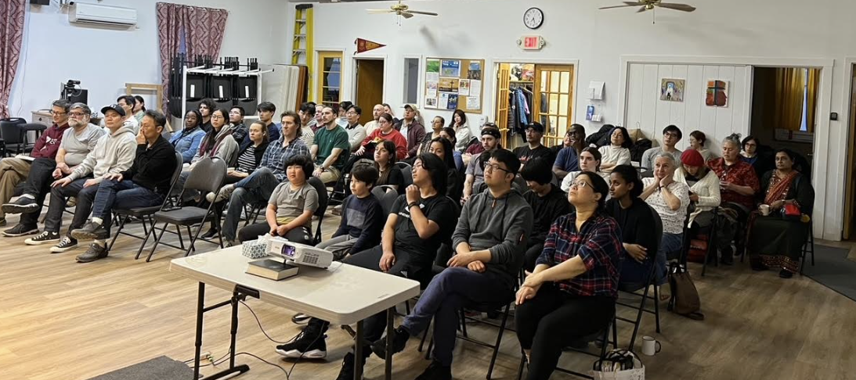
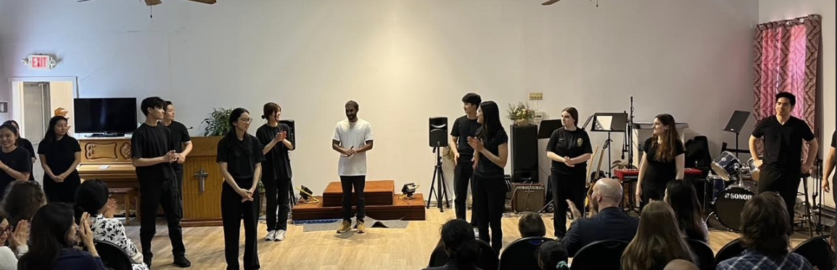

We are so thankful to God for blessing our Easter celebration with such an amazing turnout. Each night many young people who have been faithfully coming to our ministry and students, despite this final exam period, to come worship the Risen Lord. Thank God for all the young people who performed the dance – which was a program 100% initiated by young people. Our Easter celebration was also blessed because of many prayers, through a 31-day prayer march, every at 6AM led by Annie. And of course, thank God all the ladies who served a meal each day to make our fellowship time so joyful. May God bless each of his people with the joy of the Risen Christ!

