UBF Zambia (Manger Ministry) 2025 Easter Program Report:
"God’s Saving Grace Through Jesus Christ"
Written by Shepherd Moses:
Introduction
The UBF Zambia Manger Ministry hosted it’s 2025 Easter Program from Friday, April 18th, to Monday, April 21st, at the university of Zambia graduate school of business. The theme of the conference was, “God’s Saving Grace Through Jesus Christ.” The program aimed to deepen our understanding of Christ’s sacrificial love, resurrection, and victory over death through Bible studies, massages, and fellowship. We had a total of 21 attendees, including 5 children, 14 students, Shepherdess Mercy, and myself. Despite scheduling adjustments due to academic commitments, the event was joyful and we received much grace.
Program Overview
Day 1: Friday, April 18th
Theme: “Jesus Died for Our Sins” (Isaiah 53:1-12)
The scheduled Bible study was postponed as most students were writing tests on Friday. By God’s grace, we commenced the program at 12:00 PM with a worship service.
I (Shepherd Moses) delivered a message on Isaiah 53, emphasizing Christ’s suffering as the ultimate sacrifice for humanity’s redemption. Key verse: “He was pierced for our transgressions, crushed for our iniquities” (Isaiah 53:5). Through the massage we could realize that Christ suffering was foretold many years before he was born. His fulfilment of the prophesy by Isaiah after about 800 years is a clear testimony that Jesus is indeed the promised Messiah. Through the massage we could see and experience God’s one sided grace. We had lunch at 2:30 PM and then sports fellowship and ended our program at 5:00 PM.
Day 2: Saturday, April 19th
Theme: “United in His Death” (Romans 6:1-14)
Brother Elvis lead the group bible study for students and shepherdess Mercy lead the bible study for children. Brother Elvis explained the meaning of dying to sin and living a new life in Christ. We started at 09:00 AM and finished the bible study at 11:00 AM. Then we had a short tea break. At 12:00 PM, we began our service. Brother Elvis was the presider and brother Chishimba delivered a powerful message on Romans 6, encouraging us to embrace our identity as “instruments of righteousness” and be united with Christ in his death and resurrection (Romans 6:13). Then at 2:30 PM we had lunch and after lunch sports fellowship.
Day 3: Sunday, April 20th
Theme: “He Is Risen” God’s Saving Grace Through Jesus Christ (Luke 24:1-12)
We began our program at 09:00 AM with three Bible study groups:
1. Children’s Group: Led by Shepherdess Mercy.
2. Student Group 1: Facilitated by brother Chilufya and Clifford.
3. Student Group 2: Guided by brother Elvis and Chishimba.
The main massage was delivered by brother Chilufya. Chilufya preached on Luke 24, highlighting the resurrection as the foundation of Christian hope. Key takeaway: “Why do you look for the living among the dead? He is not here; He has risen!” (Luke 24:5-6). The program concluded with heartfelt prayers and thanksgiving for God’s grace. Then we had our special lunch at East park from 4:00PM to 6:00 PM.
Fun Day: Monday, April 21st
The group visited Happy Land Play Park from 09:00 AM to 5:00 PM, enjoying games, laughter, and fellowship. This day strengthened bonds and celebrated the joy of Easter together.
Conclusion
The 2025 Easter Program helped us to experience God’s faithfulness amid challenges. Though academic tests and time limitations required flexibility, the Holy Spirit moved powerfully through His Word. Participants left with renewed gratitude for Christ’s sacrifice and resurrection. Brother Chishimba wrote after the conference, “Thank you so much for the conference, we had spiritual refreshment and not only that we also had physical refreshment, school has been stressful and we feel that sense of liberation, that's how I feel I am not quite sure about the rest.” Then brother Clifford responded, “You speak on behalf of us all.” The students were very happy and excited after the conference. Am really thankful for your prayer support. Special thanks to Shepherdess Mercy, the student leaders, and all attendees for their dedication. We pray this program sows’ seeds of faith that continue to grow in Zambia and beyond.
Shepherd Moses
UBF Zambia, Manger Ministry
Below are some selected photos.
Children’s Bible study
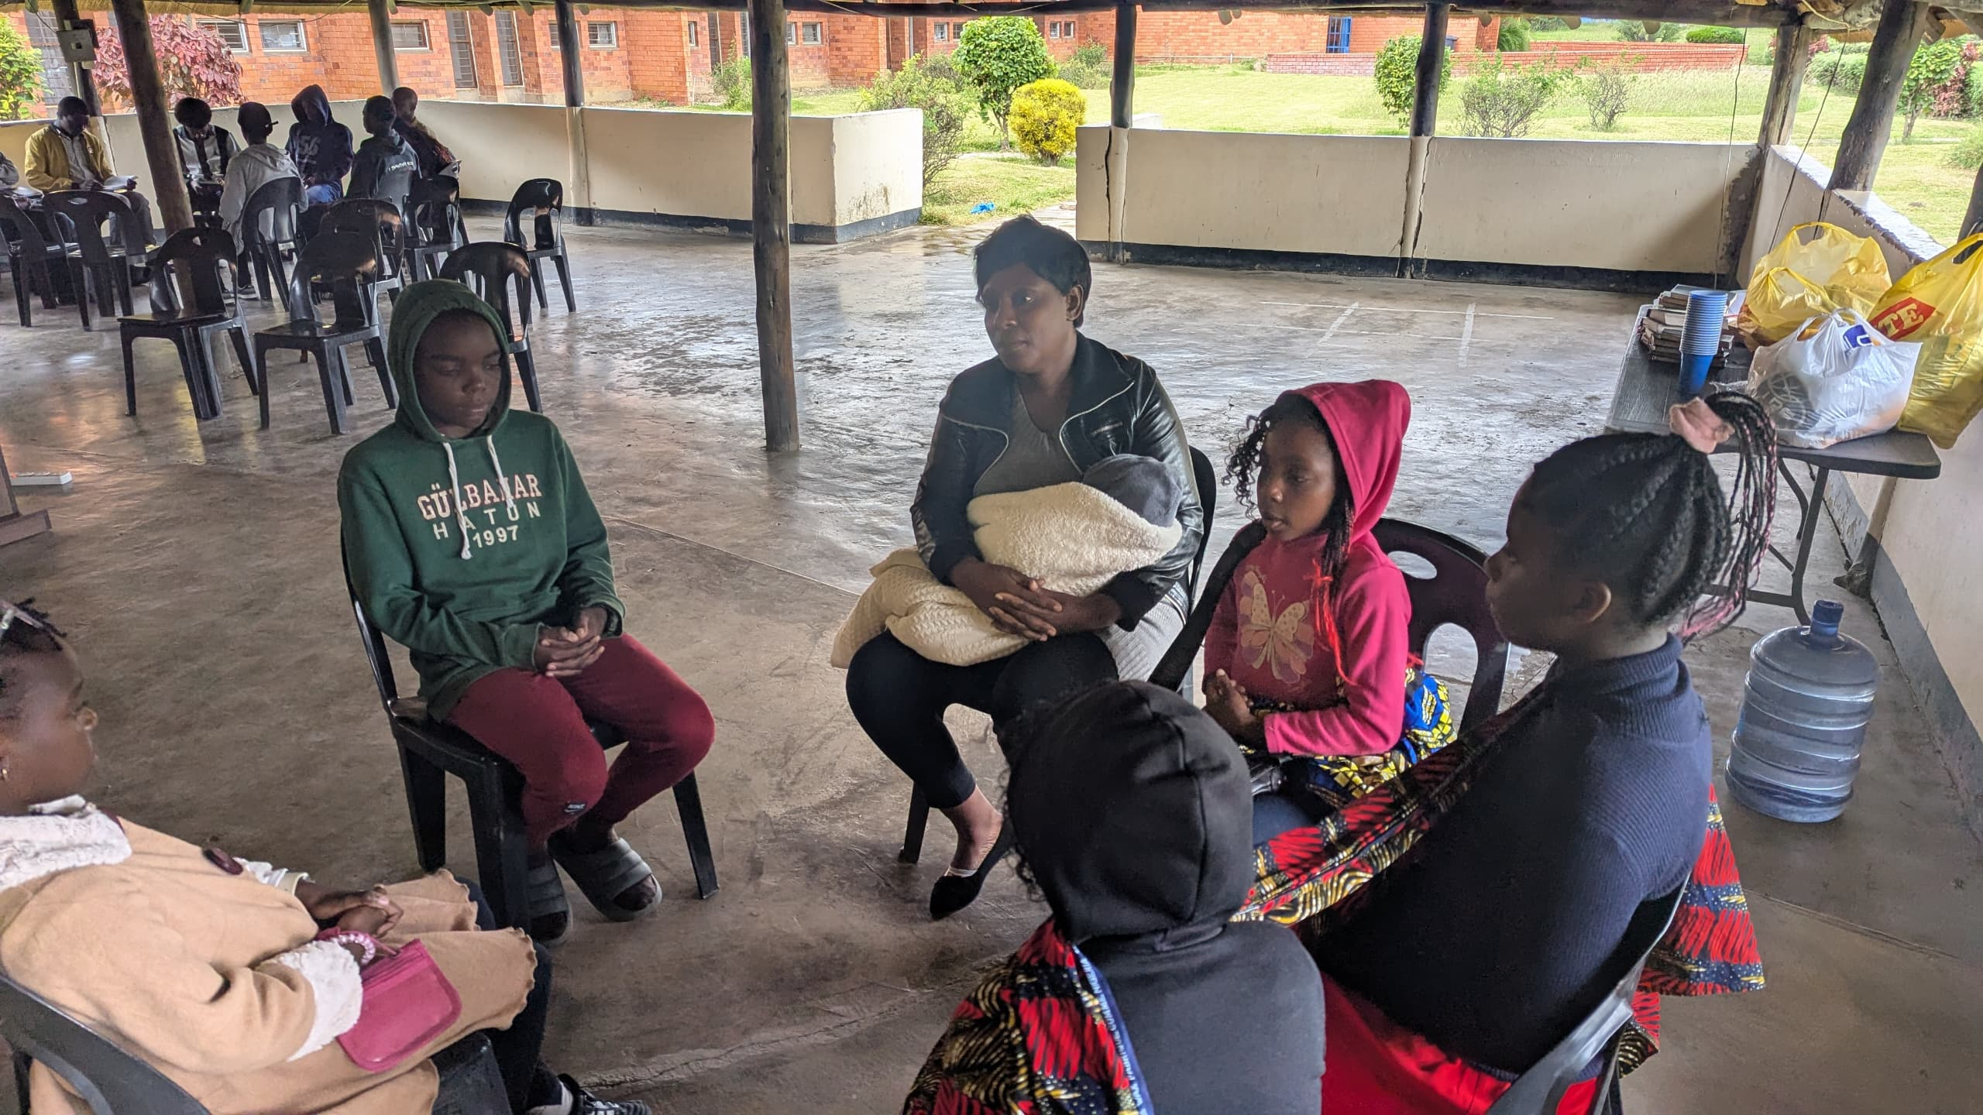
Children group bible study
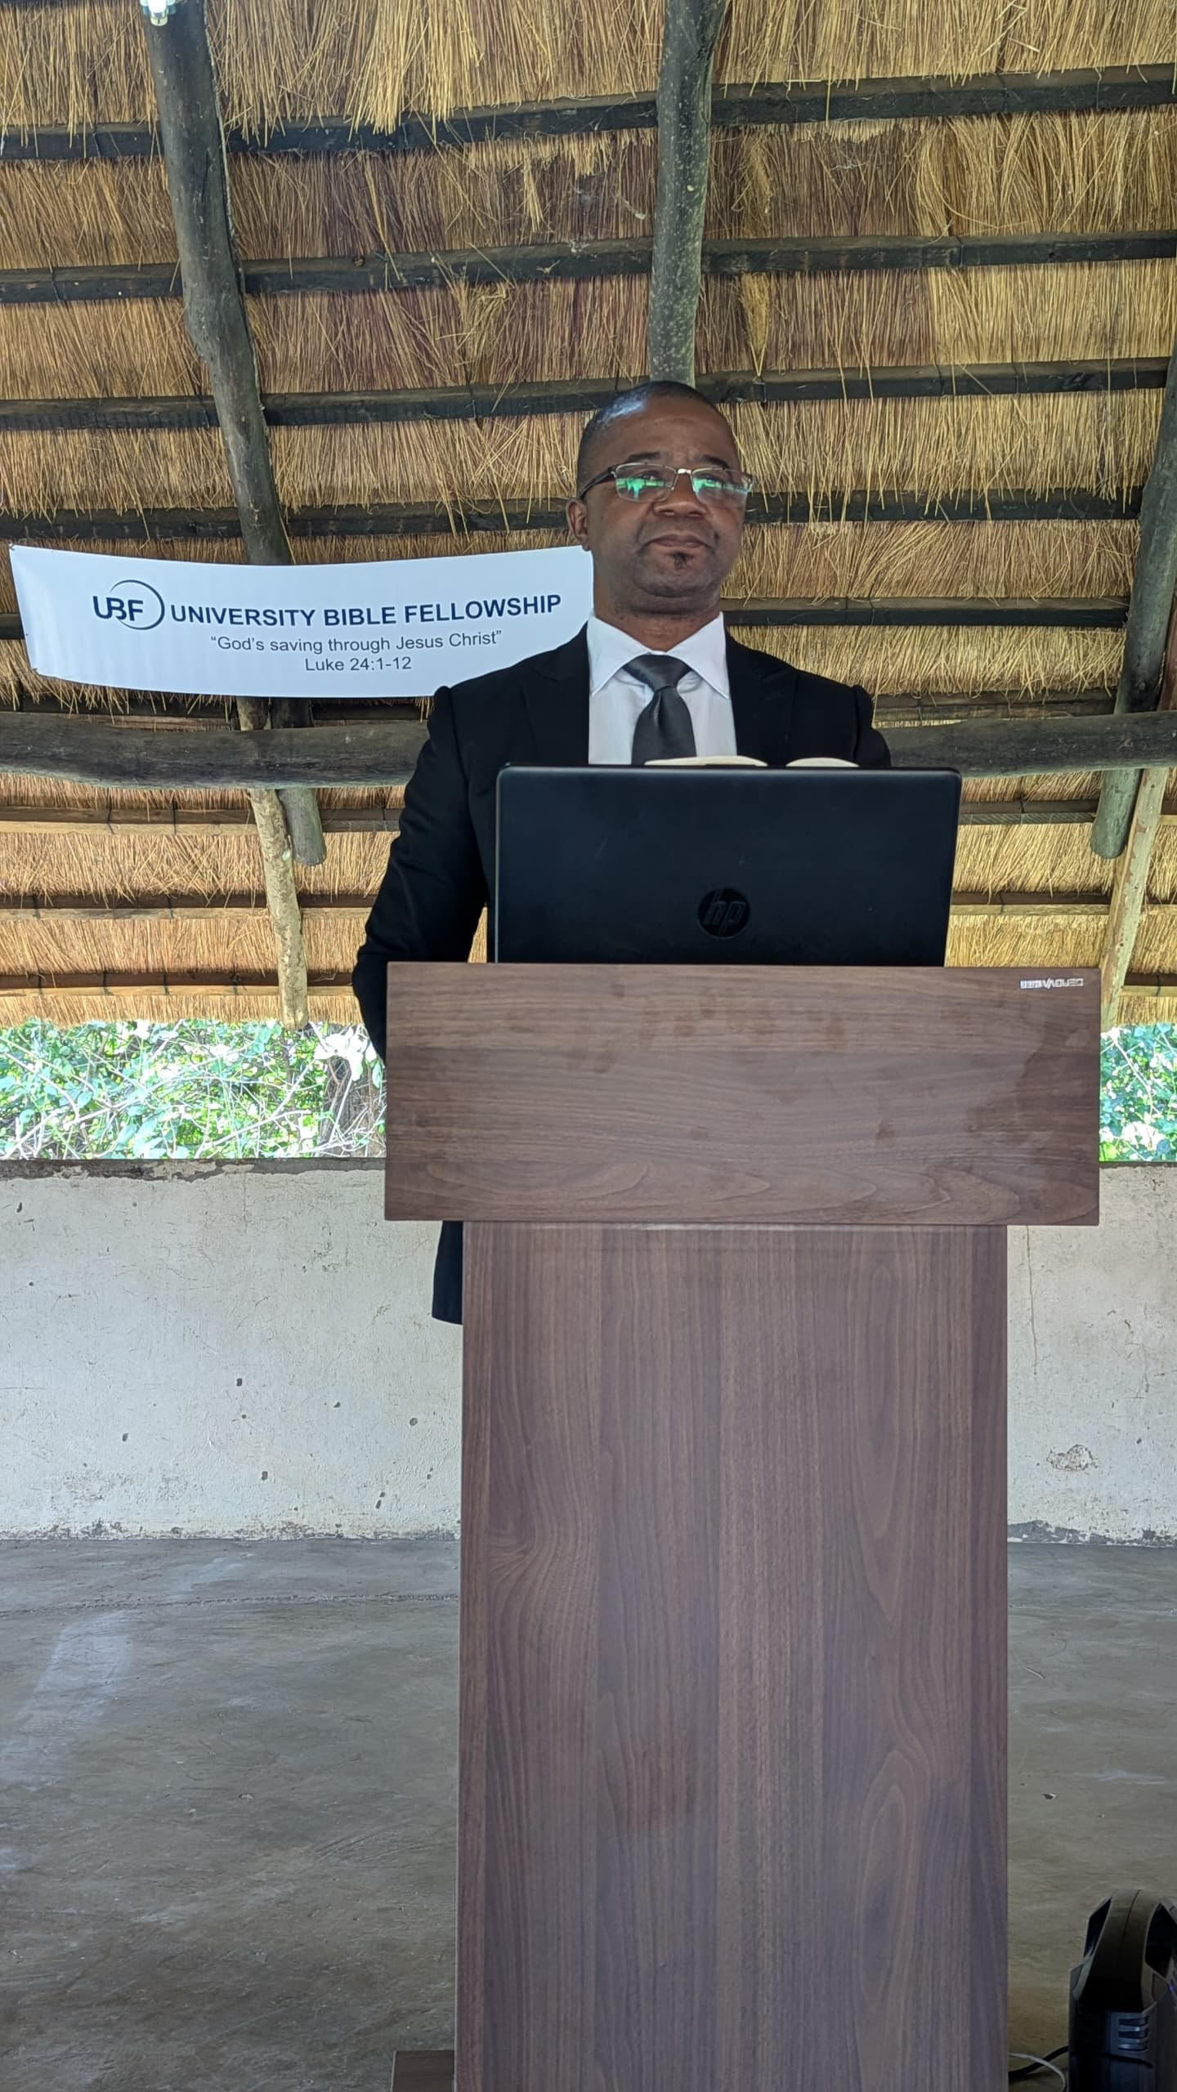
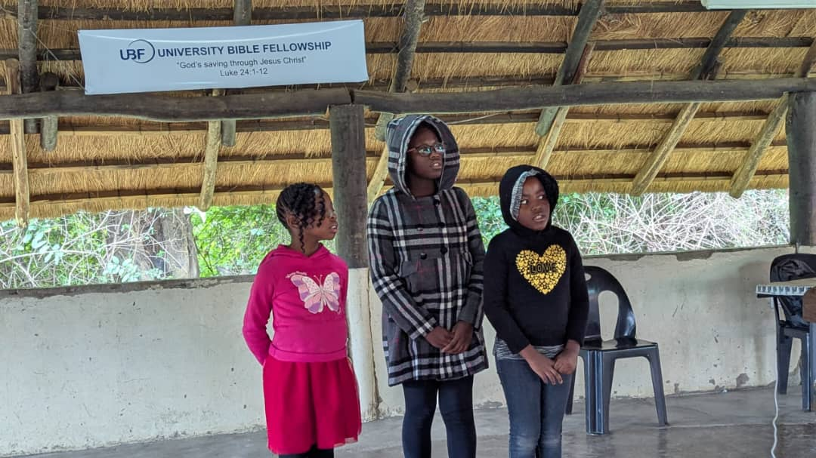
Special song by three sisters, Rebecca Chisha, Mercy Chisha and Sarah Chisha

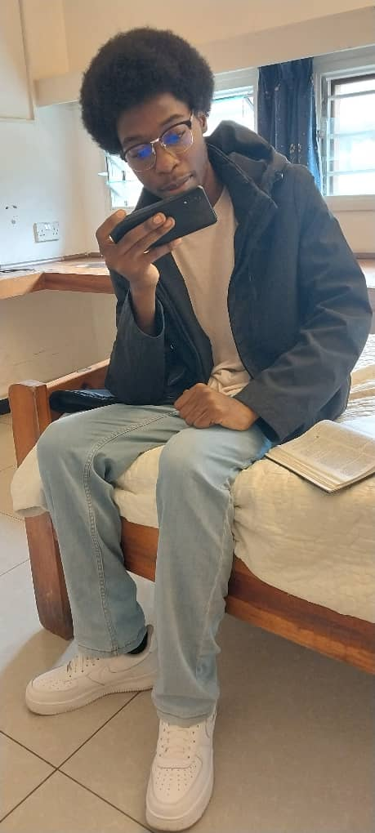
Massage training (Chishimba)
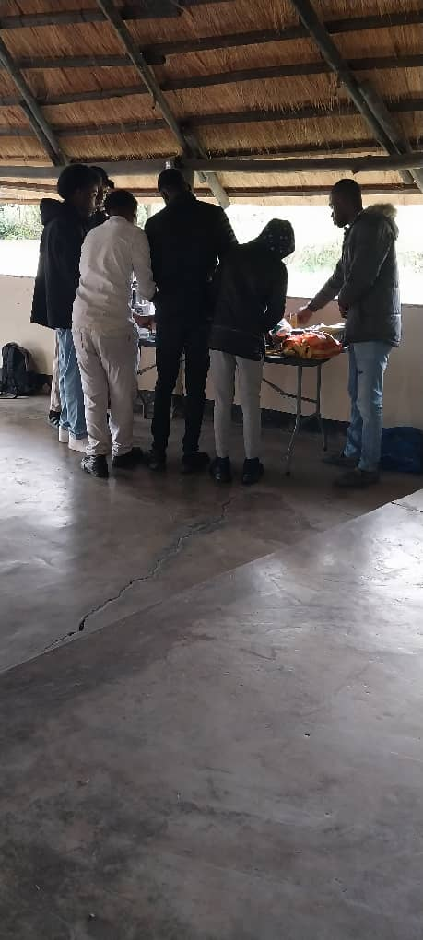
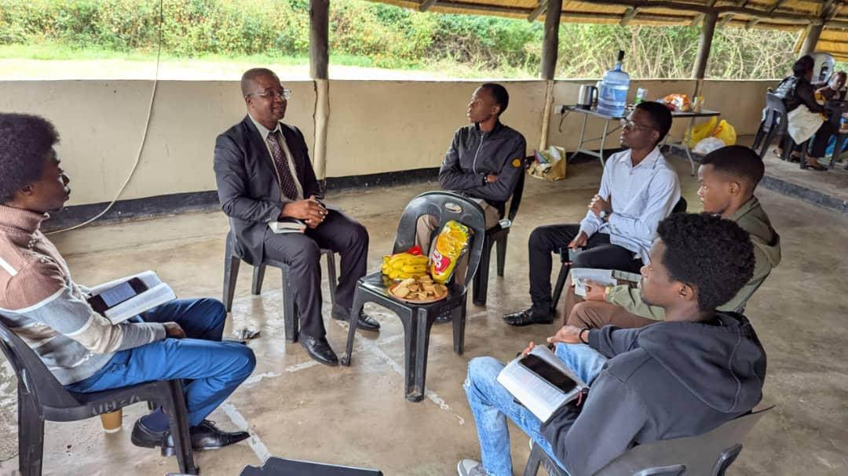
Bible study group led by Chishimba and Elvis

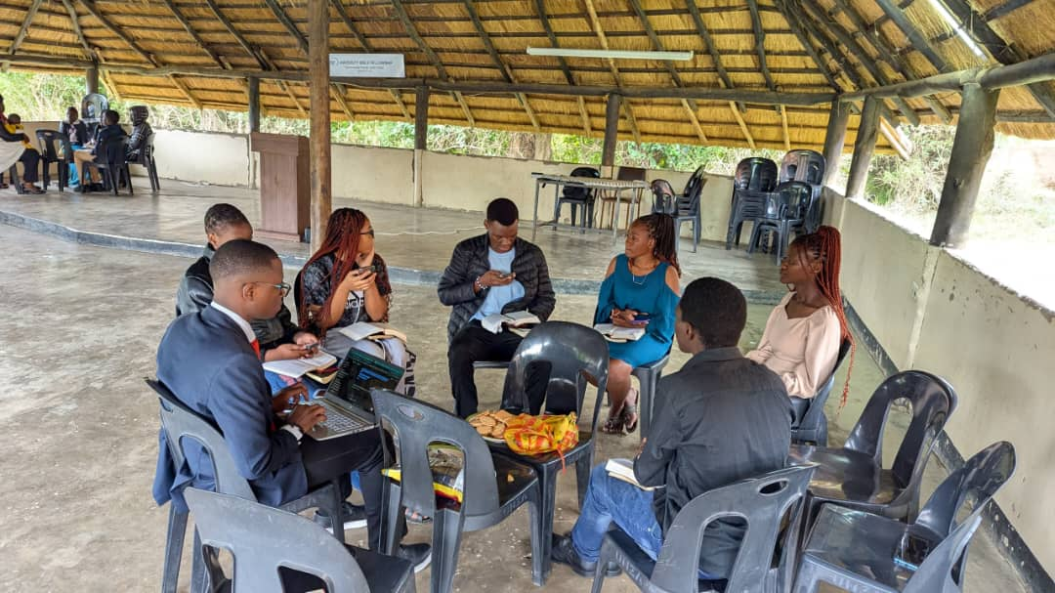
Bible study led by Clifford and Chilufya
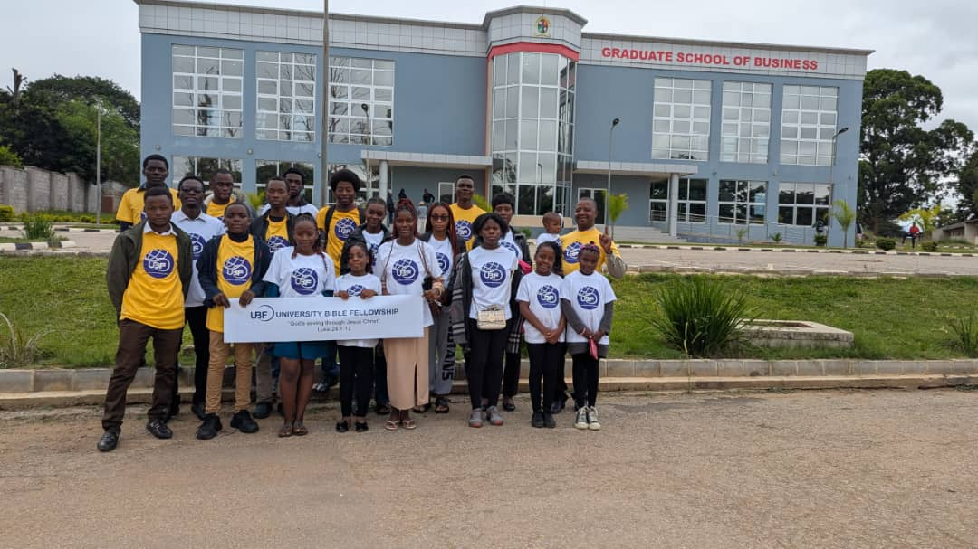
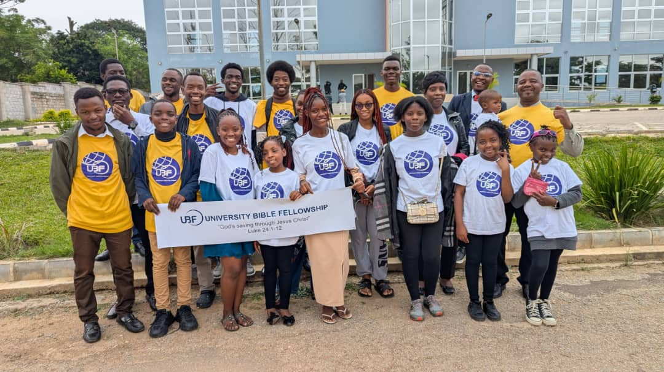
Photo session
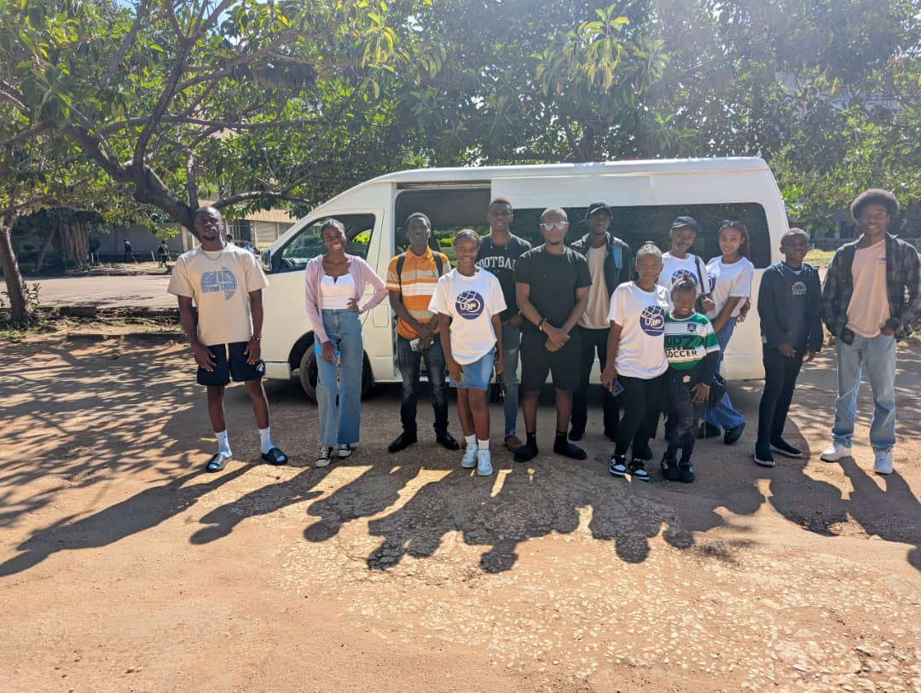
Tour day
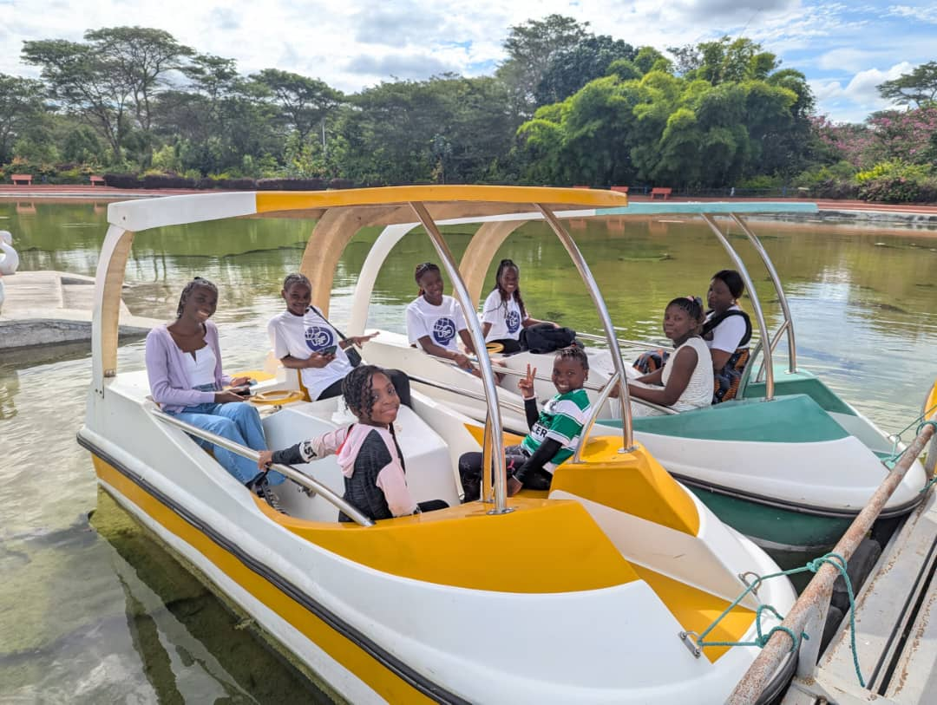


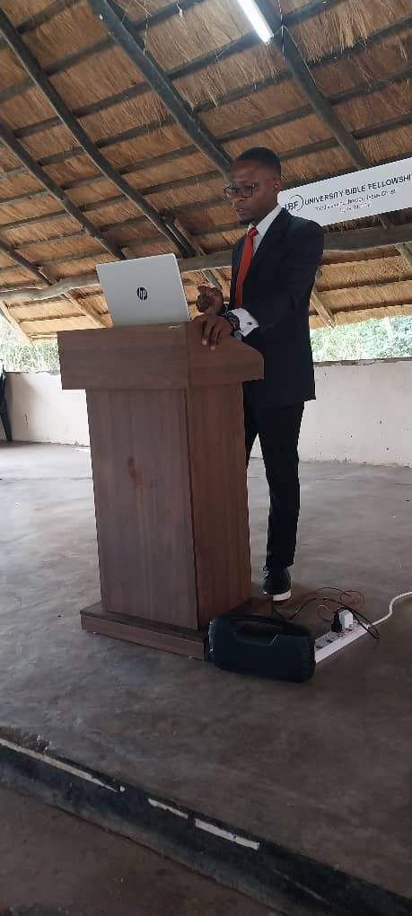
C
Massage by Chilufya

