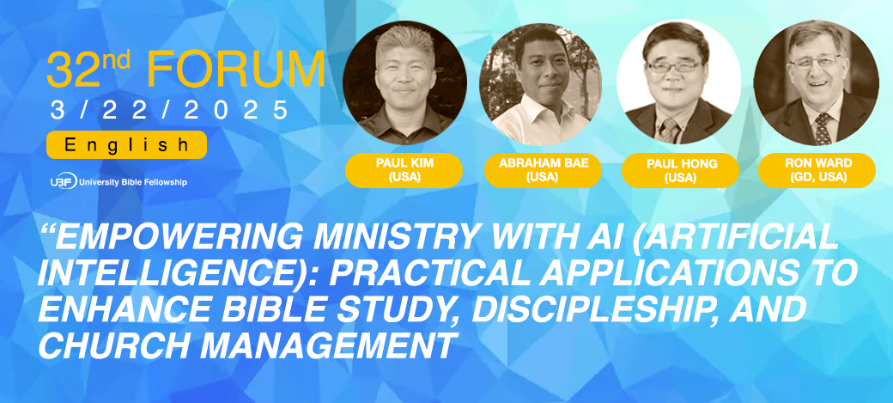

Dear UBF Mission Coworkers,
We will have the 32nd English Online Forum on Saturday, March 22, 2025. The topic will be “Empowering Ministry with AI (Artificial Intelligence): Practical Applications to Enhance Bible Study, Discipleship, and Church Management” We live in an era where AI technologies are proliferating rapidly and having a powerful impact on every aspect of our lives. In this age, we need wisdom to embrace AI technology and apply it effectively in God's work. In this 32nd English Forum, we will discuss how AI technology can be used effectively and practically for the growth of God's work. Join us to learn God's wisdom and AI technology together.
Date: Saturday, March 22, 2025.
Time: 9 am (CDT Chicago, USA), 10 am (EDT New York, USA), 3 pm (CEST Berlin, Germany), 11 pm (KST Korea)
Target Attendees: English-speaking leaders and 2nd gens
Panelists: Dr. Paul Kim (DuPage, USA), Dr. Abraham Bae (Washington, USA), Dr. Paul Hong (Toledo, USA), P. Ron Ward (GD)
Moderator: Dr. Helen Rarick (USA)
Presented via Zoom: The Zoom invitation will be sent to registered emails before the meeting. If you want to join the 32nd English Online Forum, please register on the HQ Website today (https://ubf.org/onlineforum/english).
* UBF Online Forum Committee
Chair: Dr. Ezra Cho (ezra5978@gmail.com)

