REPORT 2023 (LATIN AMERICA LEADERS SCHOOL)

Joshua Chun

"And the things you have heard me say in the presence of many witnesses entrust to reliable people who will also be qualified to teach others." (2 Timothy 2:2)

- SUMMARY 2023

Thanks be to God for hearing the longing prayer of His servants and blessing this school abundantly according to His faithfulness and goodness this year. Finally, 8 leaders from COHORTE 3 / 8 from COHORTE 4 attended the classes during 2023 and took all corresponding materials with enormous passion in spite of their difficulties (from March to December).

Inicio 2022 | COHORTE 4 (8 alumnos) |  | Inicio 2023 | COHORTE 5 (9 alumnos)
Méx-CU | Fermín Ibarra Rosas |  | Méx-CU | Luis Enrique De la Cruz Gama
Méx-Gj | Gonzalo Solís Sánchez |  | Méx-CU | Luis Lucio Lugo Soriano
Méx-Iz | Angelina Rosario Hernández García |  | Méx-Gj | Víctor Martínez Juárez
Méx-Iz | Jorge David Ríos Arteaga |  | Méx-Iz | Virginia Montserrat Hernández G.
Méx-Saltillo | Pedro Mariano Gómez Vera |  | Méx-Cuautit | Audiel Alaves Hernández
Colombia | Carolina Cárdenas Vega |  | Panamá | María de las Mercedes Rosales P.
Ecuador | Ester Kim |  | Méx-Iz | Juan Carlos Saavedra
Guatemala | Saúl López Pineda |  | Ecuador | Luisa Ana Suarez Otacoma
 |  |  | La Plata | Claudia Elena Farfán

The year's classes consist of 5 materials. 10 materials in two years. Each Material takes 6 study sessions (a month and a half, once a week, 2-3 hours per session); and then 2 weeks break between materials. The facilitators are as follows: John Seo, Joshua Maiker, John Lee, Marcos Kim, Juan Carlos, Esteban Cho, Ana Seo(guest), Joshua Chun, and Edwar Ti. And M, Timothy Lee, M, Elias Park, and M, Joshua Ham are supporting and sponsoring this school's administration with prayer.
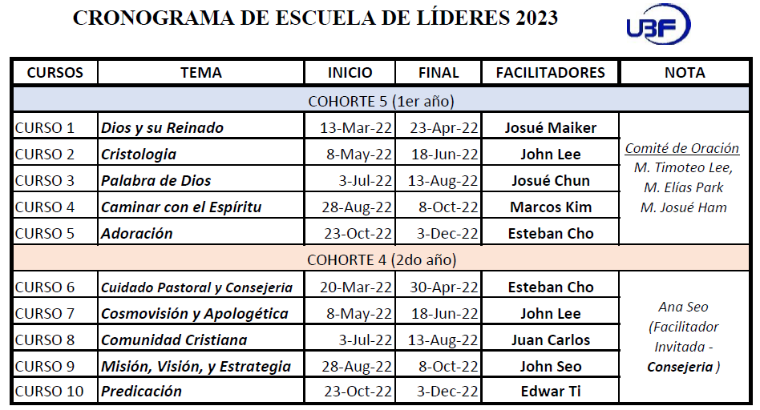
 | Inicio 2024 | COHORTE 6 (11 alumnos)
 | Méx-Iz | José Alfredo
 | Méx-Iz | Norelkis Elena
 | Méx-Saltillo | Sara Gómez
 | El Salvador | Verónica Ramírez
 | Panamá | Darío Ernesto
 | Panamá | Karen Elizabeth
 | Colombia | Joice Astrid
 | Ecuador | Mar Lorena Quintero
 | Argentina-BsAs | Christian Nicolas
 | Argentina-BsAs | Victoria Reinaldo
 | Argentina-La Plata | Iliana La Cruz

The shepherds of COHORTE 4 have finished their 2-year study by the grace of God and had their graduation on January 12, 2024, at the conference in Colombia. We pray the Lord will continually bless their faith efforts to be used as mature servants for God's work. Now 11 new students from 8 chapters are waiting to enter the School of Leaders this year 2024. Thank you for their spiritual longings and desires. We pray that all the courses will be truly guided and blessed by the Holy Spirit for the glory of God.

- THANKFULNESS

God heard our prayer and thus allowed us to have a graduation ceremony in person this year. It was all by His grace. Thanks be to God. We especially appreciate the great efforts and dedication of our facilitators. In spite of their very busy schedules, they have served the courses and the needs of the shepherds with all passion for the love of Christ. They will all receive a small award from the HQ education committee this year. Thank you to the HQ Education Committee.

- PERSONAL LEARNING AND PRAYER TOPICS

"His master replied, ‘Well done, good and faithful servant! You have been faithful with a few things; I will put you in charge of many things. Come and share your master’s happiness!" (Mt 25:23) As a School administrator, I have been able to see and learn the faithfulness of the shepherds and facilitators. During the time of the school, I sometimes got to thinking "What would this learning struggle before God really mean?" and it seemed to me that our pastors need more than intellectual knowledge. It was noticed that our facilitators are becoming more and more professional in their intellectual capacity and spirituality. That has made me want to be their student. Glory to God. We pray that this school will become a huge support visibly and invisibly for the ministry of each chapter in Latin America.

Our prayer topics are as follows.

- May it be the School of Christ.
- May God send to Leaders School of Leaders many shepherds passionate with the love of Christ every year.
- May God give the necessary health and passion to all the facilitators who serve the courses.
- The classes are more useful and practical to serve the ministry of each chapter.
- To have good access to all the digital materials

