Texas Visiting Report
November 2023, Jim and Helen Rarick

Helen and I visited Houston and Arlington UBF ministries from November 18-22, 2023. There were a couple of reasons. First, since I became the President of the UBF North American Board of Elders, we decided to try to visit one chapter per month, to learn prayer topics and encourage coworkers around North America. For the first time in 35 years, Helen and I are not in a position of responsibility in Chicago UBF. So, we have the freedom to not attend the Sunday Worship Service every week. This enables us to travel. Second, we have wanted to visit Missionaries Joshua and Gloria Choo for many years, as they were my (Jim’s) original shepherds in Milwaukee UBF. They cared for me with all their heart for three years, even allowing me to live with them for more than one year. I literally owe all I am in Christ to them.

Helen and I flew to Houston on Saturday November 18th and stayed a hotel in Galveston, TX. On Sunday morning, we drove (renting a car) to Katy, TX, where Paul and Danielle Jo live. Outside their house we were met by Paul Jo and his son Samuel, a handsome 19 y/o. Inside we met two precious coworkers, Oscar and Jane Ng, a young family who moved to Houston from Hong Kong. Oscar had studied the Bible in Hong Kong. Since moving to Houston, both Jane and Oscar had been faithful to the Sunday Worship Service and Bible study. They are faithful coworkers to the Jo family. God also blessed the Ngs with a baby boy this year, Matthew. Gustavo Prato’s family, who had just moved to Houston that week, attended and we were overjoyed to see them. We somehow spent more time with them in Houston than we had in Chicago. The Sunday Worship message was delivered by Missionary Bunyan Beom, a visiting researcher from Korea. His teenage daughters, Yejin and Yehan, also attended. Missionary Bunyan gave a heart-moving message on Psalm 30. He focused on how God helps us in our roller-coaster life. He gave three “T’s” to remember: 1-Think about God; 2-Trust God; 3-Thank God. We were all moved by his message and delivery. Afterward we had a fellowship lunch. After all left, Missionary Paul and Danielle took us on a walking tour and then bought us a delicious Texas barbecue. After dinner, Helen and I drove back to Galveston.

I realized how important Houston UBF is. Houston is the 4th largest city in the U.S. Missionary Paul’s family is a mustard seed of the kingdom of God. I didn’t know, but he has a Master of Theology (Th.M) from Dallas Theological Seminary. He is now a full-time servant of God. We have been praying for full-time gospel workers in North America, and one is already serving in Houston. We pray God blesses their ministry, and Houston UBF can be a power source for pioneering all Texas and all Southwestern U.S. campus ministries. They pray God may send more coworkers to Houston. We will join in prayer for them.

On Monday, Helen and I flew to Arlington and were met by Missionaries Joshua and Gloria Choo. Missionary Joshua has retired from teaching at the University of Texas Arlington and now also studies the Bible and serves Arlington UBF full-time. Missionary Gloria has also retired from nursing. We went to lunch and then to their house, where we met their youngest child, Sarah, who is living with them. Like Houston, Arlington UBF is served out of the Choo’s house. It is a literal house church. They bought the house from a physical who had the house built for his practice. He created a large room for a waiting room, which is perfect for holding a worship service of about 30 people. It is truly God’s grace to prepare this space, and that the house has been used for God’s ministry for the last 30 years.

The next day as special meeting was prepared for the Arlington ministry. I was to deliver a message on 1 John 4, as I had in Boston, and Helen was to deliver her life testimony. Since it was late afternoon, we rested and worked on what we would deliver.

On Tuesday, Missionary Joshua and Gloria took us hiking in a nearby forest, with a precious coworker of theirs, Missionary Monica. Together we had time to reflect on our lives together in Milwaukee. It was a blessed time. Missionary Monica then bought us lunch and we began to prepare for the meeting that evening.

At 6 p.m. around 25 people arrived, and we had dinner together. At 7 p.m., we began a program with hymn singing. Then I delivered the message and Helen shared her life testimony. At the meeting we were especially moved by one precious Bible student, Kimberly Ortiz. She is a 28 nurse who has been studying the Bible for 8 years with Missionary Gloria. In that time, she has grown from a sheep to precious coworker. She brought her brother Jose to Bible study, and now he too is a coworker, a 26 y/o handsome young man working as a civil engineer. Together their family brought 15-20 people this special meeting. Both are praying to marry and we promised to pray for them, and through them all Arlington UBF, and all of Texas.

The next day Helen and I were dropped off at the airport by Missionaries Joshua and Gloria, and I said a tearful goodbye. I feel I was only blessed by them when I came to thank them. They promised to pray for Helen and me as we serve North American ministry and pray to go as missionaries one day.

Praise God who blessed our short visit to Texas. May God bless and grow his precious work in Houston and Arlington. May God raise many coworkers who can shepherd the large state of Texas with the gospel.

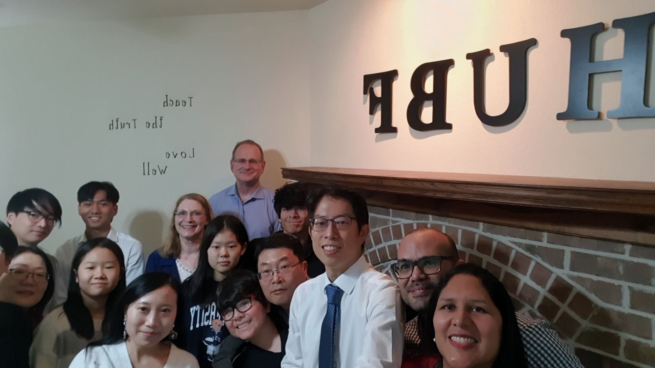
Figure 1 Houston UBF

